|  |
| --- |
| **E:\My Documents\Desktop\Logo_FPT_University_doc.jpgMinistry of education and training** |
| Software Requirement Specifications |
| FPT Management Trainning Process |
|  |
| |  |  | | --- | --- | | **FMTP Team** | | | **Group Members** | Nguyễn Huỳnh Long – 00571 – LongNH00571  Trần Minh Trực– 00570 – TrucTM00570  Phạm Duy Khương – 00576 – KhuongPD00576  Nguyễn Anh Tuấn – 00751 – TuanNA00751 | | **Supervisor** | Teacher Kiều Trọng Khánh | | **Ext Supervisor** | N/A | | **Capstone Project code** | FMTP | |
| **Ho Chi Minh, 26th Jan, 2012** |

**Record of Changes**

|  |  |  |  |  |
| --- | --- | --- | --- | --- |
| **Date** | **Change Item** | **Description** | **By** | **Version** |
| 26/01/2012 | All | Create the document | LongNH | 0.1 |
| 12/02/2012 | Usecase diagram | Add usecase diagram | TrucTM, LongNH, TuanNA, KhuongPD | 0.2 |
| 12/02/2012 | ERD | Add ERD | TrucTM | 0.3 |

# Table of Contents

[Table of Contents 2](#_Toc316819115)

[I. User Requirement Specification 5](#_Toc316819116)

[1. Student Requirements 5](#_Toc316819117)

[2. Staff requirements 5](#_Toc316819118)

[3. Import Data File requirements 5](#_Toc316819119)

[4. Grading requirement 5](#_Toc316819120)

[5. Filter Student Requirement 5](#_Toc316819121)

[6. Export Data File Requirement 6](#_Toc316819122)

[7. Input Data Requirement 6](#_Toc316819123)

[8. Admin Requirement 6](#_Toc316819124)

[II. System Requirement Specification (Specific Requirements) 6](#_Toc316819125)

[1. External Interface Requirements 6](#_Toc316819126)

[1.1 User Interfaces 6](#_Toc316819127)

[1.2 Hardware Interfaces 7](#_Toc316819128)

[1.3 Software Interfaces 7](#_Toc316819129)

[1.4 Communications Protocol 7](#_Toc316819130)

[2. System Features 8](#_Toc316819131)

[2.1 <User> Login 8](#_Toc316819132)

[2.2 <User>Forget password 11](#_Toc316819133)

[2.3 <Staff>Add Class 15](#_Toc316819134)

[2.4 <Staff>Edit Class 18](#_Toc316819135)

[2.5 <Staff>View Class 22](#_Toc316819136)

[2.6 <Staff> Add Student Score 25](#_Toc316819137)

[2.7 <Staff> Edit Student Score 29](#_Toc316819138)

[2.8 <Staff> View Student Score 34](#_Toc316819139)

[2.9 <Staff> Add Semester 37](#_Toc316819140)

[2.10 <Staff> Edit Semester 41](#_Toc316819141)

[2.11 <Staff> View Semester 45](#_Toc316819142)

[2.12 <Staff> Add Major 48](#_Toc316819143)

[2.13 <Staff> Edit Major 51](#_Toc316819144)

[2.14 <Staff> View Major 55](#_Toc316819145)

[2.15 <Staff> Add Subject 57](#_Toc316819146)

[2.16 <Staff> Edit Subject 61](#_Toc316819147)

[2.17 <Staff> View Subject 65](#_Toc316819148)

[2.18 <Staff> Add Subject Group 68](#_Toc316819149)

[2.19 <Staff> Edit Subject Group 72](#_Toc316819150)

[2.20 <Staff>View Subject Group 75](#_Toc316819151)

[2.21 <Staff> Add Special 78](#_Toc316819152)

[2.22 <Staff> Edit Special 82](#_Toc316819153)

[2.23 <Staff> View Special 85](#_Toc316819154)

[2.24 <Staff> Add Mode of Study 88](#_Toc316819155)

[2.25 <Staff> Edit Mode of Study 92](#_Toc316819156)

[2.26 <Staff> View Mode of Study 95](#_Toc316819157)

[2.27 <Admin> Add User 98](#_Toc316819158)

[2.28 <Admin> Edit User 102](#_Toc316819159)

[2.29 <Admin> View User 106](#_Toc316819160)

[2.30 <Admin> Add Staff 108](#_Toc316819161)

[2.31 <Admin> Edit Staff 114](#_Toc316819162)

[2.32 <Admin> View Staff 119](#_Toc316819163)

[2.33 <Staff> Add Student 121](#_Toc316819164)

[2.34 <Staff> Edit Student 126](#_Toc316819165)

[2.35 <Staff> View Student 131](#_Toc316819166)

[2.36 <System> Grading 134](#_Toc316819167)

[2.37 <Student> View Private Information 137](#_Toc316819168)

[2.38 <Student> Edit Student’s Information 142](#_Toc316819169)

[2.39 <Student> Auto Suggest Semester 148](#_Toc316819170)

[2.40 <Student> Filter by Semester 152](#_Toc316819171)

[2.41 <Student> Auto Suggest Subject 157](#_Toc316819172)

[2.42 <Student> Filter by Subject 161](#_Toc316819173)

[2.43 <Student> Export Reports by Semester 165](#_Toc316819174)

[2.44 <Student> Export All Collection Reports 168](#_Toc316819175)

[2.45 <Staff> View List Students 171](#_Toc316819176)

[2.46 <Staff> View List Subjects of Student 206](#_Toc316819219)

[2.47 <Staff> Edit Staff’s Personal Information 236](#_Toc316819263)

[2.48 <System> Send Report Mail for Student 241](#_Toc316819264)

[2.49 <Staff>Import Excel Data File 245](#_Toc316819265)

[3. Software System Attributes 276](#_Toc316819282)

[3.1 Usability 276](#_Toc316819283)

[3.2 Reliability 277](#_Toc316819284)

[3.3 Availability 277](#_Toc316819285)

[3.4 Security 278](#_Toc316819286)

[3.5 Maintainability 278](#_Toc316819287)

[3.6 Portability 278](#_Toc316819288)

[3.7 Performance 278](#_Toc316819289)

[III. Entity Relationship Diagram (Specific Requirements) 280](#_Toc316819290)

[I. References 280](#_Toc316819291)

## User Requirement Specification

### Student Requirements

* Student can edit his/her account information that allow for modify such as: Full Name, email, phone....
* Student can view his/her reports which are filtered by Semester, and Subject.
* Student can view the statistic of subject’s status such as total Credit, total pass Credit and total fail Credit of his/her.
* Student can export their final grade report and their semester grade report.

### Staff requirements

* Staff can edit his/her account information such as: Full Name, email, phone....
* Staff can view list of students’ information which are filtered by Semester, Subjects, and Class.
* Staff can view list of student’s subjects which are filtered by Student Name, Semester, and Subject Status.
* Staff can view the statistic of subject’s status such as total Credit, total pass Credit and total fail Credit of one student.
* Staff can export final grade report and semester grade report for student.
* Staffs can edit Student’s information such as: Full Name, phone, email…
* Staff can edit student’ subjects grade information such as: Status, Grade, and Rank…

### Import Data File requirements

* Authorized user can import data into tables by fill in excel file
* Authorized user can download import excel file templates
* Authorized user can validate excel file by request system to check import excel file headers and data field types

### Grading requirement

* System will auto calculate total score of student.
* System will auto calculate total credit of student.
* System will auto calculate average score of student.
* System update auto score to student data

### Filter Student Requirement

* Staff can filter list of students by Semester to view all students in a selected semester in the University.
* Staff can filter list of students by Subject to view all students who have studied selected subject in the University.
* Staff can filter list of students by Class to view all students belong to a selected class in the University.
* Staff can filter list of student’s subjects by Student Name to view all subjects which was studied by this student in the University.
* Staff can filter list of student’s subjects by Student Name and Semester to view all subjects which was studied by this student in a selected semester in the University.
* Staff can filter list of student’s subjects by Student Name and Status of Subject to view all subjects which was studied by this student and have the status equals with the status filter condition in the University.
* Because the University has a lot of semesters, Filter by Semester have to support function auto suggest semester for users to easily select the right semester they want.
* Because the University has a lot of students, Filter by Student Name have to support function auto suggest student for users to easily select the right student they want.
* Because the University has a lot of subjects, Filter by Subjects have to support function auto suggest subject name for users to easily select the right subject they want.
* Because the University has a lot of classes, Filter by Class have to support function auto suggest class for users to easily select the right class they want.

### Export Data File Requirement

* The final grade report must be in form of English language and follows the template of the FPT University with includes the student information such as: name of student, Date of Birth, Major, Mode of Study, Special… The student’s subject’s information such as list of subjects, subject’s grade, and subject’s rank, subject’s status, and subject’s IDs…
* The semester grade report must be in form of English language and follow the template of the FPT University with include the student information such as: name of student, Date of Birth, Major, Mode of Study, Special… The semester’s information and the subject’s nformation.
* All report files must be in excel file format.
* Staff can export final grade report for one selected student he/she has chosen.
* Staff can export semester grade report for one selected student he/she has chosen.
* Staff can export final grade report for list of selected students he/she has chosen.
* Staff can export semester grade report for list of selected students he/she has chosen.
* The final grade export file of each student has to be automatically sent via e-mail to this student’ FPT University mail address within 1 day after staff has exported this report by the system.

### Input Data Requirement

This requirement allows user input data to system

* Allowing staff input student data, student score data, semester data, …
* Allowing staff edit student data, student score data, semester data, …
* Allowing staff view student data, student score data, semester data …

### Admin Requirement

* Allow admin input, edit and view staff data.
* Allow admin manage system user and assign access right for user.

## System Requirement Specification (Specific Requirements)

### External Interface Requirements

#### User Interfaces

Interface need to attract the attention of users and easy for them to regconize each controls and using the system. Products are things having a lot of lists view and diversity combination in order to attract users. Website should have the background simple, less color, less attention but that also shows clear boundaries between each section: Menu Bar, List Table, and Filter area with the background…So color choices should be pleasing to the eye and should stimulate the user's interest.

The look and feel of this website should be based on user requirements. Page layout and navigation should be as intuitive and easy as possible.

The overuse of product images should not increase the time in which a page downloads, which has a negative impact on usability.

#### Hardware Interfaces

FMTP website needs to run are the peripheral devices mouse and keyboard.

#### Software Interfaces

Products run on web application, it requires the use of programming languages supported on the browser.

Outside, the system should use the program to manage resources data, this program can be combined with the system, can change and update from the system. Data products will be exchanged between systems and external data through data management software

|  |  |  |
| --- | --- | --- |
| Software name | Version | Source |
| .NET Framework | 4.0 | Microsoft |
| SQL Server | R2 | Microsoft |
| Visual Studio | 2010 | Microsoft |
| Enterprise Library |  | Microsoft |

#### Communications Protocol

FMTP system use the mailing window service to auto check data and send e-mail with the Grade report attachment for each students. Also this system use HTTP requests to specific URLs, passing URL parameters as arguments to the entire system. Generally, these processes return data in the HTTP request as JSON for parsing and/or processing by system with the support of AJAX, XQuery, and CSS technology in the front-end. Beside, this website helps users easily and quickly imports data such as students’ information, grades…by using formatted excel file data to fill information into the system and finally, export to final grade report for each student whenever user need to.

System implemented on the browser, using standard protocols to communicate between users and server.

In the process of communication, some important information of the user system will be encrypted using special algorithms.

Besides the design synchronize data and systems, all components of the system can access data at any time.

The system should produce nicely formatted HTML that helps users use easily in managing grade training process of the University.

The web pages must be easy for integrate with the entire management web pages of the FPT University.

### System Features

Fig\_2 Overview Use case

#### <User> Login

##### Use Case Diagram

Fig\_2.1.1 Login use case diagram

##### Use Case Specification

|  |  |  |  |  |
| --- | --- | --- | --- | --- |
| **USE CASE – Login Use Cae** | | | | |
| **Use-case No.** | UC001 | **Use-case Version** | | 0.1 |
| **Use-case Name** | Login | | | |
| **Author** | TrucTM | | | |
| **Date** | 05/02/2012 | **Priority** | Normal | |
| **Actor:** User: Admin, Staff, Student  **Summary:** This use case allows users login  **Goal:** Allow users login into system  **Triggers: .** Access web system  **Preconditions:** Access System.  **Post Conditions.**  Success: User login into system and redirect to right pages  Fail: Report that user login fail  **Main Success Scenario.**   |  |  |  | | --- | --- | --- | | Step | Actor Action | System Response | | 1 | Users enter the system | System will display “Home Page” page. | | 2 | At the “Home Page” page, user enters username and password |  | | 3 | User click login button | - System checks username and password [Exception1]  - System redirect to the right page as his or her permission (Student, Staff, Admin) |   **Alternative Scenario.**   |  |  |  | | --- | --- | --- | | No. | Actor Action | System Response | | 1 | At “Home Page” Page, user click “Forget password” link button | System will redirect to the “Forget Password” page for entering email. |   **Exceptions.**   |  |  |  | | --- | --- | --- | | No. | Actor Action | System Response | | 1 | At “Home Page” page, user has entered the incorrect username and password and click “Login” button | System will report that “Incorrect username and password. If you forget password please contact admin or click “Forget password”. |   **Relationships.** None  **Business Rules:**   |  |  |  | | --- | --- | --- | | **No** | **Rule Description** | **Error Message** | | 1 | In order to log in to the system, user name and password are required. | System will report that “Incorrect username and password. If you forget password please contact admin or click “Forget password”. | | | | | |
| **Description.**  When users enter the system, the system require users login into system by their username and password. After login by their username and password, system will redirect to the right page for managing their information and their job. | | | | |

**Screen**

**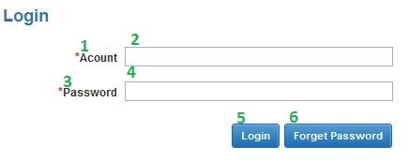**

Fig\_2.1.2 Login screen

**Data Fields Definition – Login**

|  |  |  |  |  |  |  |
| --- | --- | --- | --- | --- | --- | --- |
| **Field name** | **Description** | **Read**  **Only** | **Mandatory** | **Control Type** | **Data Type** | **Length** |
| (2)txtUsername | Users enter their username | - | y | Textbox | Text | 200 |
| (4)txtPassword | User enter their password | - | y | Textbox | Text | 200 |
| (1)lblUsername | Label username | y | - | Label | Text | Fixed |
| (3)lblPassword | Label Password | y | - | Label | Text | Fixed |

**Buttons / Hyper Links – Login**

|  |  |  |  |  |
| --- | --- | --- | --- | --- |
| **Function** | **Description** | **Available Criteria** | **Validations** | **Outcome** |
| (5)Login | The button allows user login into system after entering username and password | Always available | Validate all mandatory fields. | Redirect to right pages if login is successful. Otherwise, report that login is failure |
| (6)Forget password | This link button allows user recovering their login information | Always available | No | Redirect to the “Forget password” pages. |

##### Sequence Diagram

Fig\_2.1.3 Sequence Diagram Login

#### <User>Forget password

##### Use Case Diagram

Fig\_2.1.1 Forget password use case diagram

##### Use Case Specification

|  |  |  |  |  |
| --- | --- | --- | --- | --- |
| **USE CASE – Forget Password Use Case** | | | | |
| **Use-case No.** | UC002 | **Use-case Version** | | 0.1 |
| **Use-case Name** | Forget password | | | |
| **Author** | TrucTM | | | |
| **Date** | 05/02/2012 | **Priority** | Normal | |
| **Actor:** User: Admin, Staff, Student  **Summary:** This use case allows users remind the password  **Goal:** Allow users recovery the password of system by sending email  **Triggers: .** Click to “Sending password by email” button at “Forget password” page  **Preconditions:** Click to “Forget password” button at “Home page” page  **Post Conditions**  Success: Users receive password by email  Fail: Report that users have entered incorrect username  **Main Success Scenario**   |  |  |  | | --- | --- | --- | | Step | Actor Action | System Response | | 1 | Users click “Forget password” link button at “Home Page” page | System will redirect to the “Forget password” page. | | 2 | At “Forget password” page, users enter the username in the textbox |  | | 3 | Users click “Send password by email” button | - System checks the username [Exception 1] and sends the password by email that getting in DB. After sending password, system will report that “Your password has sent, Checking email”. |   **Alternative Scenario.**   |  |  |  | | --- | --- | --- | | No. | Actor Action | System Response | | 1 | Users click “Home” button | System will redirect to the “Home Page” page |   **Exceptions.**   |  |  |  | | --- | --- | --- | | No. | Actor Action | System Response | | 1 | At “Forget password” page, users have entered the incorrect username | System reports that “Incorrect username. Try again”. |   **Relationships.** None  **Business Rules:**   |  |  |  | | --- | --- | --- | | **No** | **Rule Description** | **Error Message** | | 1 | In order to get password, users have provided correct email to admin | System reports that “Incorrect username. Try again”. | | | | | |
| **Description:**  When users enter the system, the users don’t remember the password so they can use this function to recovery their password by email. After user entered username and click “Send password by email”, system will check the username in DB and send password by email that store in the DB. | | | | |

**Screen**

**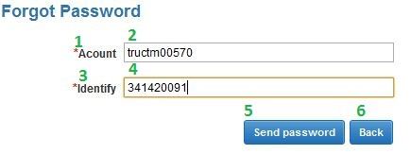**

Fig\_2.2.2 Forget password Screen

**Data Fields Definition – Forget Password**

|  |  |  |  |  |  |  |
| --- | --- | --- | --- | --- | --- | --- |
| **Field name** | **Description** | **Read**  **Only** | **Mandatory** | **Control Type** | **Data Type** | **Length** |
| (2) txtUsername | Users enter their username | - | y | Textbox | Text | 200 |
| (1) lblUsername | Label username | y | - | Label | Text | Fixed |
| (4) txtIdentify | Users enter Identify | - | y | Textbox | Text | 200 |
| (3) lblIdentify | Label Identify | y | - | Label | Text | Fixed |

**Buttons / Hyper Links – Forget Password**

|  |  |  |  |  |
| --- | --- | --- | --- | --- |
| **Function** | **Description** | **Available Criteria** | **Validations** | **Outcome** |
| (5) Send password by email | This button allows users recovery password after entering username | Always available | Validate all mandatory fields. | Sending password by email and report success or fail. |
| (6) Back | This link button allows users redirect to “Home Page” page | Always available | No | Redirect to the “Home Page” page. |

##### Sequence Diagram

Fig\_2.2.3 Sequence Diagram Forget Password

#### <Staff>Add Class

##### Use Case Diagram

Fig\_2.2.1 Add Class

##### Use Case Specification

|  |  |  |  |  |
| --- | --- | --- | --- | --- |
| **USE CASE – Add new Class** | | | | |
| **Use-case No.** | UC003 | **Use-case Version** | | 0.1 |
| **Use-case Name** | Add class | | | |
| **Author** | TrucTM | | | |
| **Date** | 05/02/2012 | **Priority** | Normal | |
| **Actor:** User: Staff  **Summary:** This use case allows staff adding class into the system.  **Goal:** Adding more class into system  **Triggers:** At “View Class” page, staff click “Add new” link button.  **Preconditions:** Staff has login into system and go to the “View Class” page  **Post Conditions**  Success: New class will be added into DB  Fail: Report that system cannot add class into system  **Main Success Scenario**   |  |  |  | | --- | --- | --- | | Step | Actor Action | System Response | | 1 | At the “View Class”, staffs click “Add new” link button | System will display the popup “Add new class” | | 2 | Staffs enter information for new class | System checks data [Exception 1] | | 3 | Staff click “Add new” button in the popup | - System inserts into DB [Exception 2]  - Message box reports that staffs have added new class and return to the “View class” screen page. |   **Alternative Scenario.**   |  |  |  | | --- | --- | --- | | No. | Actor Action | System Response | | 1 | Users click “Cancel” button at “Add new class” popup. | System will return to the “View class” screen page. |   **Exceptions.**   |  |  |  | | --- | --- | --- | | No. | Actor Action | System Response | | 1 | Staffs left ‘ClassName” with text field blank | Message will display “You must fill the Class Name” | | 1 | Staffs left ‘ClassName” with length > 200 chars | Message will display “Class Name has exceeded character length.” | | 2 | Staffs click “Add new” button in the popup | - System checks this class is exist in DB, message box “This class name is exist, try another name” will be displayed.  - System checks the connection of web system with DB, if errors occur, message box “Cannot add new class, please checking network.” will be displayed |   **Relationships.** Login use case, view class use case.  **Business Rules:**   |  |  |  | | --- | --- | --- | | **No** | **Rule Description** | **Error Message** | | 1 | Each class has the unique class name | “This class name is exist, try another name” | | 2 | Class name have been exist and staffs just fill class name into the system. |  | | | | | |
| **Description:**  Class information provided more information for student. System provides “add class” function to allow staff can add new class for student. Each class has the unique class name and class name is required field. When staffs want to add new class, staff must check the network connection and ensure that the same class name hasn’t existed. | | | | |

**Screen**

**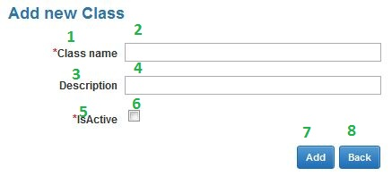**

Fig\_2.3.2 Add Class Screen Page

**Data Fields Definition – Add class**

|  |  |  |  |  |  |  |
| --- | --- | --- | --- | --- | --- | --- |
| **Field name** | **Description** | **Read**  **Only** | **Mandatory** | **Control Type** | **Data Type** | **Length** |
| (2)txtClassname | Staffs enter the class name | - | y | Textbox | Text | 50 |
| (1)lblClassname | Label class name | y | - | Label | Text | Fixed |
| (4)txtDescription | Staffs provide more detail for this class | - | - | Textbox | Text | Max |
| (3)lblDescription | Label description | y | - | Label | Text | Fixed |
| (6)chkIsActive | This field is marked is this class have been exist or not | - | y | Checkbox | Bool | Fixed |
| (5)lblStatus | Label status of class | y | - | Label | Text | Fixed |

**Buttons / Hyper Links – Add class**

|  |  |  |  |  |
| --- | --- | --- | --- | --- |
| **Function** | **Description** | **Available Criteria** | **Validations** | **Outcome** |
| (7)Add new | This button allows staffs add new class | Always available | Validate all mandatory fields. | Insert Data into DB |
| (8)Back | This button allows staffs return to the “View Class” screen page | Always available | No | Close popup “Add new Class” and return to the “View Class” page. |

##### Sequence Diagram

Fig\_2.3.3 Sequence Diagram Add new Class

#### <Staff>Edit Class

##### Use Case Diagram

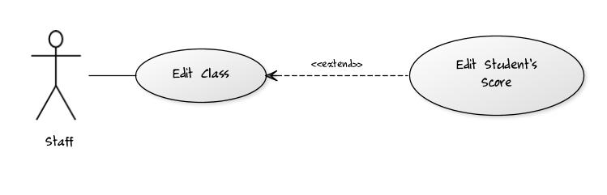Fig\_2.4.1 Edit Class

##### Use Case Specification

|  |  |  |  |  |
| --- | --- | --- | --- | --- |
| **USE CASE – Edit Class** | | | | |
| **Use-case No.** | UC004 | **Use-case Version** | | 0.1 |
| **Use-case Name** | Edit class | | | |
| **Author** | TrucTM | | | |
| **Date** | 05/02/2012 | **Priority** | Normal | |
| **Actor:** User: Staff  **Summary:** This use case allows staff edits class has existed in DB.  **Goal:** Editing exist class.  **Triggers: .**In the Gridview information at “View Class” page, staff click “Edit” link button. At least 1 class is existing.  **Preconditions:** Staff has login into system and go to the “View Class” page.  **Post Conditions.**  Success: Class will be edited.  Fail: Report that system cannot edit class.  **Main Success Scenario.**   |  |  |  | | --- | --- | --- | | Step | Actor Action | System Response | | 1 | In Gridview information at the “View Class”, staffs click “Edit” link button | System will display the popup “Edit class” | | 2 | Staffs edit information for this class | System checks data [Exception 1] | | 3 | Staff click “Update” button in the popup | - System updates into DB [Exception 2]  - Message box reports that staffs have edited class and return to the “View class” screen page. |   **Alternative Scenario.**   |  |  |  | | --- | --- | --- | | No. | Actor Action | System Response | | 1 | Users click “Cancel” button at “Edit class” popup. | System will return to the “View class” screen page. |   **Exceptions.**   |  |  |  | | --- | --- | --- | | No. | Actor Action | System Response | | 1 | Staffs left ‘ClassName” with text field blank | Message will display “You must fill the Class Name” | | 1 | Staffs left ‘ClassName” with length > 200 chars | Message will display “Class Name has exceeded character length.” | | 2 | Staffs click “Update” button in the popup | - System checks this class is exist in DB, message box “This class name is exist, try another name” will be displayed.  - System checks the connection of web system with DB, if errors occur, message box “Cannot Update Class, please checking network.” will be displayed |   **Relationships.**  Login use case, view class use case.  **Business Rules:**   |  |  |  | | --- | --- | --- | | **No** | **Rule Description** | **Error Message** | | 1 | Each class has the unique class name | “This class name is exist, try another name” | | 2 | Class name have been exist and staffs just fill class name into the system. |  | | | | | |
| **Description:**  This use case allows staff editing exist class in system. When staffs enter class information, system will check validation of data and report when data is incorrect. After staffs click “Update” button, system will update this class and report. This use case can extend the edit Student Score use case. When staffs change isActive property of this class this can cause occur of Student Score. | | | | |

**Screen**

**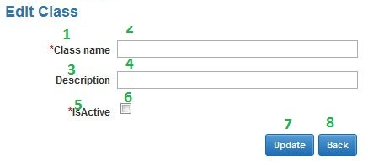**

Fig\_2.4.2 Edit Class Screen

**Data Fields Definition – Edit class**

|  |  |  |  |  |  |  |
| --- | --- | --- | --- | --- | --- | --- |
| **Field name** | **Description** | **Read**  **Only** | **Mandatory** | **Control Type** | **Data Type** | **Length** |
| (2)txtClassname | Staffs enter the class name | - | y | Textbox | Text | 50 |
| (1)lblClassname | Label class name | y | - | Label | Text | Fixed |
| (4)txtDescription | Staffs provide more detail for this class | - | - | Textbox | Text | Max |
| (3)lblDescription | Label description | y | - | Label | Text | Fixed |
| (5)chkIsActive | This field is marked is this class have been exist or not | - | y | Checkbox | Bool | Fixed |
| (6)lblStatus | Label status of class | y | - | Label | Text | Fixed |

**Buttons / Hyper Links – Edit class**

|  |  |  |  |  |
| --- | --- | --- | --- | --- |
| **Function** | **Description** | **Available Criteria** | **Validations** | **Outcome** |
| (7)Update | This button allows staffs edit exist class | Always available | Validate all mandatory fields. | Update Data into DB |
| (8)Back | This button allows staffs return to the “View Class” screen page | Always available | No | Close popup “Add new Class” and return to the “View Class” page. |

##### Sequence Diagram

Fig\_2.4.3 Sequence Diagram Edit Class

#### <Staff>View Class

##### Use Case Diagram

Fig\_2.5.1 View Class

##### Use Case Specification

|  |  |  |  |  |
| --- | --- | --- | --- | --- |
| **USE CASE – View Class** | | | | |
| **Use-case No.** | UC005 | **Use-case Version** | | 0.1 |
| **Use-case Name** | Add class | | | |
| **Author** | TrucTM | | | |
| **Date** | 05/02/2012 | **Priority** | Normal | |
| **Actor:** User: Staff  **Summary:** This use case allows staff views list of class  **Goal:** Display all classes.  **Triggers:** In any pages of system (Except “Home Page” page), staff click “View Class” link in menu bar.  **Preconditions:** Staff has login into system.  **Post Conditions.**  Success: Display all classes  Fail: Report that errors have occurred.  **Main Success Scenario.**   |  |  |  | | --- | --- | --- | | Step | Actor Action | System Response | | 1 | In any page of system (except “Home Page” page), staffs click “View Class” link in menu bar. | System will redirect to “View Class” page and show all classes [Exception 1] |   **Alternative Scenario.**   |  |  |  | | --- | --- | --- | | No. | Actor Action | System Response | | 1 | Staffs click “Add” link button at “View Class” page | System will display “Add new Class” popup | | 2 | Staff click “Edit” link button in gridview data at “View Class” page. | System will display “Edit Class” popup | | 3 | Staffs click any link in menu bar | System will redirect to link page. |   **Exceptions.**   |  |  |  | | --- | --- | --- | | No. | Actor Action | System Response | | 1 | Staffs click “View Class” link in menu bar | If errors occur, System will redirect to “View Class” and display “Cannot display information. Please check network connection” text |   **Relationships.**  Login use case.  **Business Rules:**   |  |  |  | | --- | --- | --- | | **No** | **Rule Description** | **Error Message** | | | | | |
| **Description:**  When staffs want to view all classes of the system, they click “View Class” in the menu bar. System will redirect to the “View class” and show all information about classes. Gridview will allow paging, each page will display 10 classes. When error occurs, system will display report text. | | | | |

**Screen**

Fig\_2.2.2 Forget password Screen

**Data Fields Definition – View class**

|  |  |  |  |  |  |  |
| --- | --- | --- | --- | --- | --- | --- |
| **Field name** | **Description** | **Read**  **Only** | **Mandatory** | **Control Type** | **Data Type** | **Length** |
| Gridview | Gridview for display list of class | - | - | Gridview | List | Fixed |

**Buttons / Hyper Links – View class**

|  |  |  |  |  |
| --- | --- | --- | --- | --- |
| **Function** | **Description** | **Available Criteria** | **Validations** | **Outcome** |
| Update | This button uses to show “Edit class” popup | Available | No | Show “Edit Class” popup |
| Add | This button uses to show “Add new Class” popup | Always available | No | Show “Add new Class” popup |

##### Sequence Diagram

Fig\_2.5.3 Sequence Diagram View Class

#### <Staff> Add Student Score

##### Use Case Diagram

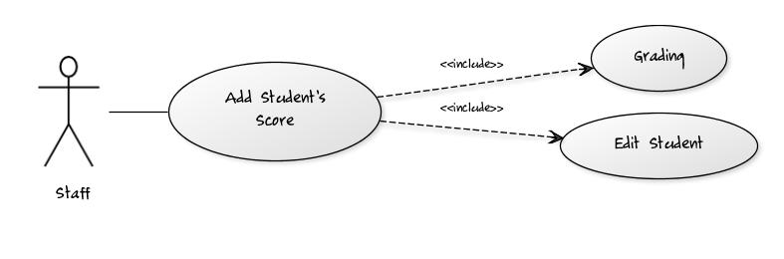Fig\_2.6.1 Add Student Score

##### Use Case Specification

|  |  |  |  |  |
| --- | --- | --- | --- | --- |
| **USE CASE – Add new Student Score** | | | | |
| **Use-case No.** | UC006 | **Use-case Version** | | 0.1 |
| **Use-case Name** | Add Student Score | | | |
| **Author** | TrucTM | | | |
| **Date** | 05/02/2012 | **Priority** | Normal | |
| **Actor:** User: Staff  **Summary:** This use case allows staff adding Student Score into the system.  **Goal:** Adding more Student Score into system  **Triggers:** At “View Student Score” page, staff click “Add new” link button.  **Preconditions:** Staff has login into system and go to the “View Student Score” page  **Post Conditions.**  Success: New Student Score will be added into DB  Fail: Report that system cannot add Student Score into system  **Main Success Scenario.**   |  |  |  | | --- | --- | --- | | Step | Actor Action | System Response | | 1 | At the “View Student Score”, staffs click “Add new” link button | System will display the popup “Add new Student Score” | | 2 | Staffs enter information for new Student Score | System checks data [Exception 1] | | 3 | Staff click “Add new” button in the popup | - System inserts into DB [Exception 2]  - Message box reports that staffs have added new Student Score and return to the “View Student Score” screen page. |   **Alternative Scenario.**   |  |  |  | | --- | --- | --- | | No. | Actor Action | System Response | | 1 | Users click “Cancel” button at “Add new Student Score” popup. | System will return to the “View Student Score” screen page. |   **Exceptions.**   |  |  |  | | --- | --- | --- | | No. | Actor Action | System Response | | 1 | Staffs left ‘Grade” with incorrect format | Message will display “You have entered incorrect Grade. Please input correct number.” | | 2 | Staffs click “Add new” button in the popup | - System checks the connection of web system with DB, if errors occur, message box “Cannot add new ModeOfStudy, please checking network.” will be displayed |   **Relationships.**  Login use case, view Student Score use case.  **Business Rules:**   |  |  |  | | --- | --- | --- | | **No** | **Rule Description** | **Error Message** | | 2 | Student Score name have been exist and staffs just fill Student Score name into the system. |  | | 3 | When staffs enter the |  | | | | | |
| **Description:**  Student Score information provided more information for student. System provides “add Student Score” function to allow staff can add new Student Score for student. Each Student Score has the unique Student Score name and Student Score name is required field. When staffs want to add new Student Score, staff must check the network connection and ensure that the same Student Score name hasn’t existed. | | | | |

**Screen**

**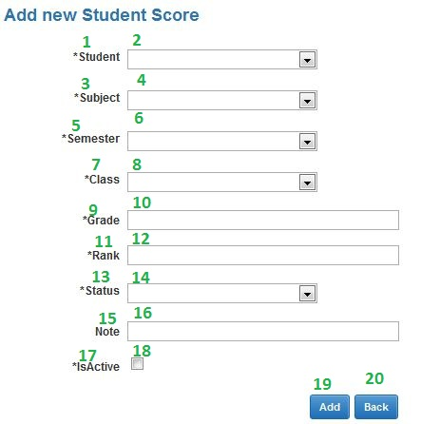**

Fig\_2.6.2 Add new Student Score Screen

**Data Fields Definition – Add Student Score**

|  |  |  |  |  |  |  |
| --- | --- | --- | --- | --- | --- | --- |
| **Field name** | **Description** | **Read**  **Only** | **Mandatory** | **Control Type** | **Data Type** | **Length** |
| (4)drdlSubjectID | Dropdown list for choosing Subject name | y | y | Dropdownlist | Int | >0 |
| (8)drdlClassID | Dropdown list for choosing Class name | y | y | Dropdownlist | Int | >0 |
| (2)drdlStudentID | Dropdown list for choosing Class name | y | y | Dropdownlist | Int | >0 |
| (6)drdlSubjectID | Dropdown list for choosing Semester name | y | y | Dropdownlist | Int | >0 |
| (10)txtGrade | Textbox for entering Score of Student | - | y | Textbox | Float | >0 |
| (12)txtRank | Textbox for input Rank of | - | y | Textbox | String | 50 |
| (14)drdlStatus | Textbox for input status of this student (Fail, Pass…) | - | y | Dropdownlist | Int | >0 |

**Buttons / Hyper Links – Add Student Score**

|  |  |  |  |  |
| --- | --- | --- | --- | --- |
| **Function** | **Description** | **Available Criteria** | **Validations** | **Outcome** |
| (19)Add new | This button allows staffs add new Student Score | Always available | Validate all mandatory fields. | Insert Data into DB |
| (20)Back | This button allows staffs return to the “View Student Score” screen page | Always available | Yes | Close popup “Add new Student Score” and return to the “View Student Score” page. |

##### Sequence Diagram

Fig\_2.7.3 Sequence Diagram Add Student Score

#### <Staff> Edit Student Score

##### Use Case Diagram

Fig\_2.7.1 Edit Student Score

##### Use Case Specification

|  |  |  |  |  |
| --- | --- | --- | --- | --- |
| **USE CASE – Edit Student Score** | | | | |
| **Use-case No.** | UC007 | **Use-case Version** | | 0.1 |
| **Use-case Name** | Edit Student Score | | | |
| **Author** | TrucTM | | | |
| **Date** | 05/02/2012 | **Priority** | Normal | |
| **Actor:** User: Staff  **Summary:** This use case allows staff edits Student Score has existed in DB.  **Goal:** Editing exist Student Score.  **Triggers:** In the Gridview information at “View Student Score” page, staff click “Edit” link button. At least 1 Student Score is exist.  **Preconditions:** Staff has login into system and go to the “View Student Score” page.  **Post Conditions.**  Success: Student Score will be edited.  Fail: Report that system cannot edit Student Score.  **Main Success Scenario.**   |  |  |  | | --- | --- | --- | | Step | Actor Action | System Response | | 1 | In Gridview information at the “View Student Score”, staffs click “Edit” link button | System will display the popup “Edit Student Score” | | 2 | Staffs edit information for this Student Score | System checks data [Exception 1] | | 3 | Staff click “Update” button in the popup | - System updates into DB [Exception 2]  - Message box reports that staffs have edited Student Score and return to the “View Student Score” screen page. |   **Alternative Scenario.**   |  |  |  | | --- | --- | --- | | No. | Actor Action | System Response | | 1 | Users click “Cancel” button at “Edit Student Score” popup. | System will return to the “View Student Score” screen page. |   **Exceptions.**   |  |  |  | | --- | --- | --- | | No. | Actor Action | System Response | | 1 | Staffs left ‘Grade” with incorrect format | Message will display “You have entered incorrect Grade. Please input correct number.” | | 2 | Staffs click “Update” button in the popup | - System checks the connection of web system with DB, if errors occur, message box “Cannot update information, please checking network.” will be displayed |   **Relationships.**  Login use case, view Student Score use case.  **Business Rules:**   |  |  |  | | --- | --- | --- | | **No** | **Rule Description** | **Error Message** | | 1 | Each Student Score has the unique Student Score name | “This Student Score name is exist, try another name” | | 2 | Student Score name have been exist and staffs just fill Student Score name into the system. |  | | | | | |
| **Description:**  This use case allows staff editing exist Student Score in system. When staffs enter Student Score information, system will check validation of data and report when data is incorrect. After staffs click “Update” button, system will update this Student Score and report. This use case can extend the edit Student Score use case. When staffs change isActive property of this Student Score this can cause occur of Student Score. | | | | |

**Screen**

**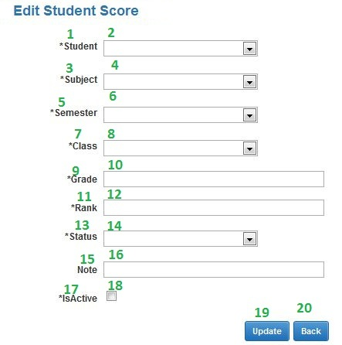**

Fig\_2.7.2 Edit Student Score Screen

**Data Fields Definition – Edit Student Score**

|  |  |  |  |  |  |  |
| --- | --- | --- | --- | --- | --- | --- |
| **Field name** | **Description** | **Read**  **Only** | **Mandatory** | **Control Type** | **Data Type** | **Length** |
| (4)drdlSubjectID | Dropdown list for choosing Subject name | y | y | Dropdownlist | Int | >0 |
| (8)drdlClassID | Dropdown list for choosing Class name | y | y | Dropdownlist | Int | >0 |
| (2)drdlStudentID | Dropdown list for choosing Class name | y | y | Dropdownlist | Int | >0 |
| (6)drdlSubjectID | Dropdown list for choosing Semester name | y | y | Dropdownlist | Int | >0 |
| (10)txtGrade | Textbox for entering Score of Student | - | y | Textbox | Float | >0 |
| (12)txtRank | Textbox for input Rank of | - | y | Textbox | String | 50 |
| (14)drdlStatus | Textbox for input status of this student (Fail, Pass…) | - | y | Dropdownlist | Int | >0 |

**Buttons / Hyper Links – Edit Student Score**

|  |  |  |  |  |
| --- | --- | --- | --- | --- |
| **Function** | **Description** | **Available Criteria** | **Validations** | **Outcome** |
| (19)Update | This button allows staffs edit exist Student Score | Always available | Validate all mandatory fields. | Update Data into DB |
| (20)Back | This button allows staffs return to the “View Student Score” screen page | Always available | No | Close popup “Add new Student Score” and return to the “View Student Score” page. |

##### Sequence Diagram

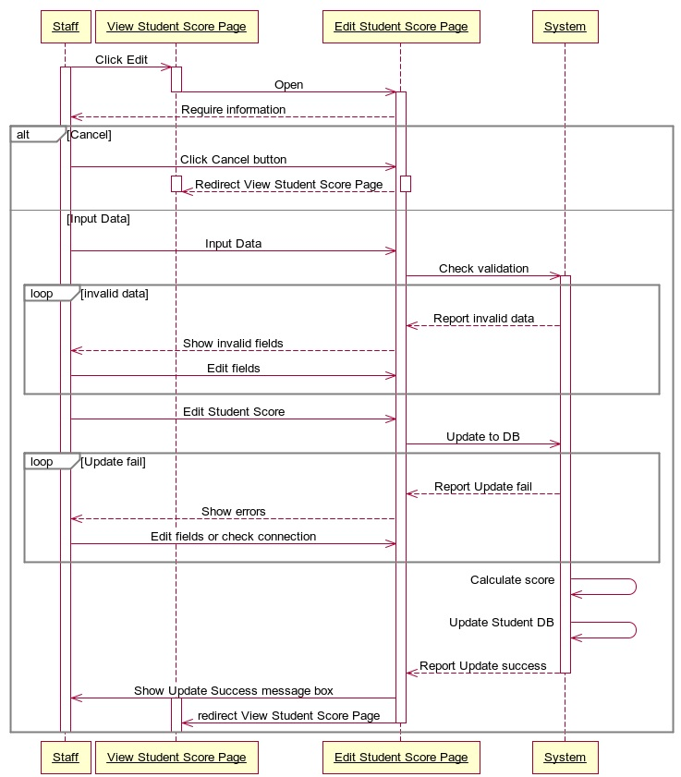Fig\_2.7.3 Sequence Diagram Edit Student Score

#### <Staff> View Student Score

##### Use Case Diagram

Fig\_2.8.1 View Student Score

##### Use Case Specification

|  |  |  |  |  |
| --- | --- | --- | --- | --- |
| **USE CASE – View Student Score** | | | | |
| **Use-case No.** | UC008 | **Use-case Version** | | 0.1 |
| **Use-case Name** | Add Student Score | | | |
| **Author** | TrucTM | | | |
| **Date** | 05/02/2012 | **Priority** | Normal | |
| **Actor:** User: Staff  **Summary:** This use case allows staff views list of Student Score  **Goal:** Display all Student Score.  **Triggers:** In any pages of system (Except “Home Page” page), staff click “View Student Score” link in menu bar.  **Preconditions:** Staff has login into system.  **Post Conditions.**  Success: Display all Student Score  Fail: Report that errors have occurred.  **Main Success Scenario.**   |  |  |  | | --- | --- | --- | | Step | Actor Action | System Response | | 1 | In any page of system (except “Home Page” page), staffs click “View Student Score” link in menu bar. | System will redirect to “View Student Score” page and show all Student Score [Exception 1] |   **Alternative Scenario.**   |  |  |  | | --- | --- | --- | | No. | Actor Action | System Response | | 1 | Staffs click “Add” link button at “View Student Score” page | System will display “Add new Student Score” popup | | 2 | Staff click “Edit” link button in gridview data at “View Student Score” page. | System will display “Edit Student Score” popup | | 3 | Staffs click any link in menu bar | System will redirect to link page. |   **Exceptions.**   |  |  |  | | --- | --- | --- | | No. | Actor Action | System Response | | 1 | Staffs click “View Student Score” link in menu bar | If errors occur, System will redirect to “View Student Score” and display “Cannot display information. Please check network connection” text |   **Relationships.**  Login use case.  **Business Rules:**   |  |  |  | | --- | --- | --- | | **No** | **Rule Description** | **Error Message** | | | | | |
| **Description:**  When staffs want to view all Student Score of the system, they click “View Student Score” in the menu bar. System will redirect to the “View Student Score” and show all information about Student Score. Gridview will allow paging, each page will display 10 Student Score. When error occurs, system will display report text. | | | | |

**Screen**

Fig\_2.2.2 Forget password Screen

**Data Fields Definition – View Student Score**

|  |  |  |  |  |  |  |
| --- | --- | --- | --- | --- | --- | --- |
| **Field name** | **Description** | **Read**  **Only** | **Mandatory** | **Control Type** | **Data Type** | **Length** |
| Gridview | Gridview for display list of Student Score | - | - | Gridview | List | Fixed |

**Buttons / Hyper Links – View Student Score**

|  |  |  |  |  |
| --- | --- | --- | --- | --- |
| **Function** | **Description** | **Available Criteria** | **Validations** | **Outcome** |
| Update | This button uses to show “Edit Student Score” popup | Available | No | Show “Edit Student Score” popup |
| Add | This button uses to show “Add new Student Score” popup | Always available | No | Show “Add new Student Score” popup |

##### Sequence Diagram

#### <Staff> Add Semester

##### Use Case Diagram

Fig\_2.9.1 Add Semester

##### Use Case Specification

|  |  |  |  |  |
| --- | --- | --- | --- | --- |
| **USE CASE – Add new Semester** | | | | |
| **Use-case No.** | UC009 | **Use-case Version** | | 0.1 |
| **Use-case Name** | Add Semester | | | |
| **Author** | TrucTM | | | |
| **Date** | 05/02/2012 | **Priority** | Normal | |
| **Actor:** User: Staff  **Summary:**  This use case allows staff adding Semester into the system.  **Goal:**  Adding more Semester into system  **Triggers:**  At “View Semester” page, staff click “Add new” link button.  **Preconditions:**  Staff has login into system and go to the “View Semester” page  **Post Conditions.**  Success: New Semester will be added into DB  Fail: Report that system cannot add Semester into system  **Main Success Scenario.**   |  |  |  | | --- | --- | --- | | Step | Actor Action | System Response | | 1 | At the “View Semester”, staffs click “Add new” link button | System will display the popup “Add new Semester” | | 2 | Staffs enter information for new Semester | System checks data [Exception 1] | | 3 | Staff click “Add new” button in the popup | - System inserts into DB [Exception 2]  - Message box reports that staffs have added new Semester and return to the “View Semester” screen page. |   **Alternative Scenario.**   |  |  |  | | --- | --- | --- | | No. | Actor Action | System Response | | 1 | Users click “Cancel” button at “Add new Semester” popup. | System will return to the “View Semester” screen page. |   **Exceptions.**   |  |  |  | | --- | --- | --- | | No. | Actor Action | System Response | | 1 | Staffs left ‘SemesterNameV” with text field blank | Message will display “You must fill the Semester Name” | | 1 | Staffs left ‘SemesterNameV” with length > 200 chars | Message will display “Semester Name has exceeded character length.” | | 1 | Staffs left ‘SemesterNameE” with text field blank | Message will display “You must fill the Semester Name” | | 1 | Staffs left ‘SemesterNameE” with length > 200 chars | Message will display “Semester Name has exceeded character length.” | | 1 | Staffs left ‘StartTime” wrong format | Message will display “You have entered incorrect time. Please following “mm-yyyy” format. | | 1 | Staffs left ‘EndTime” wrong format | Message will display “You have entered incorrect time. Please following “mm-yyyy” format. | | 2 | Staffs click “Add new” button in the popup | - System checks this Semester is exist in DB, message box “This Semester name is exist, try another name” will be displayed.  - System checks the connection of web system with DB, if errors occur, message box “Cannot add new Semester, please checking network.” will be displayed |   **Relationships.**  Login use case, view Semester use case.  **Business Rules:**   |  |  |  | | --- | --- | --- | | **No** | **Rule Description** | **Error Message** | | 1 | Each Semester has the unique Semester name | “This Semester name is exist, try another name” | | 2 | Semester name have been exist and staffs just fill Semester name into the system. |  | | | | | |
| **Description:**  Semester information provided more information for student. System provides “add Semester” function to allow staff can add new Semester for student. Each Semester has the unique Semester name and Semester name is required field. When staffs want to add new Semester, staff must check the network connection and ensure that the same Semester name hasn’t existed. | | | | |

**Screen**

**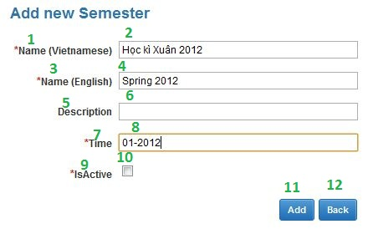**

Fig\_2.9.2 Add new Semester Screen

**Data Fields Definition – Add Semester**

|  |  |  |  |  |  |  |
| --- | --- | --- | --- | --- | --- | --- |
| **Field name** | **Description** | **Read**  **Only** | **Mandatory** | **Control Type** | **Data Type** | **Length** |
| (2)txtSemesternameV | Staffs enter the Semester name Vietnamese | - | y | Textbox | Text | 200 |
| (1)lblSemesternameV | Label Semester name Vietnamese | y | - | Label | Text | Fixed |
| (4)txtSemesternameE | Staffs enter the Semester name English | - | y | Textbox | Text | 200 |
| (3)lblSemesternameE | Label Semester name English | y | - | Label | Text | Fixed |
| (8)txtTime | Staff provide Time for this semester | - | - | Textbox | Text | Max |
| (7)lblTime | Label Time | y | - | Label | Text | Fixed |
| (6)txtDescription | Staffs provide more detail for this Semester | - | - | Textbox | Text | Max |
| (5)lblDescription | Label description | y | - | Label | Text | Fixed |
| (10)chkIsActive | This field is marked is this Semester have been exist or not | - | y | Checkbox | Bool | Fixed |
| (9)lblStatus | Label status of Semester | y | - | Label | Text | Fixed |

**Buttons / Hyper Links – Add Semester**

|  |  |  |  |  |
| --- | --- | --- | --- | --- |
| **Function** | **Description** | **Available Criteria** | **Validations** | **Outcome** |
| (11)Add new | This button allows staffs add new Semester | Always available | Validate all mandatory fields. | Insert Data into DB |
| (12)Back | This button allows staffs return to the “View Semester” screen page | Always available | No | Close popup “Add new Semester” and return to the “View Semester” page. |

##### Sequence Diagram

#### <Staff> Edit Semester

##### Use Case Diagram

Fig\_2.10.1 Edit Semester

##### Use Case Specification

|  |  |  |  |  |
| --- | --- | --- | --- | --- |
| **USE CASE – Edit Semester** | | | | |
| **Use-case No.** | UC010 | **Use-case Version** | | 0.1 |
| **Use-case Name** | Edit Semester | | | |
| **Author** | TrucTM | | | |
| **Date** | 05/02/2012 | **Priority** | Normal | |
| **Actor:** User: Staff  **Summary:** This use case allows staff edits Semester has existed in DB.  **Goal:** Editing exist Semester.  **Triggers:** In the Gridview information at “View Semester” page, staff click “Edit” link button. At least 1, Semester is existing.  **Preconditions:** Staff has login into system and go to the “View Semester” page.  **Post Conditions.**  Success: Semester will be edited.  Fail: Report that system cannot edit Semester.  **Main Success Scenario.**   |  |  |  | | --- | --- | --- | | Step | Actor Action | System Response | | 1 | In Gridview information at the “View Semester”, staffs click “Edit” link button | System will display the popup “Edit Semester” | | 2 | Staffs edit information for this Semester | System checks data [Exception 1] | | 3 | Staff click “Update” button in the popup | - System updates into DB [Exception 2]  - Message box reports that staffs have edited Semester and return to the “View Semester” screen page. |   **Alternative Scenario.**   |  |  |  | | --- | --- | --- | | No. | Actor Action | System Response | | 1 | Users click “Cancel” button at “Edit Semester” popup. | System will return to the “View Semester” screen page. |   **Exceptions.**   |  |  |  | | --- | --- | --- | | No. | Actor Action | System Response | | 1 | Staffs left ‘SemesterNameV” with text field blank | Message will display “You must fill the Semester Name” | | 1 | Staffs left ‘SemesterNameV” with length > 200 chars | Message will display “Semester Name has exceeded character length.” | | 1 | Staffs left ‘SemesterNameE” with text field blank | Message will display “You must fill the Semester Name” | | 1 | Staffs left ‘SemesterNameE” with length > 200 chars | Message will display “Semester Name has exceeded character length.” | | 1 | Staffs left ‘StartTime” wrong format | Message will display “You have entered incorrect time. Please following “mm-yyyy” format. | | 1 | Staffs left ‘EndTime” wrong format | Message will display “You have entered incorrect time. Please following “mm-yyyy” format. | | 2 | Staffs click “Update” button in the popup | - System checks this Semester is exist in DB, message box “This Semester name is exist, try another name” will be displayed.  - System checks the connection of web system with DB, if errors occur, message box “Cannot Update Semester, please checking network.” will be displayed |   **Relationships.**  Login use case, view Semester use case.  **Business Rules:**   |  |  |  | | --- | --- | --- | | **No** | **Rule Description** | **Error Message** | | 1 | Each Semester has the unique Semester name | “This Semester name is exist, try another name” | | 2 | Semester name have been exist and staffs just fill Semester name into the system. |  | | | | | |
| **Description:**  This use case allows staff editing exist Semester in system. When staffs enter Semester information, system will check validation of data and report when data is incorrect. After staffs click “Update” button, system will update this Semester and report. This use case can extend the edit Student Score use case. When staffs change isActive property of this Semester this can cause occur error of Student Score. | | | | |

**Screen**

**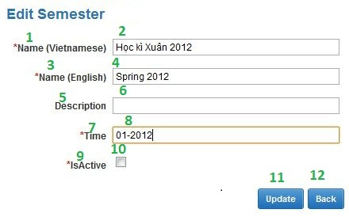**

Fig\_2.10.2 Edit Semester Screen

**Data Fields Definition – Edit Semester**

|  |  |  |  |  |  |  |
| --- | --- | --- | --- | --- | --- | --- |
| **Field name** | **Description** | **Read**  **Only** | **Mandatory** | **Control Type** | **Data Type** | **Length** |
| (2)txtSemesternameV | Staffs enter the Semester name Vietnamese | - | y | Textbox | Text | 200 |
| (1)lblSemesternameV | Label Semester name Vietnamese | y | - | Label | Text | Fixed |
| (4)txtSemesternameE | Staffs enter the Semester name English | - | y | Textbox | Text | 200 |
| (3)lblSemesternameE | Label Semester name English | y | - | Label | Text | Fixed |
| (8)txtTime | Staff provide Time for this semester | - | - | Textbox | Text | Max |
| (7)lblTime | Label Time | y | - | Label | Text | Fixed |
| (6)txtDescription | Staffs provide more detail for this Semester | - | - | Textbox | Text | Max |
| (5)lblDescription | Label description | y | - | Label | Text | Fixed |
| (10)chkIsActive | This field is marked is this Semester have been exist or not | - | y | Checkbox | Bool | Fixed |
| (9)lblStatus | Label status of Semester | y | - | Label | Text | Fixed |

**Buttons / Hyper Links – Edit Semester**

|  |  |  |  |  |
| --- | --- | --- | --- | --- |
| **Function** | **Description** | **Available Criteria** | **Validations** | **Outcome** |
| (11)Update | This button allows staffs edit exist Semester | Always available | Validate all mandatory fields. | Update Data into DB |
| (12)Back | This button allows staffs return to the “View Semester” screen page | Always available | No | Close popup “Add new Semester” and return to the “View Semester” page. |

##### Sequence Diagram

#### <Staff> View Semester

##### Use Case Diagram

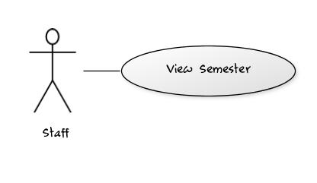Fig\_2.11.1 View Semester

##### Use Case Specification

|  |  |  |  |  |
| --- | --- | --- | --- | --- |
| **USE CASE – View Semester** | | | | |
| **Use-case No.** | UC005 | **Use-case Version** | | 0.1 |
| **Use-case Name** | Add Semester | | | |
| **Author** | TrucTM | | | |
| **Date** | 05/02/2012 | **Priority** | Normal | |
| **Actor:** User: Staff  **Summary:** This use case allows staff views list of Semester  **Goal:** Display all Semesters.  **Triggers:** In any pages of system (Except “Home Page” page), staff click “View Semester” link in menu bar.  **Preconditions:** Staff has login into system.  **Post Conditions.**  Success: Display all Semesters  Fail: Report that errors have occurred.  **Main Success Scenario.**   |  |  |  | | --- | --- | --- | | Step | Actor Action | System Response | | 1 | In any page of system (except “Home Page” page), staffs click “View Semester” link in menu bar. | System will redirect to “View Semester” page and show all Semesters [Exception 1] |   **Alternative Scenario.**   |  |  |  | | --- | --- | --- | | No. | Actor Action | System Response | | 1 | Staffs click “Add” link button at “View Semester” page | System will display “Add new Semester” popup | | 2 | Staff click “Edit” link button in gridview data at “View Semester” page. | System will display “Edit Semester” popup | | 3 | Staffs click any link in menu bar | System will redirect to link page. |   **Exceptions.**   |  |  |  | | --- | --- | --- | | No. | Actor Action | System Response | | 1 | Staffs click “View Semester” link in menu bar | If errors occur, System will redirect to “View Semester” and display “Cannot display information. Please check network connection” text |   **Relationships.**  Login use case.  **Business Rules:**   |  |  |  | | --- | --- | --- | | **No** | **Rule Description** | **Error Message** | | | | | |
| **Description:**  When staffs want to view all Semesters of the system, they click “View Semester” in the menu bar. System will redirect to the “View Semester” and show all information about Semesters. Gridview will allow paging; each page will display 10 Semesters. When error occurs, system will display report text. | | | | |

**Screen**

Fig\_2.2.2

**Data Fields Definition – View Semester**

|  |  |  |  |  |  |  |
| --- | --- | --- | --- | --- | --- | --- |
| **Field name** | **Description** | **Read**  **Only** | **Mandatory** | **Control Type** | **Data Type** | **Length** |
| Gridview | Gridview for display list of Semester | - | - | Gridview | List | Fixed |

**Buttons / Hyper Links – View Semester**

|  |  |  |  |  |
| --- | --- | --- | --- | --- |
| **Function** | **Description** | **Available Criteria** | **Validations** | **Outcome** |
| Update | This button uses to show “Edit Semester” popup | Available | No | Show “Edit Semester” popup |
| Add | This button uses to show “Add new Semester” popup | Always available | No | Show “Add new Semester” popup |

##### Sequence Diagram

#### <Staff> Add Major

##### Use Case Diagram

Fig\_2.12.1 Add Major

##### Use Case Specification

|  |  |  |  |  |
| --- | --- | --- | --- | --- |
| **USE CASE – Add new Major** | | | | |
| **Use-case No.** | UC012 | **Use-case Version** | | 0.1 |
| **Use-case Name** | Add Major | | | |
| **Author** | TrucTM | | | |
| **Date** | 05/02/2012 | **Priority** | Normal | |
| **Actor:** User: Staff  **Summary:** This use case allows staff adding Major into the system.  **Goal:** Adding more Major into system  **Triggers:** At “View Major” page, staff click “Add new” link button.  **Preconditions:** Staff has login into system and go to the “View Major” page  **Post Conditions.**  Success: New Major will be added into DB  Fail: Report that system cannot add Major into system  **Main Success Scenario.**   |  |  |  | | --- | --- | --- | | Step | Actor Action | System Response | | 1 | At the “View Major”, staffs click “Add new” link button | System will display the popup “Add new Major” | | 2 | Staffs enter information for new Major | System checks data [Exception 1] | | 3 | Staff click “Add new” button in the popup | - System inserts into DB [Exception 2]  - Message box reports that staffs have added new Major and return to the “View Major” screen page. |   **Alternative Scenario.**   |  |  |  | | --- | --- | --- | | No. | Actor Action | System Response | | 1 | Users click “Cancel” button at “Add new Major” popup. | System will return to the “View Major” screen page. |   **Exceptions.**   |  |  |  | | --- | --- | --- | | No. | Actor Action | System Response | | 1 | Staffs left ‘MajorNameV” with text field blank | Message will display “You must fill the Major Name” | | 1 | Staffs left ‘MajorNameV” with length > 200 chars | Message will display “Major Name has exceeded character length.” | | 1 | Staffs left ‘MajorNameE” with text field blank | Message will display “You must fill the Major Name” | | 1 | Staffs left ‘MajorNameE” with length > 200 chars | Message will display “Major Name has exceeded character length.” | | 2 | Staffs click “Add new” button in the popup | - System checks this Major is exist in DB, message box “This Major name is exist, try another name” will be displayed.  - System checks the connection of web system with DB, if errors occur, message box “Cannot add new Major, please checking network.” will be displayed |   **Relationships.**  Login use case, view Major use case.  **Business Rules:**   |  |  |  | | --- | --- | --- | | **No** | **Rule Description** | **Error Message** | | 1 | Each Major has the unique Major name | “This Major name is exist, try another name” | | 2 | Major name have been exist and staffs just fill Major name into the system. |  | | | | | |
| **Description:**  Major information provided more information for student. System provides “add Major” function to allow staff can add new Major for student. Each Major has the unique Major name and Major name is required field. When staffs want to add new Major, staff must check the network connection and ensure that the same Major name hasn’t existed. | | | | |

**Screen**

**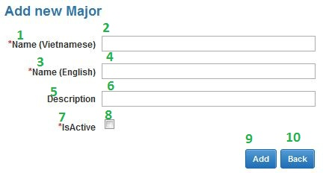**

Fig\_2.12.2 Add new Major Screen

**Data Fields Definition – Add Major**

|  |  |  |  |  |  |  |
| --- | --- | --- | --- | --- | --- | --- |
| **Field name** | **Description** | **Read**  **Only** | **Mandatory** | **Control Type** | **Data Type** | **Length** |
| (2)txtMajorname | Staffs enter the Major name | - | y | Textbox | Text | 50 |
| (1)lblMajorname | Label Major name | y | - | Label | Text | Fixed |
| (4)txtMajornameE | Staffs enter the Major name English | - | y | Textbox | Text | 200 |
| (3)lblMajornameE | Label Major name English | y | - | Label | Text | Fixed |
| (6)txtDescription | Staffs provide more detail for this Major | - | - | Textbox | Text | Max |
| (5)lblDescription | Label description | y | - | Label | Text | Fixed |
| (8)chkIsActive | This field is marked is this Major have been exist or not | - | y | Checkbox | Bool | Fixed |
| (7)lblStatus | Label status of Major | y | - | Label | Text | Fixed |

**Buttons / Hyper Links – Add Major**

|  |  |  |  |  |
| --- | --- | --- | --- | --- |
| **Function** | **Description** | **Available Criteria** | **Validations** | **Outcome** |
| (9)Add new | This button allows staffs add new Major | Always available | Validate all mandatory fields. | Insert Data into DB |
| (10)Back | This button allows staffs return to the “View Major” screen page | Always available | No | Close popup “Add new Major” and return to the “View Major” page. |

##### Sequence Diagram

#### <Staff> Edit Major

##### Use Case Diagram

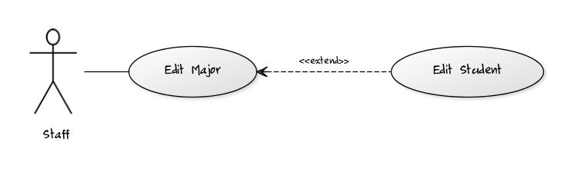Fig\_2.13.1 Edit Major

##### Use Case Specification

|  |  |  |  |  |
| --- | --- | --- | --- | --- |
| **USE CASE – Edit Major** | | | | |
| **Use-case No.** | UC013 | **Use-case Version** | | 0.1 |
| **Use-case Name** | Edit Major | | | |
| **Author** | TrucTM | | | |
| **Date** | 05/02/2012 | **Priority** | Normal | |
| **Actor:** User: Staff  **Summary:** This use case allows staff edits Major has existed in DB.  **Goal:** Editing exist Major.  **Triggers: I**n the Gridview information at “View Major” page, staff click “Edit” link button. At least 1 Major is exist.  **Preconditions:** Staff has login into system and go to the “View Major” page.  **Post Conditions.**  Success: Major will be edited.  Fail: Report that system cannot edit Major.  **Main Success Scenario.**   |  |  |  | | --- | --- | --- | | Step | Actor Action | System Response | | 1 | In Gridview information at the “View Major”, staffs click “Edit” link button | System will display the popup “Edit Major” | | 2 | Staffs edit information for this Major | System checks data [Exception 1] | | 3 | Staff click “Update” button in the popup | - System updates into DB [Exception 2]  - Message box reports that staffs have edited Major and return to the “View Major” screen page. |   **Alternative Scenario.**   |  |  |  | | --- | --- | --- | | No. | Actor Action | System Response | | 1 | Users click “Cancel” button at “Edit Major” popup. | System will return to the “View Major” screen page. |   **Exceptions.**   |  |  |  | | --- | --- | --- | | No. | Actor Action | System Response | | 1 | Staffs left ‘MajorNameV” with text field blank | Message will display “You must fill the Major Name” | | 1 | Staffs left ‘MajorNameV” with length > 200 chars | Message will display “Major Name has exceeded character length.” | | 1 | Staffs left ‘MajorNameE” with text field blank | Message will display “You must fill the Major Name” | | 1 | Staffs left ‘MajorNameE” with length > 200 chars | Message will display “Major Name has exceeded character length.” | | 2 | Staffs click “Update” button in the popup | - System checks this Major is exist in DB, message box “This Major name is exist, try another name” will be displayed.  - System checks the connection of web system with DB, if errors occur, message box “Cannot Update Major, please checking network.” will be displayed |   **Relationships.**  Login use case, view Major use case.  **Business Rules:**   |  |  |  | | --- | --- | --- | | **No** | **Rule Description** | **Error Message** | | 1 | Each Major has the unique Major name | “This Major name is exist, try another name” | | 2 | Major name have been exist and staffs just fill Major name into the system. |  | | | | | |
| **Description:**  This use case allows staff editing exist Major in system. When staffs enter Major information, system will check validation of data and report when data is incorrect. After staffs click “Update” button, system will update this Major and report. This use case can extend the edit Student use case. When staffs change isActive property of this Major this can cause occur error of Student. | | | | |

**Screen**

**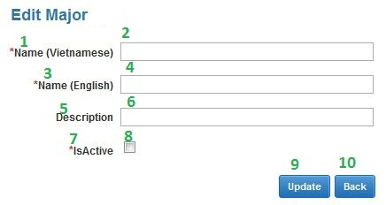**

Fig\_2.13.2 Edit Major Screen

**Data Fields Definition – Edit Major**

|  |  |  |  |  |  |  |
| --- | --- | --- | --- | --- | --- | --- |
| **Field name** | **Description** | **Read**  **Only** | **Mandatory** | **Control Type** | **Data Type** | **Length** |
| (2)txtMajorname | Staffs enter the Major name | - | y | Textbox | Text | 50 |
| (1)lblMajorname | Label Major name | y | - | Label | Text | Fixed |
| (4)txtMajornameE | Staffs enter the Major name English | - | y | Textbox | Text | 200 |
| (3)lblMajornameE | Label Major name English | y | - | Label | Text | Fixed |
| (6)txtDescription | Staffs provide more detail for this Major | - | - | Textbox | Text | Max |
| (5)lblDescription | Label description | y | - | Label | Text | Fixed |
| (8)chkIsActive | This field is marked is this Major have been exist or not | - | y | Checkbox | Bool | Fixed |
| (7)lblStatus | Label status of Major | y | - | Label | Text | Fixed |

**Buttons / Hyper Links – Edit Major**

|  |  |  |  |  |
| --- | --- | --- | --- | --- |
| **Function** | **Description** | **Available Criteria** | **Validations** | **Outcome** |
| (9)Update | This button allows staffs edit exist Major | Always available | Validate all mandatory fields. | Update Data into DB |
| (10)Back | This button allows staffs return to the “View Major” screen page | Always available | No | Close popup “Add new Major” and return to the “View Major” page. |

##### Sequence Diagram

#### <Staff> View Major

##### Use Case Diagram

Fig\_2.14.1 View Major

##### Use Case Specification

|  |  |  |  |  |
| --- | --- | --- | --- | --- |
| **USE CASE – View Major** | | | | |
| **Use-case No.** | UC014 | **Use-case Version** | | 0.1 |
| **Use-case Name** | Add Major | | | |
| **Author** | TrucTM | | | |
| **Date** | 05/02/2012 | **Priority** | Normal | |
| **Actor: U**ser: Staff  **Summary:** This use case allows staff views list of Major  **Goal:** Display all Majors.  **Triggers: I**n any pages of system (Except “Home Page” page), staff click “View Major” link in menu bar.  **Preconditions:** Staff has login into system.  **Post Conditions.**  Success: Display all Majors  Fail: Report that errors have occurred.  **Main Success Scenario.**   |  |  |  | | --- | --- | --- | | Step | Actor Action | System Response | | 1 | In any page of system (except “Home Page” page), staffs click “View Major” link in menu bar. | System will redirect to “View Major” page and show all Majors [Exception 1] |   **Alternative Scenario.**   |  |  |  | | --- | --- | --- | | No. | Actor Action | System Response | | 1 | Staffs click “Add” link button at “View Major” page | System will display “Add new Major” popup | | 2 | Staff click “Edit” link button in gridview data at “View Major” page. | System will display “Edit Major” popup | | 3 | Staffs click any link in menu bar | System will redirect to link page. |   **Exceptions.**   |  |  |  | | --- | --- | --- | | No. | Actor Action | System Response | | 1 | Staffs click “View Major” link in menu bar | If errors occur, System will redirect to “View Major” and display “Cannot display information. Please check network connection” text |   **Relationships.**  Login use case.  **Business Rules:**   |  |  |  | | --- | --- | --- | | **No** | **Rule Description** | **Error Message** | | | | | |
| **Description:**  When staffs want to view all Majors of the system, they click “View Major” in the menu bar. System will redirect to the “View Major” and show all information about Majors. Gridview will allow paging, each page will display 10 Majors. When error occurs, system will display report text. | | | | |

**Screen**

Fig\_2.2.2

**Data Fields Definition – View Major**

|  |  |  |  |  |  |  |
| --- | --- | --- | --- | --- | --- | --- |
| **Field name** | **Description** | **Read**  **Only** | **Mandatory** | **Control Type** | **Data Type** | **Length** |
| Gridview | Gridview for display list of Major | - | - | Gridview | List | Fixed |

**Buttons / Hyper Links – View Major**

|  |  |  |  |  |
| --- | --- | --- | --- | --- |
| **Function** | **Description** | **Available Criteria** | **Validations** | **Outcome** |
| Update | This button uses to show “Edit Major” popup | Available | No | Show “Edit Major” popup |
| Add | This button uses to show “Add new Major” popup | Always available | No | Show “Add new Major” popup |

##### Sequence Diagram

#### <Staff> Add Subject

##### Use Case Diagram

Fig\_2.15.1 Add Subject

##### Use Case Specification

|  |  |  |  |  |
| --- | --- | --- | --- | --- |
| **USE CASE – Add new Subject** | | | | |
| **Use-case No.** | UC015 | **Use-case Version** | | 0.1 |
| **Use-case Name** | Add Subject | | | |
| **Author** | TrucTM | | | |
| **Date** | 05/02/2012 | **Priority** | Normal | |
| **Actor: U**ser: Staff  **Summary:** This use case allows staff adding Subject into the system.  **Goal:** Adding more Subject into system  **Triggers:** At “View Subject” page, staff click “Add new” link button.  **Preconditions:**  Staff has login into system and go to the “View Subject” page, Subject group has data.  **Post Conditions.**  Success: New Subject will be added into DB  Fail: Report that system cannot add Subject into system  **Main Success Scenario.**   |  |  |  | | --- | --- | --- | | Step | Actor Action | System Response | | 1 | At the “View Subject”, staffs click “Add new” link button | System will display the popup “Add new Subject” | | 2 | Staffs enter information for new Subject | System checks data [Exception 1] | | 3 | Staff click “Add new” button in the popup | - System inserts into DB [Exception 2]  - Message box reports that staffs have added new Subject and return to the “View Subject” screen page. |   **Alternative Scenario.**   |  |  |  | | --- | --- | --- | | No. | Actor Action | System Response | | 1 | Users click “Cancel” button at “Add new Subject” popup. | System will return to the “View Subject” screen page. |   **Exceptions.**   |  |  |  | | --- | --- | --- | | No. | Actor Action | System Response | | 1 | Staffs left ‘SubjectNameV” with text field blank | Message will display “You must fill the Subject Name” | | 1 | Staffs left ‘SubjectNameV” with length > 200 chars | Message will display “Subject Name has exceeded character length.” | | 1 | Staffs left ‘SubjectNameE” with text field blank | Message will display “You must fill the Subject Name” | | 1 | Staffs left ‘SubjectNameE” with length > 200 chars | Message will display “Subject Name has exceeded character length.” | | 2 | Staffs click “Add new” button in the popup | - System checks this Subject is exist in DB, message box “This Subject name is exist, try another name” will be displayed.  - System checks the connection of web system with DB, if errors occur, message box “Cannot add new Subject, please checking network.” will be displayed |   **Relationships.**  Login use case, view Subject use case.  **Business Rules:**   |  |  |  | | --- | --- | --- | | **No** | **Rule Description** | **Error Message** | | 1 | Each Subject has the unique Subject name | “This Subject name is exist, try another name” | | 2 | Subject name have been exist and staffs just fill Subject name into the system. |  | | | | | |
| **Description:**  Subject information provided more information for student. System provides “add Subject” function to allow staff can add new Subject for student. Each Subject has the unique Subject name and Subject name is required field. When staffs want to add new Subject, staff must check the network connection and ensure that the same Subject name hasn’t existed. This use case includes use case view of Subject Group for identifying what’s group of this subject. | | | | |

**Screen**

**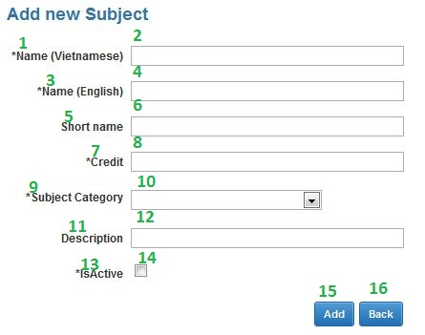**

Fig\_2.15.2 Add new Subject Screen

**Data Fields Definition – Add Subject**

|  |  |  |  |  |  |  |
| --- | --- | --- | --- | --- | --- | --- |
| **Field name** | **Description** | **Read**  **Only** | **Mandatory** | **Control Type** | **Data Type** | **Length** |
| (2)txtSubjectnameV | Staffs enter the Subject name Vietnamese | - | y | Textbox | Text | 200 |
| (1)lblSubjectnameV | Label Subject name Vietnamese | y | - | Label | Text | Fixed |
| (4)txtSubjectnameE | Staffs enter the Subject name English | - | y | Textbox | Text | 200 |
| (3)lblSubjectnameE | Label Subject name English | y | - | Label | Text | Fixed |
| (6)txtShortName | Short name for this object. Such as: Organization Behavior has OB is short name | - | y | Textbox | Text | Max |
| (5)lblShortName | Label short name | y | - | Label | Text | Fixed |
| (8)txtCredit | Credit number of this subject | - | y | Textbox | Integer | >0 |
| (7)lblCredit | Label Credit | y | - | Label | Text | Fixed |
| (10)drdlSubjectCategory | Subject Group | - | y | Dropdown list | Integer | Fixed |
| (9)lblSubjectCategory | Label Subject Group | y | - | Label | Text | Fixed |
| (12)txtDescription | Staffs provide more detail for this Subject | - | - | Textbox | Text | Max |
| (11)lblDescription | Label description | y | - | Label | Text | Fixed |
| (14)chkIsActive | This field is marked is this Subject have been exist or not | - | y | Checkbox | Bool | Fixed |
| (13)lblStatus | Label status of Subject | y | - | Label | Text | Fixed |

**Buttons / Hyper Links – Add Subject**

|  |  |  |  |  |
| --- | --- | --- | --- | --- |
| **Function** | **Description** | **Available Criteria** | **Validations** | **Outcome** |
| (15)Add new | This button allows staffs add new Subject | Always available | Validate all mandatory fields. | Insert Data into DB |
| (16)Back | This button allows staffs return to the “View Subject” screen page | Always available | No | Close popup “Add new Subject” and return to the “View Subject” page. |

##### Sequence Diagram

#### <Staff> Edit Subject

##### Use Case Diagram

Fig\_2.16.1 Edit Subject

##### Use Case Specification

|  |  |  |  |  |
| --- | --- | --- | --- | --- |
| **USE CASE – Edit Subject** | | | | |
| **Use-case No.** | UC016 | **Use-case Version** | | 0.1 |
| **Use-case Name** | Edit Subject | | | |
| **Author** | TrucTM | | | |
| **Date** | 05/02/2012 | **Priority** | Normal | |
| **Actor:** User: Staff  **Summary:** This use case allows staff edits Subject has existed in DB.  **Goal:** Editing exist Subject.  **Triggers: I**n the Gridview information at “View Subject” page, staff click “Edit” link button. At least 1 Subject is existing and Subject Group has data.  **Preconditions:** Staff has login into system and go to the “View Subject” page.  **Post Conditions.**  Success: Subject will be edited.  Fail: Report that system cannot edit Subject.  **Main Success Scenario.**   |  |  |  | | --- | --- | --- | | Step | Actor Action | System Response | | 1 | In Gridview information at the “View Subject”, staffs click “Edit” link button | System will display the popup “Edit Subject” | | 2 | Staffs edit information for this Subject | System checks data [Exception 1] | | 3 | Staff click “Update” button in the popup | - System updates into DB [Exception 2]  - Message box reports that staffs have edited Subject and return to the “View Subject” screen page. |   **Alternative Scenario.**   |  |  |  | | --- | --- | --- | | No. | Actor Action | System Response | | 1 | Users click “Cancel” button at “Edit Subject” popup. | System will return to the “View Subject” screen page. |   **Exceptions.**   |  |  |  | | --- | --- | --- | | No. | Actor Action | System Response | | 1 | Staffs left ‘SubjectNameV” with text field blank | Message will display “You must fill the Subject Name” | | 1 | Staffs left ‘SubjectNameV” with length > 200 chars | Message will display “Subject Name has exceeded character length.” | | 1 | Staffs left ‘SubjectNameE” with text field blank | Message will display “You must fill the Subject Name” | | 1 | Staffs left ‘SubjectNameE” with length > 200 chars | Message will display “Subject Name has exceeded character length.” | | 2 | Staffs click “Update” button in the popup | - System checks this Subject is exist in DB, message box “This Subject name is exist, try another name” will be displayed.  - System checks the connection of web system with DB, if errors occur, message box “Cannot Update Subject, please checking network.” will be displayed |   **Relationships.**  Login use case, view Subject use case, view Subject Group use case.  **Business Rules:**   |  |  |  | | --- | --- | --- | | **No** | **Rule Description** | **Error Message** | | 1 | Each Subject has the unique Subject name | “This Subject name is exist, try another name” | | 2 | Subject name have been exist and staffs just fill Subject name into the system. |  | | | | | |
| **Description:**  This use case allows staff editing exist Subject in system. When staffs enter Subject information, system will check validation of data and report when data is incorrect. After staffs click “Update” button, system will update this Subject and report. This use case can extend the edit Student Score use case. When staffs change isActive property of this Subject this can cause occur error of Student Score. This use case includes use case view of Subject Group for identifying what’s group of this subject. | | | | |

**Screen**

**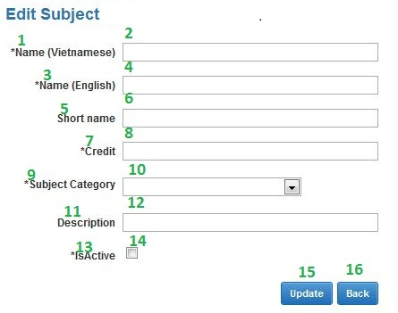**

Fig\_2.16.2 Edit Subject Screen

**Data Fields Definition – Edit Subject**

|  |  |  |  |  |  |  |
| --- | --- | --- | --- | --- | --- | --- |
| **Field name** | **Description** | **Read**  **Only** | **Mandatory** | **Control Type** | **Data Type** | **Length** |
| (2)txtSubjectnameV | Staffs enter the Subject name Vietnamese | - | y | Textbox | Text | 200 |
| (1)lblSubjectnameV | Label Subject name Vietnamese | y | - | Label | Text | Fixed |
| (4)txtSubjectnameE | Staffs enter the Subject name English | - | y | Textbox | Text | 200 |
| (3)lblSubjectnameE | Label Subject name English | y | - | Label | Text | Fixed |
| (6)txtShortName | Short name for this object. Such as: Organization Behavior has OB is short name | - | y | Textbox | Text | Max |
| (5)lblShortName | Label short name | y | - | Label | Text | Fixed |
| (8)txtCredit | Credit number of this subject | - | y | Textbox | Integer | >0 |
| (7)lblCredit | Label Credit | y | - | Label | Text | Fixed |
| (10)drdlSubjectCategory | Subject Group | - | y | Dropdown list | Integer | Fixed |
| (9)lblSubjectCategory | Label Subject Group | y | - | Label | Text | Fixed |
| (12)txtDescription | Staffs provide more detail for this Subject | - | - | Textbox | Text | Max |
| (11)lblDescription | Label description | y | - | Label | Text | Fixed |
| (14)chkIsActive | This field is marked is this Subject have been exist or not | - | y | Checkbox | Bool | Fixed |
| (13)lblStatus | Label status of Subject | y | - | Label | Text | Fixed |

**Buttons / Hyper Links – Edit Subject**

|  |  |  |  |  |
| --- | --- | --- | --- | --- |
| **Function** | **Description** | **Available Criteria** | **Validations** | **Outcome** |
| (15)Update | This button allows staffs edit exist Subject | Always available | Validate all mandatory fields. | Update Data into DB |
| (16)Back | This button allows staffs return to the “View Subject” screen page | Always available | No | Close popup “Add new Subject” and return to the “View Subject” page. |

##### Sequence Diagram

#### <Staff> View Subject

##### Use Case Diagram

Fig\_2.17.1 View Subject

##### Use Case Specification

|  |  |  |  |  |
| --- | --- | --- | --- | --- |
| **USE CASE – View Subject** | | | | |
| **Use-case No.** | UC017 | **Use-case Version** | | 0.1 |
| **Use-case Name** | Add Subject | | | |
| **Author** | TrucTM | | | |
| **Date** | 05/02/2012 | **Priority** | Normal | |
| **Actor:** User: Staff  **Summary:** This use case allows staff views list of Subject  **Goal:** Display all Subjects.  **Triggers:** In any pages of system (Except “Home Page” page), staff click “View Subject” link in menu bar.  **Preconditions:** Staff has login into system, Subject Group has data.  **Post Conditions.**  Success: Display all Subjects  Fail: Report that errors have occurred.  **Main Success Scenario.**   |  |  |  | | --- | --- | --- | | Step | Actor Action | System Response | | 1 | In any page of system (except “Home Page” page), staffs click “View Subject” link in menu bar. | System will redirect to “View Subject” page and show all Subjects [Exception 1] |   **Alternative Scenario.**   |  |  |  | | --- | --- | --- | | No. | Actor Action | System Response | | 1 | Staffs click “Add” link button at “View Subject” page | System will display “Add new Subject” popup | | 2 | Staff click “Edit” link button in gridview data at “View Subject” page. | System will display “Edit Subject” popup | | 3 | Staffs click any link in menu bar | System will redirect to link page. |   **Exceptions.**   |  |  |  | | --- | --- | --- | | No. | Actor Action | System Response | | 1 | Staffs click “View Subject” link in menu bar | If errors occur, System will redirect to “View Subject” and display “Cannot display information. Please check network connection” text |   **Relationships.**  Login use case.  **Business Rules:**   |  |  |  | | --- | --- | --- | | **No** | **Rule Description** | **Error Message** | | | | | |
| **Description:**  When staffs want to view all Subjects of the system, they click “View Subject” in the menu bar. System will redirect to the “View Subject” and show all information about Subjects. Gridview will allow paging; each page will display 10 Subjects. When error occurs, system will display report text. | | | | |

**Screen**

Fig\_2.2.2

**Data Fields Definition – View Subject**

|  |  |  |  |  |  |  |
| --- | --- | --- | --- | --- | --- | --- |
| **Field name** | **Description** | **Read**  **Only** | **Mandatory** | **Control Type** | **Data Type** | **Length** |
| Gridview | Gridview for display list of Subject | - | - | Gridview | List | Fixed |

**Buttons / Hyper Links – View Subject**

|  |  |  |  |  |
| --- | --- | --- | --- | --- |
| **Function** | **Description** | **Available Criteria** | **Validations** | **Outcome** |
| Update | This button uses to show “Edit Subject” popup | Available | No | Show “Edit Subject” popup |
| Add | This button uses to show “Add new Subject” popup | Always available | No | Show “Add new Subject” popup |

##### Sequence Diagram

#### <Staff> Add Subject Group

##### Use Case Diagram

Fig\_2.18.1 Add Subject Group

##### Use Case Specification

|  |  |  |  |  |
| --- | --- | --- | --- | --- |
| 1. **USE CASE – Add new Subject Group** | | | | |
| **Use-case No.** | UC018 | **Use-case Version** | | 0.1 |
| **Use-case Name** | Add Subject Group | | | |
| **Author** | TrucTM | | | |
| **Date** | 05/02/2012 | **Priority** | Normal | |
| **Actor:**  User: Staff  **Summary:**  This use case allows staff adding Subject Group into the system.  **Goal:**  Adding more Subject Group into system  **Triggers:**  At “View Subject Group” page, staff click “Add new” link button.  **Preconditions:**  Staff has login into system and go to the “View Subject Group” page  **Post Conditions.**  Success: New Subject Group will be added into DB  Fail: Report that system cannot add Subject Group into system  **Main Success Scenario.**   |  |  |  | | --- | --- | --- | | Step | Actor Action | System Response | | 1 | At the “View Subject Group”, staffs click “Add new” link button | System will display the popup “Add new Subject Group” | | 2 | Staffs enter information for new Subject Group | System checks data [Exception 1] | | 3 | Staff click “Add new” button in the popup | - System inserts into DB [Exception 2]  - Message box reports that staffs have added new Subject Group and return to the “View Subject Group” screen page. |   **Alternative Scenario.**   |  |  |  | | --- | --- | --- | | No. | Actor Action | System Response | | 1 | Users click “Cancel” button at “Add new Subject Group” popup. | System will return to the “View Subject Group” screen page. |   **Exceptions.**   |  |  |  | | --- | --- | --- | | No. | Actor Action | System Response | | 1 | Staffs left ‘SubjectGroupNameV” with text field blank | Message will display “You must fill the SubjectGroup Name” | | 1 | Staffs left ‘SubjectGroupNameV” with length > 200 chars | Message will display “SubjectGroup Name has exceeded character length.” | | 1 | Staffs left ‘SubjectGroupNameE” with text field blank | Message will display “You must fill the SubjectGroup Name” | | 1 | Staffs left ‘SubjectGroupNameE” with length > 200 chars | Message will display “SubjectGroup Name has exceeded character length.” | | 2 | Staffs click “Add new” button in the popup | - System checks this SubjectGroup is exist in DB, message box “This SubjectGroup name is exist, try another name” will be displayed.  - System checks the connection of web system with DB, if errors occur, message box “Cannot add new SubjectGroup, please checking network.” will be displayed |   **Relationships.**  Login use case, view Subject Group use case.  **Business Rules:**   |  |  |  | | --- | --- | --- | | **No** | **Rule Description** | **Error Message** | | 1 | Each Subject Group has the unique Subject Group name | “This Subject Group name is exist, try another name” | | 2 | Subject Group name have been exist and staffs just fill Subject Group name into the system. |  | | | | | |
| **Description:**  Subject Group information provided more information for student. System provides “add Subject Group” function to allow staff can add new Subject Group for student. Each Subject Group has the unique Subject Group name and Subject Group name is required field. When staffs want to add new Subject Group, staff must check the network connection and ensure that the same Subject Group name hasn’t existed. | | | | |

**Screen**

**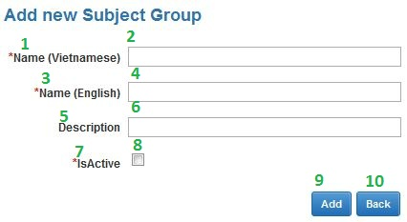**

Fig\_2.18.2 Add Subject Group Screen

**Data Fields Definition – Add Subject Group**

|  |  |  |  |  |  |  |
| --- | --- | --- | --- | --- | --- | --- |
| **Field name** | **Description** | **Read**  **Only** | **Mandatory** | **Control Type** | **Data Type** | **Length** |
| (2)txtCategoryNameV | Staffs enter the Subject Group name Vietnamese | - | y | Textbox | Text | 200 |
| (1)lblCategoryNameV | Label Subject Group name Vietnamese | y | - | Label | Text | Fixed |
| (4)txtCategoryNameE | Staffs enter the Subject Group name English | - | y | Textbox | Text | 200 |
| (3)lblCategoryNameE | Label Subject Group name English | y | - | Label | Text | Fixed |
| (6)txtDescription | Staffs provide more detail for this Subject Group | - | - | Textbox | Text | Max |
| (8)lblDescription | Label description | y | - | Label | Text | Fixed |
| (10)chkIsActive | This field is marked is this Subject Group have been exist or not | - | y | Checkbox | Bool | Fixed |
| (9)lblStatus | Label status of Subject Group | y | - | Label | Text | Fixed |

**Buttons / Hyper Links – Add Subject Group**

|  |  |  |  |  |
| --- | --- | --- | --- | --- |
| **Function** | **Description** | **Available Criteria** | **Validations** | **Outcome** |
| (11)Add new | This button allows staffs add new Subject Group | Always available | Validate all mandatory fields. | Insert Data into DB |
| (12)Back | This button allows staffs return to the “View Subject Group” screen page | Always available | No | Close popup “Add new Subject Group” and return to the “View Subject Group” page. |

##### Sequence Diagram

#### <Staff> Edit Subject Group

##### Use Case Diagram

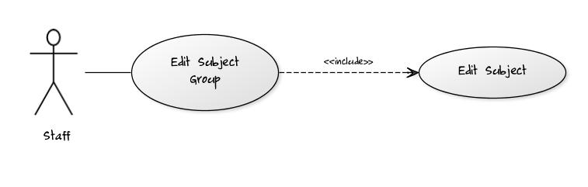Fig\_2.19.1 Edit Subject Group

##### Use Case Specification

|  |  |  |  |  |
| --- | --- | --- | --- | --- |
| **USE CASE – Edit Subject Group** | | | | |
| **Use-case No.** | UC0`9 | **Use-case Version** | | 0.1 |
| **Use-case Name** | Edit Subject Group | | | |
| **Author** | TrucTM | | | |
| **Date** | 05/02/2012 | **Priority** | Normal | |
| **Actor:** User: Staff  **Summary:** This use case allows staff edits Subject Group has existed in DB.  **Goal:** Editing exist Subject Group.  **Triggers:** In the Gridview information at “View Subject Group” page, staff click “Edit” link button. At least 1 Subject Group is exist.  **Preconditions:** Staff has login into system and go to the “View Subject Group” page.  **Post Conditions.**  Success: Subject Group will be edited.  Fail: Report that system cannot edit Subject Group.  **Main Success Scenario.**   |  |  |  | | --- | --- | --- | | Step | Actor Action | System Response | | 1 | In Gridview information at the “View Subject Group”, staffs click “Edit” link button | System will display the popup “Edit Subject Group” | | 2 | Staffs edit information for this Subject Group | System checks data [Exception 1] | | 3 | Staff click “Update” button in the popup | - System updates into DB [Exception 2]  - Message box reports that staffs have edited Subject Group and return to the “View Subject Group” screen page. |   **Alternative Scenario.**   |  |  |  | | --- | --- | --- | | No. | Actor Action | System Response | | 1 | Users click “Cancel” button at “Edit Subject Group” popup. | System will return to the “View Subject Group” screen page. |   **Exceptions.**   |  |  |  | | --- | --- | --- | | No. | Actor Action | System Response | | 1 | Staffs left ‘SubjectGroupNameV” with text field blank | Message will display “You must fill the SubjectGroup Name” | | 1 | Staffs left ‘SubjectGroupNameV” with length > 200 chars | Message will display “SubjectGroup Name has exceeded character length.” | | 1 | Staffs left ‘SubjectGroupNameE” with text field blank | Message will display “You must fill the SubjectGroup Name” | | 1 | Staffs left ‘SubjectGroupNameE” with length > 200 chars | Message will display “SubjectGroup Name has exceeded character length.” | | 2 | Staffs click “Update” button in the popup | - System checks this SubjectGroup is exist in DB, message box “This SubjectGroup name is exist, try another name” will be displayed.  - System checks the connection of web system with DB, if errors occur, message box “Cannot Update SubjectGroup, please checking network.” will be displayed |   **Relationships.**  Login use case, view Subject Group use case.  **Business Rules:**   |  |  |  | | --- | --- | --- | | **No** | **Rule Description** | **Error Message** | | 1 | Each Subject Group has the unique Subject Group name | “This Subject Group name is exist, try another name” | | 2 | Subject Group name have been exist and staffs just fill Subject Group name into the system. |  | | | | | |
| **Description:**  This use case allows staff editing exist Subject Group in system. When staffs enter Subject Group information, system will check validation of data and report when data is incorrect. After staffs click “Update” button, system will update this Subject Group and report. This use case can extend the edit Subject use case. When staffs change isActive property of this Subject Group this can cause occur error of Subject. | | | | |

**Screen**

**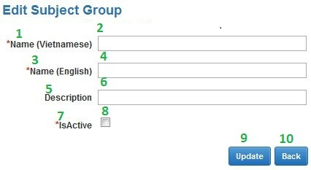**

Fig\_2.19.2 Edit Subject Group Screen

**Data Fields Definition – Edit Subject Group**

|  |  |  |  |  |  |  |
| --- | --- | --- | --- | --- | --- | --- |
| **Field name** | **Description** | **Read**  **Only** | **Mandatory** | **Control Type** | **Data Type** | **Length** |
| (2)txtCategoryNameV | Staffs enter the Subject Group name Vietnamese | - | y | Textbox | Text | 200 |
| (1)lblCategoryNameV | Label Subject Group name Vietnamese | y | - | Label | Text | Fixed |
| (4)txtCategoryNameE | Staffs enter the Subject Group name English | - | y | Textbox | Text | 200 |
| (3)lblCategoryNameE | Label Subject Group name English | y | - | Label | Text | Fixed |
| (6)txtDescription | Staffs provide more detail for this Subject Group | - | - | Textbox | Text | Max |
| (5)lblDescription | Label description | y | - | Label | Text | Fixed |
| (8)chkIsActive | This field is marked is this Subject Group have been exist or not | - | y | Checkbox | Bool | Fixed |
| (7)lblStatus | Label status of Subject Group | y | - | Label | Text | Fixed |

**Buttons / Hyper Links – Edit Subject Group**

|  |  |  |  |  |
| --- | --- | --- | --- | --- |
| **Function** | **Description** | **Available Criteria** | **Validations** | **Outcome** |
| (9)Update | This button allows staffs edit exist Subject Group | Always available | Validate all mandatory fields. | Update Data into DB |
| (10)Back | This button allows staffs return to the “View Subject Group” screen page | Always available | No | Close popup “Add new Subject Group” and return to the “View Subject Group” page. |

##### Sequence Diagram

#### <Staff>View Subject Group

##### Use Case Diagram

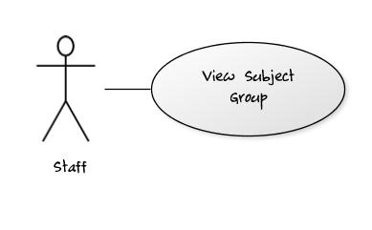

Fig\_2.20.1 View Subject Group

##### Use Case Specification

|  |  |  |  |  |
| --- | --- | --- | --- | --- |
| **USE CASE – View Subject Group** | | | | |
| **Use-case No.** | UC020 | **Use-case Version** | | 0.1 |
| **Use-case Name** | Add Subject Group | | | |
| **Author** | TrucTM | | | |
| **Date** | 05/02/2012 | **Priority** | Normal | |
| **Actor:** User: Staff  **Summary:** This use case allows staff views list of Subject Group  **Goal:** Display all Subject Groups.  **Triggers:** In any pages of system (Except “Home Page” page), staff click “View Subject Group” link in menu bar.  **Preconditions:** Staff has login into system.  **Post Conditions.**  Success: Display all Subject Groups  Fail: Report that errors have occurred.  **Main Success Scenario.**   |  |  |  | | --- | --- | --- | | Step | Actor Action | System Response | | 1 | In any page of system (except “Home Page” page), staffs click “View Subject Group” link in menu bar. | System will redirect to “View Subject Group” page and show all Subject Groups [Exception 1] |   **Alternative Scenario.**   |  |  |  | | --- | --- | --- | | No. | Actor Action | System Response | | 1 | Staffs click “Add” link button at “View Subject Group” page | System will display “Add new Subject Group” popup | | 2 | Staff click “Edit” link button in gridview data at “View Subject Group” page. | System will display “Edit Subject Group” popup | | 3 | Staffs click any link in menu bar | System will redirect to link page. |   **Exceptions.**   |  |  |  | | --- | --- | --- | | No. | Actor Action | System Response | | 1 | Staffs click “View Subject Group” link in menu bar | If errors occur, System will redirect to “View Subject Group” and display “Cannot display information. Please check network connection” text |   **Relationships.**  Login use case.  **Business Rules:**   |  |  |  | | --- | --- | --- | | **No** | **Rule Description** | **Error Message** | | | | | |
| **Description:**  When staffs want to view all Subject Groups of the system, they click “View Subject Group” in the menu bar. System will redirect to the “View Subject Group” and show all information about Subject Groups. Gridview will allow paging, each page will display 10 Subject Groups. When error occurs, system will display report text. | | | | |

**Screen**

Fig\_2.2.2

**Data Fields Definition – View Subject Group**

|  |  |  |  |  |  |  |
| --- | --- | --- | --- | --- | --- | --- |
| **Field name** | **Description** | **Read**  **Only** | **Mandatory** | **Control Type** | **Data Type** | **Length** |
| Gridview | Gridview for display list of Subject Group | - | - | Gridview | List | Fixed |

**Buttons / Hyper Links – View Subject Group**

|  |  |  |  |  |
| --- | --- | --- | --- | --- |
| **Function** | **Description** | **Available Criteria** | **Validations** | **Outcome** |
| Update | This button uses to show “Edit Subject Group” popup | Available | No | Show “Edit Subject Group” popup |
| Add | This button uses to show “Add new Subject Group” popup | Always available | No | Show “Add new Subject Group” popup |

##### Sequence Diagram

#### <Staff> Add Special

##### Use Case Diagram

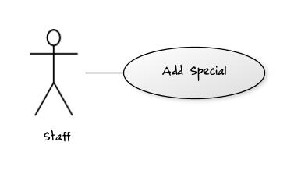Fig\_2.21.1 Add Special

##### Use Case Specification

|  |  |  |  |  |
| --- | --- | --- | --- | --- |
| **USE CASE – Add new Special** | | | | |
| **Use-case No.** | UC021 | **Use-case Version** | | 0.1 |
| **Use-case Name** | Add Special | | | |
| **Author** | TrucTM | | | |
| **Date** | 05/02/2012 | **Priority** | Normal | |
| **Actor:**  User: Staff  **Summary:**  This use case allows staff adding Special into the system.  **Goal:**  Adding more Special into system  **Triggers:**  At “View Special” page, staff click “Add new” link button.  **Preconditions:**  Staff has login into system and go to the “View Special” page  **Post Conditions.**  Success: New Special will be added into DB  Fail: Report that system cannot add Special into system  **Main Success Scenario.**   |  |  |  | | --- | --- | --- | | Step | Actor Action | System Response | | 1 | At the “View Special”, staffs click “Add new” link button | System will display the popup “Add new Special” | | 2 | Staffs enter information for new Special | System checks data [Exception 1] | | 3 | Staff click “Add new” button in the popup | - System inserts into DB [Exception 2]  - Message box reports that staffs have added new Special and return to the “View Special” screen page. |   **Alternative Scenario.**   |  |  |  | | --- | --- | --- | | No. | Actor Action | System Response | | 1 | Users click “Cancel” button at “Add new Special” popup. | System will return to the “View Special” screen page. |   **Exceptions.**   |  |  |  | | --- | --- | --- | | No. | Actor Action | System Response | | 1 | Staffs left ‘SpecialNameV” with text field blank | Message will display “You must fill the Special Name” | | 1 | Staffs left ‘SpecialNameV” with length > 200 chars | Message will display “Special Name has exceeded character length.” | | 1 | Staffs left ‘SpecialNameE” with text field blank | Message will display “You must fill the Special Name” | | 1 | Staffs left ‘SpecialNameE” with length > 200 chars | Message will display “Special Name has exceeded character length.” | | 2 | Staffs click “Add new” button in the popup | - System checks this Special is exist in DB, message box “This Special name is exist, try another name” will be displayed.  - System checks the connection of web system with DB, if errors occur, message box “Cannot add new Special, please checking network.” will be displayed |   **Relationships.**  Login use case, view Special use case.  **Business Rules:**   |  |  |  | | --- | --- | --- | | **No** | **Rule Description** | **Error Message** | | 1 | Each Special has the unique Special name | “This Special name is exist, try another name” | | 2 | Special name have been exist and staffs just fill Special name into the system. |  | | | | | |
| **Description:**  Special information provided more information for student. System provides “add Special” function to allow staff can add new Special for student. Each Special has the unique Special name and Special name is required field. When staffs want to add new Special, staff must check the network connection and ensure that the same Special name hasn’t existed. | | | | |

**Screen**

**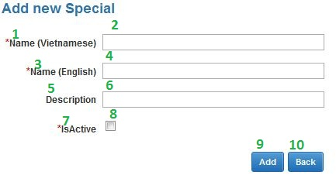**

Fig\_2.21.2 Add new Special Screen

**Data Fields Definition – Add Special**

|  |  |  |  |  |  |  |
| --- | --- | --- | --- | --- | --- | --- |
| **Field name** | **Description** | **Read**  **Only** | **Mandatory** | **Control Type** | **Data Type** | **Length** |
| (2)txtSpecialnameV | Staffs enter the Special name V | - | y | Textbox | Text | 50 |
| (1)lblSpecialnameV | Label Special name V | y | - | Label | Text | Fixed |
| (4)txtSpecialnameE | Staffs enter the Special name E | - | y | Textbox | Text | 50 |
| (3)lblSpecialnameE | Label Special nameE | y | - | Label | Text | Fixed |
| (6)txtDescription | Staffs provide more detail for this Special | - | - | Textbox | Text | Max |
| (5)lblDescription | Label description | y | - | Label | Text | Fixed |
| (8)chkIsActive | This field is marked is this Special have been exist or not | - | y | Checkbox | Bool | Fixed |
| (7)lblStatus | Label status of Special | y | - | Label | Text | Fixed |

**Buttons / Hyper Links – Add Special**

|  |  |  |  |  |
| --- | --- | --- | --- | --- |
| **Function** | **Description** | **Available Criteria** | **Validations** | **Outcome** |
| (9)Add new | This button allows staffs add new Special | Always available | Validate all mandatory fields. | Insert Data into DB |
| (10)Back | This button allows staffs return to the “View Special” screen page | Always available | No | Close popup “Add new Special” and return to the “View Special” page. |

##### Sequence Diagram

#### <Staff> Edit Special

##### Use Case Diagram

Fig\_2.22.1 Edit Special

##### Use Case Specification

|  |  |  |  |  |
| --- | --- | --- | --- | --- |
| **USE CASE – Edit Special** | | | | |
| **Use-case No.** | UC022 | **Use-case Version** | | 0.1 |
| **Use-case Name** | Edit Special | | | |
| **Author** | TrucTM | | | |
| **Date** | 05/02/2012 | **Priority** | Normal | |
| **Actor:**  User: Staff  **Summary:**  This use case allows staff edits Special has existed in DB.  **Goal:**  Editing exist Special.  **Triggers:**  In the Gridview information at “View Special” page, staff click “Edit” link button. At least 1 Special is exist.  **Preconditions:**  Staff has login into system and go to the “View Special” page.  **Post Conditions.**  Success: Special will be edited.  Fail: Report that system cannot edit Special.  **Main Success Scenario.**   |  |  |  | | --- | --- | --- | | Step | Actor Action | System Response | | 1 | In Gridview information at the “View Special”, staffs click “Edit” link button | System will display the popup “Edit Special” | | 2 | Staffs edit information for this Special | System checks data [Exception 1] | | 3 | Staff click “Update” button in the popup | - System updates into DB [Exception 2]  - Message box reports that staffs have edited Special and return to the “View Special” screen page. |   **Alternative Scenario.**   |  |  |  | | --- | --- | --- | | No. | Actor Action | System Response | | 1 | Users click “Cancel” button at “Edit Special” popup. | System will return to the “View Special” screen page. |   **Exceptions.**   |  |  |  | | --- | --- | --- | | No. | Actor Action | System Response | | 1 | Staffs left ‘SpecialNameV” with text field blank | Message will display “You must fill the Special Name” | | 1 | Staffs left ‘SpecialNameV” with length > 200 chars | Message will display “Special Name has exceeded character length.” | | 1 | Staffs left ‘SpecialNameE” with text field blank | Message will display “You must fill the Special Name” | | 1 | Staffs left ‘SpecialNameE” with length > 200 chars | Message will display “Special Name has exceeded character length.” | | 2 | Staffs click “Update” button in the popup | - System checks this Special is exist in DB, message box “This Special name is exist, try another name” will be displayed.  - System checks the connection of web system with DB, if errors occur, message box “Cannot Update Special, please checking network.” will be displayed |   **Relationships.**  Login use case, view Special use case.  **Business Rules:**   |  |  |  | | --- | --- | --- | | **No** | **Rule Description** | **Error Message** | | 1 | Each Special has the unique Special name | “This Special name is exist, try another name” | | 2 | Special name have been exist and staffs just fill Special name into the system. |  | | | | | |
| **Description:**  This use case allows staff editing exist Special in system. When staffs enter Special information, system will check validation of data and report when data is incorrect. After staffs click “Update” button, system will update this Special and report. This use case can extend the edit Student use case. When staffs change isActive property of this Special this can cause occur error of Student. | | | | |

**Screen**

**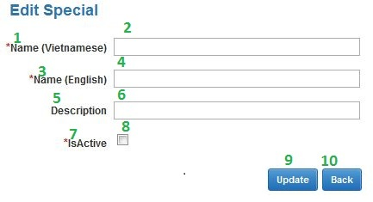**

Fig\_2.22.2 Edit Special Screen

**Data Fields Definition – Edit Special**

|  |  |  |  |  |  |  |
| --- | --- | --- | --- | --- | --- | --- |
| **Field name** | **Description** | **Read**  **Only** | **Mandatory** | **Control Type** | **Data Type** | **Length** |
| (2)txtSpecialnameV | Staffs enter the Special name V | - | y | Textbox | Text | 50 |
| (1)lblSpecialnameV | Label Special name V | y | - | Label | Text | Fixed |
| (4)txtSpecialnameE | Staffs enter the Special name E | - | y | Textbox | Text | 50 |
| (3)lblSpecialnameE | Label Special nameE | y | - | Label | Text | Fixed |
| (6)txtDescription | Staffs provide more detail for this Special | - | - | Textbox | Text | Max |
| (5)lblDescription | Label description | y | - | Label | Text | Fixed |
| (8)chkIsActive | This field is marked is this Special have been exist or not | - | y | Checkbox | Bool | Fixed |
| (7)lblStatus | Label status of Special | y | - | Label | Text | Fixed |

**Buttons / Hyper Links – Edit Special**

|  |  |  |  |  |
| --- | --- | --- | --- | --- |
| **Function** | **Description** | **Available Criteria** | **Validations** | **Outcome** |
| (9)Update | This button allows staffs edit exist Special | Always available | Validate all mandatory fields. | Update Data into DB |
| (10)Back | This button allows staffs return to the “View Special” screen page | Always available | No | Close popup “Add new Special” and return to the “View Special” page. |

##### Sequence Diagram

#### <Staff> View Special

##### Use Case Diagram

Fig\_2.23.1 View Special

##### Use Case Specification

|  |  |  |  |  |
| --- | --- | --- | --- | --- |
| **USE CASE – View Special** | | | | |
| **Use-case No.** | UC023 | **Use-case Version** | | 0.1 |
| **Use-case Name** | Add Special | | | |
| **Author** | TrucTM | | | |
| **Date** | 05/02/2012 | **Priority** | Normal | |
| **Actor:**  User: Staff  **Summary:**  This use case allows staff views list of Special  **Goal:**  Display all Specials.  **Triggers:**  In any pages of system (Except “Home Page” page), staff click “View Special” link in menu bar.  **Preconditions:**  Staff has login into system.  **Post Conditions.**  Success: Display all Specials  Fail: Report that errors have occurred.  **Main Success Scenario.**   |  |  |  | | --- | --- | --- | | Step | Actor Action | System Response | | 1 | In any page of system (except “Home Page” page), staffs click “View Special” link in menu bar. | System will redirect to “View Special” page and show all Specials [Exception 1] |   **Alternative Scenario.**   |  |  |  | | --- | --- | --- | | No. | Actor Action | System Response | | 1 | Staffs click “Add” link button at “View Special” page | System will display “Add new Special” popup | | 2 | Staff click “Edit” link button in gridview data at “View Special” page. | System will display “Edit Special” popup | | 3 | Staffs click any link in menu bar | System will redirect to link page. |   **Exceptions.**   |  |  |  | | --- | --- | --- | | No. | Actor Action | System Response | | 1 | Staffs click “View Special” link in menu bar | If errors occur, System will redirect to “View Special” and display “Cannot display information. Please check network connection” text |   **Relationships.**  Login use case.  **Business Rules:**   |  |  |  | | --- | --- | --- | | **No** | **Rule Description** | **Error Message** | | | | | |
| **Description:**  When staffs want to view all Specials of the system, they click “View Special” in the menu bar. System will redirect to the “View Special” and show all information about Specials. Gridview will allow paging; each page will display 10 Specials. When error occurs, system will display report text. | | | | |

**Screen**

Fig\_2.2.2

**Data Fields Definition – View Special**

|  |  |  |  |  |  |  |
| --- | --- | --- | --- | --- | --- | --- |
| **Field name** | **Description** | **Read**  **Only** | **Mandatory** | **Control Type** | **Data Type** | **Length** |
| Gridview | Gridview for display list of Special | - | - | Gridview | List | Fixed |

**Buttons / Hyper Links – View Special**

|  |  |  |  |  |
| --- | --- | --- | --- | --- |
| **Function** | **Description** | **Available Criteria** | **Validations** | **Outcome** |
| Update | This button uses to show “Edit Special” popup | Available | No | Show “Edit Special” popup |
| Add | This button uses to show “Add new Special” popup | Always available | No | Show “Add new Special” popup |

##### Sequence Diagram

#### <Staff> Add Mode of Study

##### Use Case Diagram

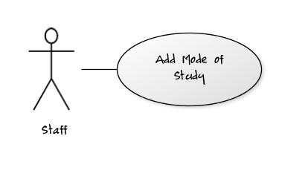Fig\_2.24.1 Add Mode of Study

##### Use Case Specification

|  |  |  |  |  |
| --- | --- | --- | --- | --- |
| **USE CASE – Add new Mode of Study** | | | | |
| **Use-case No.** | UC024 | **Use-case Version** | | 0.1 |
| **Use-case Name** | Add Mode of Study | | | |
| **Author** | TrucTM | | | |
| **Date** | 05/02/2012 | **Priority** | Normal | |
| **Actor:** User: Staff  **Summary:** This use case allows staff adding Mode of Study into the system.  **Goal:** Adding more Mode of Study into system  **Triggers:** At “View Mode of Study” page, staff click “Add new” link button.  **Preconditions:** Staff has login into system and go to the “View Mode of Study” page  **Post Conditions.**  Success: New Mode of Study will be added into DB  Fail: Report that system cannot add Mode of Study into system  **Main Success Scenario.**   |  |  |  | | --- | --- | --- | | Step | Actor Action | System Response | | 1 | At the “View Mode of Study”, staffs click “Add new” link button | System will display the popup “Add new Mode of Study” | | 2 | Staffs enter information for new Mode of Study | System checks data [Exception 1] | | 3 | Staff click “Add new” button in the popup | - System inserts into DB [Exception 2]  - Message box reports that staffs have added new Mode of Study and return to the “View Mode of Study” screen page. |   **Alternative Scenario.**   |  |  |  | | --- | --- | --- | | No. | Actor Action | System Response | | 1 | Users click “Cancel” button at “Add new Mode of Study” popup. | System will return to the “View Mode of Study” screen page. |   **Exceptions.**   |  |  |  | | --- | --- | --- | | No. | Actor Action | System Response | | 1 | Staffs left ‘ModeOfStudyNameV” with text field blank | Message will display “You must fill the ModeOfStudy Name” | | 1 | Staffs left ‘ModeOfStudyNameV” with length > 200 chars | Message will display “ModeOfStudy Name has exceeded character length.” | | 1 | Staffs left ‘ModeOfStudyNameE” with text field blank | Message will display “You must fill the ModeOfStudy Name” | | 1 | Staffs left ‘ModeOfStudyNameE” with length > 200 chars | Message will display “ModeOfStudy Name has exceeded character length.” | | 2 | Staffs click “Add new” button in the popup | - System checks this ModeOfStudy is exist in DB, message box “This ModeOfStudy name is exist, try another name” will be displayed.  - System checks the connection of web system with DB, if errors occur, message box “Cannot add new ModeOfStudy, please checking network.” will be displayed |   **Relationships.**  Login use case, view Mode of Study use case.  **Business Rules:**   |  |  |  | | --- | --- | --- | | **No** | **Rule Description** | **Error Message** | | 1 | Each Mode of Study has the unique Mode of Study name | “This Mode of Study name is exist, try another name” | | 2 | Mode of Study name have been exist and staffs just fill Mode of Study name into the system. |  | | | | | |
| **Description:**  Mode of Study information provided more information for student. System provides “add Mode of Study” function to allow staff can add new Mode of Study for student. Each Mode of Study has the unique Mode of Study name and Mode of Study name is required field. When staffs want to add new Mode of Study, staff must check the network connection and ensure that the same Mode of Study name hasn’t existed. | | | | |

**Screen**

**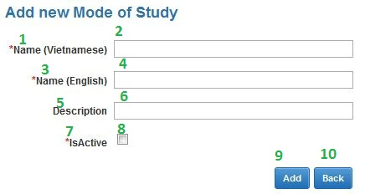**

Fig\_2.24.2 Add mode of Study Screen

**Data Fields Definition – Add Mode of Study**

|  |  |  |  |  |  |  |
| --- | --- | --- | --- | --- | --- | --- |
| **Field name** | **Description** | **Read**  **Only** | **Mandatory** | **Control Type** | **Data Type** | **Length** |
| (2)txtModeofStudynameV | Staffs enter the Mode of Study name Vietnamese | - | y | Textbox | Text | 200 |
| (1)lblModeofStudynameV | Label Mode of Study name Vietnamese | y | - | Label | Text | Fixed |
| (4)txtModeofStudynameE | Staffs enter the Mode of Study name English | - | y | Textbox | Text | 200 |
| (3)lblModeofStudynameE | Label Mode of Study name English | y | - | Label | Text | Fixed |
| (6)txtDescription | Staffs provide more detail for this Mode of Study | - | - | Textbox | Text | Max |
| (5)lblDescription | Label description | y | - | Label | Text | Fixed |
| (8)chkIsActive | This field is marked is this Mode of Study have been exist or not | - | y | Checkbox | Bool | Fixed |
| (7)lblStatus | Label status of Mode of Study | y | - | Label | Text | Fixed |

**Buttons / Hyper Links – Add Mode of Study**

|  |  |  |  |  |
| --- | --- | --- | --- | --- |
| **Function** | **Description** | **Available Criteria** | **Validations** | **Outcome** |
| (9)Add new | This button allows staffs add new Mode of Study | Always available | Validate all mandatory fields. | Insert Data into DB |
| (10)Back | This button allows staffs return to the “View Mode of Study” screen page | Always available | No | Close popup “Add new Mode of Study” and return to the “View Mode of Study” page. |

##### Sequence Diagram

#### <Staff> Edit Mode of Study

##### Use Case Diagram

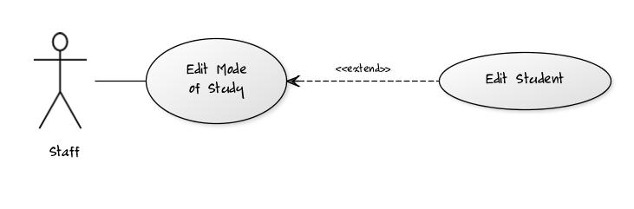Fig\_2.25.1 Edit Mode of Study

##### Use Case Specification

|  |  |  |  |  |
| --- | --- | --- | --- | --- |
| **USE CASE – Edit Mode of Study** | | | | |
| **Use-case No.** | UC025 | **Use-case Version** | | 0.1 |
| **Use-case Name** | Edit Mode of Study | | | |
| **Author** | TrucTM | | | |
| **Date** | 05/02/2012 | **Priority** | Normal | |
| **Actor:** User: Staff  **Summary:** This use case allows staff edits Mode of Study has existed in DB.  **Goal:** Editing exist Mode of Study.  **Triggers:** In the Gridview information at “View Mode of Study” page, staff click “Edit” link button. At least 1 Mode of Study is exist.  **Preconditions:** Staff has login into system and go to the “View Mode of Study” page.  **Post Conditions.**  Success: Mode of Study will be edited.  Fail: Report that system cannot edit Mode of Study.  **Main Success Scenario.**   |  |  |  | | --- | --- | --- | | Step | Actor Action | System Response | | 1 | In Gridview information at the “View Mode of Study”, staffs click “Edit” link button | System will display the popup “Edit Mode of Study” | | 2 | Staffs edit information for this Mode of Study | System checks data [Exception 1] | | 3 | Staff click “Update” button in the popup | - System updates into DB [Exception 2]  - Message box reports that staffs have edited Mode of Study and return to the “View Mode of Study” screen page. |   **Alternative Scenario.**   |  |  |  | | --- | --- | --- | | No. | Actor Action | System Response | | 1 | Users click “Cancel” button at “Edit Mode of Study” popup. | System will return to the “View Mode of Study” screen page. |   **Exceptions.**   |  |  |  | | --- | --- | --- | | No. | Actor Action | System Response | | 1 | Staffs left ‘ModeOfStudyNameV” with text field blank | Message will display “You must fill the ModeOfStudy Name” | | 1 | Staffs left ‘ModeOfStudyNameV” with length > 200 chars | Message will display “ModeOfStudy Name has exceeded character length.” | | 1 | Staffs left ‘ModeOfStudyNameE” with text field blank | Message will display “You must fill the ModeOfStudy Name” | | 1 | Staffs left ‘ModeOfStudyNameE” with length > 200 chars | Message will display “ModeOfStudy Name has exceeded character length.” | | 2 | Staffs click “Update” button in the popup | - System checks this ModeOfStudy is exist in DB, message box “This ModeOfStudy name is exist, try another name” will be displayed.  - System checks the connection of web system with DB, if errors occur, message box “Cannot Update ModeOfStudy, please checking network.” will be displayed |   **Relationships.**  Login use case, view Mode of Study use case.  **Business Rules:**   |  |  |  | | --- | --- | --- | | **No** | **Rule Description** | **Error Message** | | 1 | Each Mode of Study has the unique Mode of Study name | “This Mode of Study name is exist, try another name” | | 2 | Mode of Study name have been exist and staffs just fill Mode of Study name into the system. |  | | | | | |
| **Description:**  This use case allows staff editing exist Mode of Study in system. When staffs enter Mode of Study information, system will check validation of data and report when data is incorrect. After staffs click “Update” button, system will update this Mode of Study and report. This use case can extend the edit Student use case. When staffs change isActive property of this Mode of Study this can cause occur error of Student. | | | | |

**Screen**

**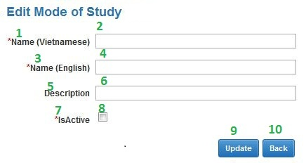**

Fig\_2.25.2 Edit mode of Study Screen

**Data Fields Definition – Edit Mode of Study**

|  |  |  |  |  |  |  |
| --- | --- | --- | --- | --- | --- | --- |
| **Field name** | **Description** | **Read**  **Only** | **Mandatory** | **Control Type** | **Data Type** | **Length** |
| (2)txtModeofStudynameV | Staffs enter the Mode of Study name Vietnamese | - | y | Textbox | Text | 200 |
| (1)lblModeofStudynameV | Label Mode of Study name Vietnamese | y | - | Label | Text | Fixed |
| (4)txtModeofStudynameE | Staffs enter the Mode of Study name English | - | y | Textbox | Text | 200 |
| (3)lblModeofStudynameE | Label Mode of Study name English | y | - | Label | Text | Fixed |
| (6)txtDescription | Staffs provide more detail for this Mode of Study | - | - | Textbox | Text | Max |
| (5)lblDescription | Label description | y | - | Label | Text | Fixed |
| (8)chkIsActive | This field is marked is this Mode of Study have been exist or not | - | y | Checkbox | Bool | Fixed |
| (7)lblStatus | Label status of Mode of Study | y | - | Label | Text | Fixed |

**Buttons / Hyper Links – Edit Mode of Study**

|  |  |  |  |  |
| --- | --- | --- | --- | --- |
| **Function** | **Description** | **Available Criteria** | **Validations** | **Outcome** |
| (9)Update | This button allows staffs edit exist Mode of Study | Always available | Validate all mandatory fields. | Update Data into DB |
| (10)Back | This button allows staffs return to the “View Mode of Study” screen page | Always available | No | Close popup “Add new Mode of Study” and return to the “View Mode of Study” page. |

##### Sequence Diagram

#### <Staff> View Mode of Study

##### Use Case Diagram

Fig\_2.26.1 View Mode of Study

##### Use Case Specification

|  |  |  |  |  |
| --- | --- | --- | --- | --- |
| **USE CASE – View Mode of Study** | | | | |
| **Use-case No.** | UC026 | **Use-case Version** | | 0.1 |
| **Use-case Name** | Add Mode of Study | | | |
| **Author** | TrucTM | | | |
| **Date** | 05/02/2012 | **Priority** | Normal | |
| **Actor:** User: Staff  **Summary:** This use case allows staff views list of Mode of Study  **Goal:** Display all Mode of Study.  **Triggers:** In any pages of system (Except “Home Page” page), staff click “View Mode of Study” link in menu bar.  **Preconditions:** Staff has login into system.  **Post Conditions.**  Success: Display all Mode of Study  Fail: Report that errors have occurred.  **Main Success Scenario.**   |  |  |  | | --- | --- | --- | | Step | Actor Action | System Response | | 1 | In any page of system (except “Home Page” page), staffs click “View Mode of Study” link in menu bar. | System will redirect to “View Mode of Study” page and show all Mode of Study [Exception 1] |   **Alternative Scenario.**   |  |  |  | | --- | --- | --- | | No. | Actor Action | System Response | | 1 | Staffs click “Add” link button at “View Mode of Study” page | System will display “Add new Mode of Study” popup | | 2 | Staff click “Edit” link button in gridview data at “View Mode of Study” page. | System will display “Edit Mode of Study” popup | | 3 | Staffs click any link in menu bar | System will redirect to link page. |   **Exceptions.**   |  |  |  | | --- | --- | --- | | No. | Actor Action | System Response | | 1 | Staffs click “View Mode of Study” link in menu bar | If errors occur, System will redirect to “View Mode of Study” and display “Cannot display information. Please check network connection” text |   **Relationships.**  Login use case.  **Business Rules:**   |  |  |  | | --- | --- | --- | | **No** | **Rule Description** | **Error Message** | | | | | |
| **Description:**  When staffs want to view all Mode of Study of the system, they click “View Mode of Study” in the menu bar. System will redirect to the “View Mode of Study” and show all information about Mode of Study. Gridview will allow paging; each page will display 10 Mode of Study. When error occurs, system will display report text. | | | | |

**Screen**

Fig\_2.2.2

**Data Fields Definition – View Mode of Study**

|  |  |  |  |  |  |  |
| --- | --- | --- | --- | --- | --- | --- |
| **Field name** | **Description** | **Read**  **Only** | **Mandatory** | **Control Type** | **Data Type** | **Length** |
| Gridview | Gridview for display list of Mode of Study | - | - | Gridview | List | Fixed |

**Buttons / Hyper Links – View Mode of Study**

|  |  |  |  |  |
| --- | --- | --- | --- | --- |
| **Function** | **Description** | **Available Criteria** | **Validations** | **Outcome** |
| Update | This button uses to show “Edit Mode of Study” popup | Available | No | Show “Edit Mode of Study” popup |
| Add | This button uses to show “Add new Mode of Study” popup | Always available | No | Show “Add new Mode of Study” popup |

##### Sequence Diagram

#### <Admin> Add User

##### Use Case Diagram

Fig\_2.27.1 Add User

##### Use Case Specification

|  |  |  |  |  |
| --- | --- | --- | --- | --- |
| **USE CASE – Add new User** | | | | |
| **Use-case No.** | UC027 | **Use-case Version** | | 0.1 |
| **Use-case Name** | Add User | | | |
| **Author** | TrucTM | | | |
| **Date** | 05/02/2012 | **Priority** | Normal | |
| **Actor:** Admin: Admin  **Summary:** This use case allows Admin adding User into the system.  **Goal:** Adding more User into system  **Triggers:** At “View User” page, Admin click “Add new” link button.  **Preconditions:** Admin has login into system and go to the “View User” page  **Post Conditions.**  Success: New User will be added into DB  Fail: Report that system cannot add User into system  **Main Success Scenario.**   |  |  |  | | --- | --- | --- | | Step | Actor Action | System Response | | 1 | At the “View User”, Admins click “Add new” link button | System will display the popup “Add new User” | | 2 | Admins enter information for new User | System checks data [Exception 1] | | 3 | Admin click “Add new” button in the popup | - System inserts into DB [Exception 2]  - Message box reports that Admins have added new User and return to the “View User” screen page. |   **Alternative Scenario.**   |  |  |  | | --- | --- | --- | | No. | Actor Action | System Response | | 1 | Admins click “Cancel” button at “Add new User” popup. | System will return to the “View User” screen page. |   **Exceptions.**   |  |  |  | | --- | --- | --- | | No. | Actor Action | System Response | | 1 | Staffs left ‘Username” with text field blank | Message will display “You must fill the Username” | | 1 | Staffs left ‘Username” with length > 200 chars | Message will display “Username has exceeded character length.” | | 1 | Staffs left ‘Password” with text field blank | Message will display “You must fill the Password” | | 1 | Staffs left ‘Password” with length > 200 chars | Message will display “Password has exceeded character length.” | | 1 | Staffs left ‘Role” with text field blank | Message will display “You must fill the Role” | | 1 | Staffs left ‘Role” with incorrect format | Message will display “You have entered incorrect Phone. Please input number between 1 - 10” | | 2 | Staffs click “Add new” button in the popup | - System checks this User is exist in DB, message box “This User name is exist, try another name” will be displayed.  - System checks the connection of web system with DB, if errors occur, message box “Cannot add new User, please checking network.” will be displayed |   **Relationships.**  Login use case, view User use case.  **Business Rules:**   |  |  |  | | --- | --- | --- | | **No** | **Rule Description** | **Error Message** | | 1 | Each User has the unique User name | “This User name is exist, try another name” | | 2 | User name have been exist and Admins just fill User name into the system. |  | | | | | |
| **Description:**  User information provided more information for student. System provides “add User” function to allow Admin can add new User for student. Each User has the unique User name and User name is required field. When Admins want to add new User, Admin must check the network connection and ensure that the same User name hasn’t existed. | | | | |

**Screen**

**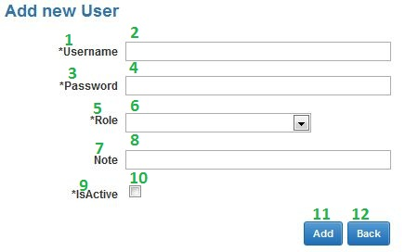**

Fig\_2.27.2 Add User Screen

**Data Fields Definition – Add User**

|  |  |  |  |  |  |  |
| --- | --- | --- | --- | --- | --- | --- |
| **Field name** | **Description** | **Read**  **Only** | **Mandatory** | **Control Type** | **Data Type** | **Length** |
| (2)txtUsername | Admins enter the Username of User | - | y | Textbox | Text | 200 |
| (1)lblUsername | Label Username | y | - | Label | Text | Fixed |
| (4)txtPassword | Default pass (123456) | - | y | Textbox | Text | 200 |
| (3)lblPassword | Label Password | y | - | Label | Text | Fixed |
| (5)drdlRole | Let admin choose role | - | y | Dropdownlist | Text | 200 |
| (6)lblPassword | Label Role | y | - | Label | Text | Fixed |
| (8)txtNote | Admins enter note for this User | - | - | Textbox | Text | Max |
| (7)lblNote | Label Note | y | - | Label | Text | Fixed |
| (10)chkIsActive | This field is marked is this User have been exist or not | - | y | Checkbox | Bool | Fixed |
| (9)lblStatus | Label status of User | y | - | Label | Text | Fixed |

**Buttons / Hyper Links – Add User**

|  |  |  |  |  |
| --- | --- | --- | --- | --- |
| **Function** | **Description** | **Available Criteria** | **Validations** | **Outcome** |
| Add new | This button allows Admins add new User | Always available | Validate all mandatory fields. | Insert Data into DB |
| Back | This button allows Admins return to the “View User” screen page | Always available | No | Close popup “Add new User” and return to the “View User” page. |

##### Sequence Diagram

#### <Admin> Edit User

##### Use Case Diagram

Fig\_2.28.1 Edit User

##### Use Case Specification

|  |  |  |  |  |
| --- | --- | --- | --- | --- |
| **USE CASE – Edit User** | | | | |
| **Use-case No.** | UC028 | **Use-case Version** | | 0.1 |
| **Use-case Name** | Edit User | | | |
| **Author** | TrucTM | | | |
| **Date** | 05/02/2012 | **Priority** | Normal | |
| **Actor:** User: Admin  **Summary:** This use case allows Admin edits User has existed in DB.  **Goal:** Editing exist User.  **Triggers:** In the Gridview information at “View User” page, Admin click “Edit” link button. At least 1 User is exist.  **Preconditions:** Admin has login into system and go to the “View User” page.  **Post Conditions.**  Success: User will be edited.  Fail: Report that system cannot edit User.  **Main Success Scenario.**   |  |  |  | | --- | --- | --- | | Step | Actor Action | System Response | | 1 | In Gridview information at the “View User”, Admins click “Edit” link button | System will display the popup “Edit User” | | 2 | Admins edit information for this User | System checks data [Exception 1] | | 3 | Admin click “Update” button in the popup | - System updates into DB [Exception 2]  - Message box reports that Admins have edited User and return to the “View User” screen page. |   **Alternative Scenario.**   |  |  |  | | --- | --- | --- | | No. | Actor Action | System Response | | 1 | Admins click “Cancel” button at “Edit User” popup. | System will return to the “View User” screen page. |   **Exceptions.**   |  |  |  | | --- | --- | --- | | No. | Actor Action | System Response | | 1 | Staffs left ‘Username” with text field blank | Message will display “You must fill the Username” | | 1 | Staffs left ‘Username” with length > 200 chars | Message will display “Username has exceeded character length.” | | 1 | Staffs left ‘Password” with text field blank | Message will display “You must fill the Password” | | 1 | Staffs left ‘Password” with length > 200 chars | Message will display “Password has exceeded character length.” | | 1 | Staffs left ‘Role” with text field blank | Message will display “You must fill the Role” | | 1 | Staffs left ‘Role” with incorrect format | Message will display “You have entered incorrect Phone. Please input number between 1 - 10” | | 2 | Staffs click “Update” button in the popup | - System checks this User is exist in DB, message box “This Username is exist, try another name” will be displayed.  - System checks the connection of web system with DB, if errors occur, message box “Cannot Update User, please checking network.” will be displayed |   **Relationships.**  Login use case, view User use case.  **Business Rules:**   |  |  |  | | --- | --- | --- | | **No** | **Rule Description** | **Error Message** | | 1 | Each User has the unique User name | “This User name is exist, try another name” | | 2 | User name have been exist and Admins just fill User name into the system. |  | | | | | |
| **Description:**  This use case allows Admin editing exist User in system. When Admins enter User information, system will check validation of data and report when data is incorrect. After Admins click “Update” button, system will update this User and report. This use case can extend the edit Student use case. When Admins change isActive property of this User this can cause occur error of Student. | | | | |

**Screen**

**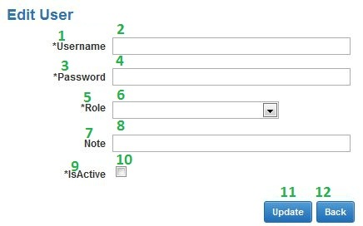**

Fig\_2.28.2 Edit User Screen

**Data Fields Definition – Edit User**

|  |  |  |  |  |  |  |
| --- | --- | --- | --- | --- | --- | --- |
| **Field name** | **Description** | **Read**  **Only** | **Mandatory** | **Control Type** | **Data Type** | **Length** |
| (2)txtUsername | Admins enter the Username of User | - | y | Textbox | Text | 200 |
| (1)lblUsername | Label Username | y | - | Label | Text | Fixed |
| (4)txtPassword | Default pass (123456) | - | y | Textbox | Text | 200 |
| (3)lblPassword | Label Password | y | - | Label | Text | Fixed |
| (5)drdlRole | Let admin choose role | - | y | Dropdownlist | Text | 200 |
| (6)lblPassword | Label Role | y | - | Label | Text | Fixed |
| (8)txtNote | Admins enter note for this User | - | - | Textbox | Text | Max |
| (7)lblNote | Label Note | y | - | Label | Text | Fixed |
| (10)chkIsActive | This field is marked is this User have been exist or not | - | y | Checkbox | Bool | Fixed |
| (9)lblStatus | Label status of User | y | - | Label | Text | Fixed |

**Buttons / Hyper Links – Edit User**

|  |  |  |  |  |
| --- | --- | --- | --- | --- |
| **Function** | **Description** | **Available Criteria** | **Validations** | **Outcome** |
| Update | This button allows Admins edit exist User | Always available | Validate all mandatory fields. | Update Data into DB |
| Back | This button allows Admins return to the “View User” screen page | Always available | No | Close popup “Edit User” and return to the “View User” page. |

##### Sequence Diagram

#### <Admin> View User

##### Use Case Diagram

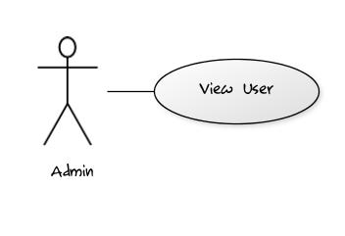

Fig\_2.29.1 View User

##### Use Case Specification

|  |  |  |  |  |
| --- | --- | --- | --- | --- |
| **USE CASE – View User** | | | | |
| **Use-case No.** | UC029 | **Use-case Version** | | 0.1 |
| **Use-case Name** | Add User | | | |
| **Author** | TrucTM | | | |
| **Date** | 05/02/2012 | **Priority** | Normal | |
| **Actor:** User: Admin  **Summary:**  This use case allows Admin views list of User  **Goal:**  Display all Users.  **Triggers:**  In any pages of system (Except “Home Page” page), Admin click “View User” link in menu bar.  **Preconditions:**  Admin has login into system.  **Post Conditions.**  Success: Display all Users  Fail: Report that errors have occurred.  **Main Success Scenario.**   |  |  |  | | --- | --- | --- | | Step | Actor Action | System Response | | 1 | In any page of system (except “Home Page” page), Admins click “View User” link in menu bar. | System will redirect to “View User” page and show all Users [Exception 1] |   **Alternative Scenario.**   |  |  |  | | --- | --- | --- | | No. | Actor Action | System Response | | 1 | Admins click “Add” link button at “View User” page | System will display “Add new User” popup | | 2 | Admin click “Edit” link button in gridview data at “View User” page. | System will display “Edit User” popup | | 3 | Admins click any link in menu bar | System will redirect to link page. |   **Exceptions.**   |  |  |  | | --- | --- | --- | | No. | Actor Action | System Response | | 1 | Admins click “View User” link in menu bar | If errors occur, System will redirect to “View User” and display “Cannot display information. Please check network connection” text |   **Relationships.**  Login use case.  **Business Rules:**   |  |  |  | | --- | --- | --- | | **No** | **Rule Description** | **Error Message** | | | | | |
| **Description:**  When Admins want to view all Users of the system, they click “View User” in the menu bar. System will redirect to the “View User” and show all information about Users. Gridview will allow paging; each page will display 10 Users. When error occurs, system will display report text. | | | | |

**Screen**

Fig\_2.2.2

**Data Fields Definition – View User**

|  |  |  |  |  |  |  |
| --- | --- | --- | --- | --- | --- | --- |
| **Field name** | **Description** | **Read**  **Only** | **Mandatory** | **Control Type** | **Data Type** | **Length** |
| Gridview | Gridview for display list of User | - | - | Gridview | List | Fixed |

**Buttons / Hyper Links – View User**

|  |  |  |  |  |
| --- | --- | --- | --- | --- |
| **Function** | **Description** | **Available Criteria** | **Validations** | **Outcome** |
| Update | This button uses to show “Edit User” popup | Available | No | Show “Edit User” popup |
| Add | This button uses to show “Add new User” popup | Always available | No | Show “Add new User” popup |

##### Sequence Diagram

#### <Admin> Add Staff

##### Use Case Diagram

Fig\_2.30.1 Add Staff

##### Use Case Specification

|  |  |  |  |  |
| --- | --- | --- | --- | --- |
| **USE CASE – Add new Staff** | | | | |
| **Use-case No.** | UC030 | **Use-case Version** | | 0.1 |
| **Use-case Name** | Add Staff | | | |
| **Author** | TrucTM | | | |
| **Date** | 05/02/2012 | **Priority** | Normal | |
| **Actor:**  User: Admin  **Summary:**  This use case allows User adding Staff into the system.  **Goal:**  Adding more Staff into system  **Triggers:**  At “View Staff” page, User click “Add new” link button.  **Preconditions:**  User has login into system and go to the “View Staff” page  **Post Conditions.**  Success: New Staff will be added into DB  Fail: Report that system cannot add Staff into system  **Main Success Scenario.**   |  |  |  | | --- | --- | --- | | Step | Actor Action | System Response | | 1 | At the “View Staff”, Users click “Add new” link button | System will display the popup “Add new Staff” | | 2 | Users enter information for new Staff | System checks data [Exception 1] | | 3 | User click “Add new” button in the popup | - System inserts into DB [Exception 2]  - Message box reports that Users have added new Staff and return to the “View Staff” screen page. |   **Alternative Scenario.**   |  |  |  | | --- | --- | --- | | No. | Actor Action | System Response | | 1 | Users click “Cancel” button at “Add new Staff” popup. | System will return to the “View Staff” screen page. |   **Exceptions.**   |  |  |  | | --- | --- | --- | | No. | Actor Action | System Response | | 1 | Admin left ‘Account” with text field blank | Message will display “You must fill the Account” | | 1 | Admin left ‘Account” with length > 200 chars | Message will display “Account has exceeded character length.” | | 1 | Admin left ‘Full Name” with text field blank | Message will display “You must fill the Full Name” | | 1 | Admin left ‘Email” with text field blank | Message will display “You must fill the Email” | | 1 | Admin left ‘StaffIdentity” with text field blank | Message will display “You must fill the StaffIdentity” | | 1 | Admin left ‘Phone” with incorrect format | Message will display “You have enter incorrect Phone. Please following 000-000-0000 format” | | 2 | Admin click “Add new” button in the popup | - System checks this ModeOfStudy is exist in DB, message box “This ModeOfStudy name is exist, try another name” will be displayed.  - System checks the connection of web system with DB, if errors occur, message box “Cannot add new ModeOfStudy, please checking network.” will be displayed |   **Relationships.**  Login use case, view Staff use case.  **Business Rules:**   |  |  |  | | --- | --- | --- | | **No** | **Rule Description** | **Error Message** | | 1 | Each Staff has the unique Staff name | “This Staff name is exist, try another name” | | 2 | Staff name have been exist and Users just fill Staff name into the system. |  | | | | | |
| **Description:**  Staff information provided more information for student. System provides “add Staff” function to allow User can add new Staff for student. Each Staff has the unique Staff name and Staff name is required field. When Users want to add new Staff, User must check the network connection and ensure that the same Staff name hasn’t existed. | | | | |

**Screen**

**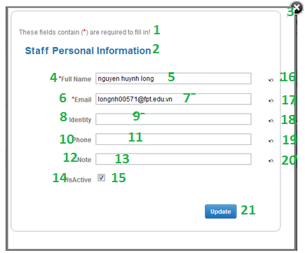**

Fig\_2.30.2 Forget password Screen

**Data Fields Definition – Add Staff**

|  |  |  |  |  |  |  |
| --- | --- | --- | --- | --- | --- | --- |
| **Field name** | **Description** | **Read**  **Only** | **Mandatory** | **Control Type** | **Data Type** | **Length** |
| (1)Instruction | This field contains instructions for edit a staff | N/A | N/A | Label | Text | Fixed |
| (2)Basic information | The following fields will be surrounded by a border to allow logical grouping of data for the staff. The border will have a heading titled “Staff Personal Information” | N/A | N/A | Label | Text | Fixed |
| (4)Full Name label | A label with contents “Full Name” | N/A | N/A | Label | Text | Fixed |
| (5)Full Name textfield | The full name of the staff that to be edited. | N | Y | Text Box | Text | 200 |
| (6)Email label | A label with contents “Email” | N/A | N/A | Label | Text | Fixed |
| (7)Email textfield | The Email of the staff that to be edited. | N | Y | Text Box | Text | 200 |
| (8) Identity label | A label with contents “Identity” | N/A | N/A | Label | Text | Fixed |
| (9) Identity textfield | The Student Identity of the staff that to be edited. | N | Y | Text Box | Text | 200 |
| (10)Phone label | A label with content “Phone” | N/A | N/A | Label | Text | Fixed |
| (11)Phone textfield | The telephone of staff that to be edited. | N | N | Text Box | Text | 50 |
| (12)Note label | A label with content “Note” | N/A | N/A | Label | Text | Fixed |
| (13)Note textfield | The Note of staff that to be edited. | N | N | Text Box | Text | 200 |
| (14)Is Active label | A label with content “Is Active” | N/A | N/A | Label | Text | Fixed |
| (15)Is Active check box | The status of staff that to be edited. | N | N | Check Box | Boolean |  |

**Buttons / Hyper Links – Add Staff**

|  |  |  |  |  |
| --- | --- | --- | --- | --- |
| **Function** | **Description** | **Available Criteria** | **Validations** | **Outcome** |
| (21)Update information | The button will allow staffs to update their personal information in the system | Always available | Validate all mandatory fields. | The record will be updated and staffs will be navigated to the previous page. |
| (16)-(20)Image buttons Undo edited fields | These buttons will allow staffs to get back the original information of each fields before they have updated | Always available | No | The original information of the textfields will be inserted into the textfields |
| (3)Close editing | The button will allow staffs cancel editing their personal information. | Always available | No | Staffs will be navigated to the previous page. |

##### Sequence Diagram

#### <Admin> Edit Staff

##### Use Case Diagram

Fig\_2.31.1 Edit Staff

##### Use Case Specification

|  |  |  |  |  |
| --- | --- | --- | --- | --- |
| **USE CASE – Edit Staff** | | | | |
| **Use-case No.** | UC031 | **Use-case Version** | | 0.1 |
| **Use-case Name** | Edit Staff | | | |
| **Author** | TrucTM | | | |
| **Date** | 05/02/2012 | **Priority** | Normal | |
| **Actor:** User: Admin  **Summary:** This use case allows User edits Staff has existed in DB.  **Goal:** Editing exist Staff.  **Triggers:** In the Gridview information at “View Staff” page, User click “Edit” link button. At least 1 Staff is exist.  **Preconditions:** User has login into system and go to the “View Staff” page.  **Post Conditions.**  Success: Staff will be edited.  Fail: Report that system cannot edit Staff.  **Main Success Scenario.**   |  |  |  | | --- | --- | --- | | Step | Actor Action | System Response | | 1 | In Gridview information at the “View Staff”, Users click “Edit” link button | System will display the popup “Edit Staff” | | 2 | Users edit information for this Staff | System checks data [Exception 1] | | 3 | User click “Update” button in the popup | - System updates into DB [Exception 2]  - Message box reports that Users have edited Staff and return to the “View Staff” screen page. |   **Alternative Scenario.**   |  |  |  | | --- | --- | --- | | No. | Actor Action | System Response | | 1 | Users click “Cancel” button at “Edit Staff” popup. | System will return to the “View Staff” screen page. |   **Exceptions.**   |  |  |  | | --- | --- | --- | | No. | Actor Action | System Response | | 1 | Admin left ‘Account” with text field blank | Message will display “You must fill the Account” | | 1 | Admin left ‘Account” with length > 200 chars | Message will display “Account has exceeded character length.” | | 1 | Admin left ‘Full Name” with text field blank | Message will display “You must fill the Full Name” | | 1 | Admin left ‘Email” with text field blank | Message will display “You must fill the Email” | | 1 | Admin left ‘StaffIdentity” with text field blank | Message will display “You must fill the StaffIdentity” | | 1 | Admin left ‘Phone” with incorrect format | Message will display “You have enter incorrect Phone. Please following 000-000-0000 format” | | 2 | Admin click “Update” button in the popup | - System checks this ModeOfStudy is exist in DB, message box “This ModeOfStudy name is exist, try another name” will be displayed.  - System checks the connection of web system with DB, if errors occur, message box “Cannot Update ModeOfStudy, please checking network.” will be displayed |   **Relationships.**  Login use case, view Staff use case.  **Business Rules:**   |  |  |  | | --- | --- | --- | | **No** | **Rule Description** | **Error Message** | | 1 | Each Staff has the unique Staff name | “This Staff name is exist, try another name” | | 2 | Staff name have been exist and Users just fill Staff name into the system. |  | | | | | |
| **Description:**  This use case allows User editing exist Staff in system. When Users enter Staff information, system will check validation of data and report when data is incorrect. After Users click “Update” button, system will update this Staff and report. This use case can extend the edit Student use case. When Users change isActive property of this Staff this can cause occur error of Student. | | | | |

**Screen**

****

Fig\_2.31.2 Edit Staff Screen

**Data Fields Definition – Edit Staff**

|  |  |  |  |  |  |  |
| --- | --- | --- | --- | --- | --- | --- |
| **Field name** | **Description** | **Read**  **Only** | **Mandatory** | **Control Type** | **Data Type** | **Length** |
| (1)Instruction | This field contains instructions for edit a staff | N/A | N/A | Label | Text | Fixed |
| (2)Basic information | The following fields will be surrounded by a border to allow logical grouping of data for the staff. The border will have a heading titled “Staff Personal Information” | N/A | N/A | Label | Text | Fixed |
| (4)Full Name label | A label with contents “Full Name” | N/A | N/A | Label | Text | Fixed |
| (5)Full Name textfield | The full name of the staff that to be edited. | N | Y | Text Box | Text | 200 |
| (6)Email label | A label with contents “Email” | N/A | N/A | Label | Text | Fixed |
| (7)Email textfield | The Email of the staff that to be edited. | N | Y | Text Box | Text | 200 |
| (8) Identity label | A label with contents “Identity” | N/A | N/A | Label | Text | Fixed |
| (9) Identity textfield | The Student Identity of the staff that to be edited. | N | Y | Text Box | Text | 200 |
| (10)Phone label | A label with content “Phone” | N/A | N/A | Label | Text | Fixed |
| (11)Phone textfield | The telephone of staff that to be edited. | N | N | Text Box | Text | 50 |
| (12)Note label | A label with content “Note” | N/A | N/A | Label | Text | Fixed |
| (13)Note textfield | The Note of staff that to be edited. | N | N | Text Box | Text | 200 |
| (14)Is Active label | A label with content “Is Active” | N/A | N/A | Label | Text | Fixed |
| (15)Is Active check box | The status of staff that to be edited. | N | N | Check Box | Boolean |  |

**Buttons / Hyper Links – Edit Staff**

|  |  |  |  |  |
| --- | --- | --- | --- | --- |
| **Function** | **Description** | **Available Criteria** | **Validations** | **Outcome** |
| (21)Update information | The button will allow staffs to update their personal information in the system | Always available | Validate all mandatory fields. | The record will be updated and staffs will be navigated to the previous page. |
| (16)-(20)Image buttons Undo edited fields | These buttons will allow staffs to get back the original information of each fields before they have updated | Always available | No | The original information of the textfields will be inserted into the textfields |
| (3)Close editing | The button will allow staffs cancel editing their personal information. | Always available | No | Staffs will be navigated to the previous page. |

##### Sequence Diagram

#### <Admin> View Staff

##### Use Case Diagram

Fig\_2.32.1 View Staff

##### Use Case Specification

|  |  |  |  |  |
| --- | --- | --- | --- | --- |
| **USE CASE – View Staff** | | | | |
| **Use-case No.** | UC032 | **Use-case Version** | | 0.1 |
| **Use-case Name** | Add Staff | | | |
| **Author** | TrucTM | | | |
| **Date** | 05/02/2012 | **Priority** | Normal | |
| **Actor:** User: Admin  **Summary:** This use case allows User views list of Staff  **Goal:** Display all Staffs.  **Triggers:** In any pages of system (Except “Home Page” page), User click “View Staff” link in menu bar.  **Preconditions:** User has login into system.  **Post Conditions.**  Success: Display all Staffs  Fail: Report that errors have occurred.  **Main Success Scenario.**   |  |  |  | | --- | --- | --- | | Step | Actor Action | System Response | | 1 | In any page of system (except “Home Page” page), Users click “View Staff” link in menu bar. | System will redirect to “View Staff” page and show all Staffs [Exception 1] |   **Alternative Scenario.**   |  |  |  | | --- | --- | --- | | No. | Actor Action | System Response | | 1 | Users click “Add” link button at “View Staff” page | System will display “Add new Staff” popup | | 2 | User click “Edit” link button in gridview data at “View Staff” page. | System will display “Edit Staff” popup | | 3 | Users click any link in menu bar | System will redirect to link page. |   **Exceptions.**   |  |  |  | | --- | --- | --- | | No. | Actor Action | System Response | | 1 | Users click “View Staff” link in menu bar | If errors occur, System will redirect to “View Staff” and display “Cannot display information. Please check network connection” text |   **Relationships.**  Login use case.  **Business Rules:**   |  |  |  | | --- | --- | --- | | **No** | **Rule Description** | **Error Message** | | | | | |
| **Description:**  When Users want to view all Staffs of the system, they click “View Staff” in the menu bar. System will redirect to the “View Staff” and show all information about Staffs. Gridview will allow paging; each page will display 10 Staffs. When error occurs, system will display report text. | | | | |

**Screen**

Fig\_2.2.2

**Data Fields Definition – View Staff**

|  |  |  |  |  |  |  |
| --- | --- | --- | --- | --- | --- | --- |
| **Field name** | **Description** | **Read**  **Only** | **Mandatory** | **Control Type** | **Data Type** | **Length** |
| Gridview | Gridview for display list of Staff | - | - | Gridview | List | Fixed |

**Buttons / Hyper Links – View Staff**

|  |  |  |  |  |
| --- | --- | --- | --- | --- |
| **Function** | **Description** | **Available Criteria** | **Validations** | **Outcome** |
| Update | This button uses to show “Edit Staff” popup | Available | No | Show “Edit Staff” popup |
| Add | This button uses to show “Add new Staff” popup | Always available | No | Show “Add new Staff” popup |

##### Sequence Diagram

#### <Staff> Add Student

##### Use Case Diagram

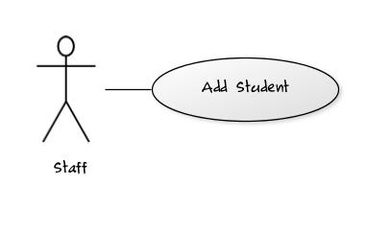Fig\_2.33.1 Add Student

##### Use Case Specification

|  |  |  |  |  |
| --- | --- | --- | --- | --- |
| **USE CASE – Add new Student** | | | | |
| **Use-case No.** | UC033 | **Use-case Version** | | 0.1 |
| **Use-case Name** | Add Student | | | |
| **Author** | TrucTM | | | |
| **Date** | 05/02/2012 | **Priority** | Normal | |
| **Actor:** Staff  **Summary:** This use case allows Staff adding Student into the system.  **Goal:** Adding more Student into system  **Triggers:** At “View Student” page, Staff click “Add new” link button.  **Preconditions:** Staff has login into system and go to the “View Student” page  **Post Conditions.**  Success: New Student will be added into DB  Fail: Report that system cannot add Student into system  **Main Success Scenario.**   |  |  |  | | --- | --- | --- | | Step | Actor Action | System Response | | 1 | At the “View Student”, Staffs click “Add new” link button | System will display the popup “Add new Student” | | 2 | Staffs enter information for new Student | System checks data [Exception 1] | | 3 | Staff click “Add new” button in the popup | - System inserts into DB [Exception 2]  - Message box reports that Staffs have added new Student and return to the “View Student” screen page. |   **Alternative Scenario.**   |  |  |  | | --- | --- | --- | | No. | Actor Action | System Response | | 1 | Staffs click “Cancel” button at “Add new Student” popup. | System will return to the “View Student” screen page. |   **Exceptions.**   |  |  |  | | --- | --- | --- | | No. | Actor Action | System Response | | 1 | Staffs left ‘Account” with text field blank | Message will display “You must fill the Account” | | 1 | Staffs left ‘Account” with length > 200 chars | Message will display “Account has exceeded character length.” | | 1 | Staffs left ‘Full Name” with text field blank | Message will display “You must fill the Full Name” | | 1 | Staffs left ‘DOB” with incorrect format | Message will display “You have enter incorrect Phone. Please following dd-mm-yyyy format” | | 1 | Staffs left ‘Email” with text field blank | Message will display “You must fill the Email” | | 1 | Staffs left ‘StudentIdentity” with text field blank | Message will display “You must fill the StudentIdentity” | | 1 | Staffs left ‘Phone” with incorrect format | Message will display “You have enter incorrect Phone. Please following 000-000-0000 format” | | 2 | Staffs click “Add new” button in the popup | - System checks this Student is exist in DB, message box “This Student name is exist, try another name” will be displayed.  - System checks the connection of web system with DB, if errors occur, message box “Cannot add new Student, please checking network.” will be displayed |   **Relationships.**  Login use case, view Student use case.  **Business Rules:**   |  |  |  | | --- | --- | --- | | **No** | **Rule Description** | **Error Message** | | 1 | Each Student has the unique Student name | “This Student name is exist, try another name” | | 2 | Student name have been exist and Staffs just fill Student name into the system. |  | | | | | |
| **Description:**  Student information provided more information for student. System provides “add Student” function to allow Staff can add new Student for student. Each Student has the unique Student name and Student name is required field. When Staffs want to add new Student, Staff must check the network connection and ensure that the same Student name hasn’t existed. This use case includes View Mode of Study, View Special, View Major for supporting more information for student | | | | |

**Screen**

**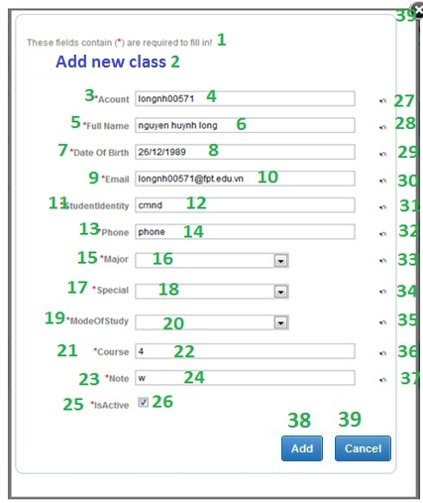**

Fig\_2.33.2 Add Student Screen

**Data Fields Definition – Add Student**

|  |  |  |  |  |  |  |
| --- | --- | --- | --- | --- | --- | --- |
| **Field name** | **Description** | **Read**  **Only** | **Mandatory** | **Control Type** | **Data Type** | **Length** |
| (1)Instruction | This field contains instructions for edit a student | N/A | N/A | Label | Text | Fixed |
| (2)Basic information | The following fields will be surrounded by a border to allow logical grouping of data for the student. The border will have a heading titled “Student Personal Information” | N/A | N/A | Label | Text | Fixed |
| (3)Account label | A label with contents “Account” | N/A | N/A | Label | Text | Fixed |
| (4)Account textfield | The account name of the student that to be edited. | N | Y | Text Box | Text | 50 |
| (5)Full Name label | A label with contents “Full Name” | N/A | N/A | Label | Text | Fixed |
| (6)Full Name textfield | The full name of the student that to be edited. | N | Y | Text Box | Text | 200 |
| (7)Date Of Birth label | A label with contents “Date Of Birth” | N/A | N/A | Label | Text | Fixed |
| (8)Date Of Birth textfield | The Date Of Birth of the student that to be edited. | N | Y | Text Box | Date | 50 |
| (9)Email label | A label with contents “Email” | N/A | N/A | Label | Text | Fixed |
| (10)Email textfield | The Email of the student that to be edited. | N | Y | Text Box | Text | 200 |
| (11)Student Identity label | A label with contents “Student Identity” | N/A | N/A | Label | Text | Fixed |
| (12)Student Identity textfield | The Student Identity of the student that to be edited. | N | Y | Text Box | Text | 200 |
| (13)Phone label | A label with content “Phone” | N/A | N/A | Label | Text | Fixed |
| (14)Phone textfield | The telephone of student that to be edited. | N | N | Text Box | Text | 50 |
| (15)Major label | A label with content “Major” | N/A | N/A | Label | Text | Fixed |
| (16)Major dropdown list | The Major of student that to be edited. | N | Y | Combo Box | Text |  |
| (17)Special label | A label with content “Special” | N/A | N/A | Label | Text | Fixed |
| (18)Special dropdown list | The Special of student that to be edited. | N | Y | Combo Box | Text |  |
| (19)Mode Of Study label | A label with content “Mode Of Study” | N/A | N/A | Label | Text | Fixed |
| (20)Mode Of Study dropdown list | The Mode Of Study of student that to be edited. | N | Y | Combo Box | Text |  |
| (21)Course label | A label with content “Course” | N/A | N/A | Label | Text | Fixed |
| (22)Course textfield | The Course of student that to be edited. | N | N | Text Box | Text | 50 |
| (23)Note label | A label with content “Note” | N/A | N/A | Label | Text | Fixed |
| (24)Note textfield | The Note of student that to be edited. | N | N | Text Box | Text | 200 |
| (25)Is Active label | A label with content “Is Active” | N/A | N/A | Label | Text | Fixed |
| (26)Is Active check box | The status of student that to be edited. | N | N | Check Box | Boolean |  |

**Buttons / Hyper Links – Add Student**

|  |  |  |  |  |
| --- | --- | --- | --- | --- |
| **Function** | **Description** | **Available Criteria** | **Validations** | **Outcome** |
| (38)Add new | This button allows Staffs add new Student | Always available | Validate all mandatory fields. | Insert Data into DB |
| Back | This button allows Staffs return to the “View Student” screen page | Always available | No | Close popup “Add new Student” and return to the “View Student” page. |

##### Sequence Diagram

#### <Staff> Edit Student

##### Use Case Diagram

Fig\_2.34.1 Edit Student

##### Use Case Specification

|  |  |  |  |  |
| --- | --- | --- | --- | --- |
| **USE CASE – Edit Student** | | | | |
| **Use-case No.** | UC034 | **Use-case Version** | | 0.1 |
| **Use-case Name** | Edit Student | | | |
| **Author** | TrucTM | | | |
| **Date** | 05/02/2012 | **Priority** | Normal | |
| **Actor:** Staff  **Summary:** This use case allows Staff edits Student has existed in DB.  **Goal:** Editing exist Student.  **Triggers:** In the Gridview information at “View Student” page, Staff click “Edit” link button. At least 1 Student is exist.  **Preconditions:** Staff has login into system and go to the “View Student” page.  **Post Conditions.**  Success: Student will be edited.  Fail: Report that system cannot edit Student.  **Main Success Scenario.**   |  |  |  | | --- | --- | --- | | Step | Actor Action | System Response | | 1 | In Gridview information at the “View Student”, Staffs click “Edit” link button | System will display the popup “Edit Student” | | 2 | Staffs edit information for this Student | System checks data [Exception 1] | | 3 | Staff click “Update” button in the popup | - System updates into DB [Exception 2]  - Message box reports that Staffs have edited Student and return to the “View Student” screen page. |   **Alternative Scenario.**   |  |  |  | | --- | --- | --- | | No. | Actor Action | System Response | | 1 | Staffs click “Cancel” button at “Edit Student” popup. | System will return to the “View Student” screen page. |   **Exceptions.**   |  |  |  | | --- | --- | --- | | No. | Actor Action | System Response | | 1 | Staffs left ‘Account” with text field blank | Message will display “You must fill the Account” | | 1 | Staffs left ‘Account” with length > 200 chars | Message will display “Account has exceeded character length.” | | 1 | Staffs left ‘Full Name” with text field blank | Message will display “You must fill the Full Name” | | 1 | Staffs left ‘Email” with text field blank | Message will display “You must fill the Email” | | 1 | Staffs left ‘StudentIdentity” with text field blank | Message will display “You must fill the StudentIdentity” | | 1 | Staffs left ‘Phone” with incorrect format | Message will display “You have enter incorrect Phone. Please following 000-000-0000 format” | | 2 | Staffs click “Update” button in the popup | - System checks this Student is exist in DB, message box “This Student name is exist, try another name” will be displayed.  - System checks the connection of web system with DB, if errors occur, message box “Cannot Update ModeOfStudy, please checking network.” will be displayed |   **Relationships.**  Login use case, view Student use case.  **Business Rules:**   |  |  |  | | --- | --- | --- | | **No** | **Rule Description** | **Error Message** | | 1 | Each Student has the unique Student name | “This Student name is exist, try another name” | | 2 | Student name have been exist and Staffs just fill Student name into the system. |  | | | | | |
| **Description:**  This use case allows Staff editing exist Student in system. When Staffs enter Student information, system will check validation of data and report when data is incorrect. After Staffs click “Update” button, system will update this Student and report. This use case can extend the edit Student use case. When Staffs change isActive property of this Student this can cause occur error of Student. | | | | |

**Screen**

**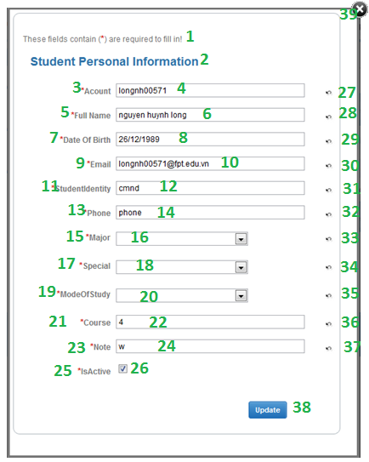**

Fig\_2.34.2 Edit Student Screen

**Data Fields Definition – Edit Student**

|  |  |  |  |  |  |  |
| --- | --- | --- | --- | --- | --- | --- |
| **Field name** | **Description** | **Read**  **Only** | **Mandatory** | **Control Type** | **Data Type** | **Length** |
| (1)Instruction | This field contains instructions for edit a student | N/A | N/A | Label | Text | Fixed |
| (2)Basic information | The following fields will be surrounded by a border to allow logical grouping of data for the student. The border will have a heading titled “Student Personal Information” | N/A | N/A | Label | Text | Fixed |
| (3)Account label | A label with contents “Account” | N/A | N/A | Label | Text | Fixed |
| (4)Account textfield | The account name of the student that to be edited. | N | Y | Text Box | Text | 50 |
| (5)Full Name label | A label with contents “Full Name” | N/A | N/A | Label | Text | Fixed |
| (6)Full Name textfield | The full name of the student that to be edited. | N | Y | Text Box | Text | 200 |
| (7)Date Of Birth label | A label with contents “Date Of Birth” | N/A | N/A | Label | Text | Fixed |
| (8)Date Of Birth textfield | The Date Of Birth of the student that to be edited. | N | Y | Text Box | Date | 50 |
| (9)Email label | A label with contents “Email” | N/A | N/A | Label | Text | Fixed |
| (10)Email textfield | The Email of the student that to be edited. | N | Y | Text Box | Text | 200 |
| (11)Student Identity label | A label with contents “Student Identity” | N/A | N/A | Label | Text | Fixed |
| (12)Student Identity textfield | The Student Identity of the student that to be edited. | N | Y | Text Box | Text | 200 |
| (13)Phone label | A label with content “Phone” | N/A | N/A | Label | Text | Fixed |
| (14)Phone textfield | The telephone of student that to be edited. | N | N | Text Box | Text | 50 |
| (15)Major label | A label with content “Major” | N/A | N/A | Label | Text | Fixed |
| (16)Major dropdown list | The Major of student that to be edited. | N | Y | Combo Box | Text |  |
| (17)Special label | A label with content “Special” | N/A | N/A | Label | Text | Fixed |
| (18)Special dropdown list | The Special of student that to be edited. | N | Y | Combo Box | Text |  |
| (19)Mode Of Study label | A label with content “Mode Of Study” | N/A | N/A | Label | Text | Fixed |
| (20)Mode Of Study dropdown list | The Mode Of Study of student that to be edited. | N | Y | Combo Box | Text |  |
| (21)Course label | A label with content “Course” | N/A | N/A | Label | Text | Fixed |
| (22)Course textfield | The Course of student that to be edited. | N | N | Text Box | Text | 50 |
| (23)Note label | A label with content “Note” | N/A | N/A | Label | Text | Fixed |
| (24)Note textfield | The Note of student that to be edited. | N | N | Text Box | Text | 200 |
| (25)Is Active label | A label with content “Is Active” | N/A | N/A | Label | Text | Fixed |
| (26)Is Active check box | The status of student that to be edited. | N | N | Check Box | Boolean |  |

**Buttons / Hyper Links – Edit Student**

|  |  |  |  |  |
| --- | --- | --- | --- | --- |
| **Function** | **Description** | **Available Criteria** | **Validations** | **Outcome** |
| Update | This button allows Staffs edit exist Student | Always available | Validate all mandatory fields. | Update Data into DB |
| Back | This button allows Staffs return to the “View Student” screen page | Always available | No | Close popup “Edit Student” and return to the “View Student” page. |

##### Sequence Diagram

#### <Staff> View Student

##### Use Case Diagram

Fig\_2.35.1 View Student

##### Use Case Specification

|  |  |  |  |  |
| --- | --- | --- | --- | --- |
| **USE CASE – View Student** | | | | |
| **Use-case No.** | UC035 | **Use-case Version** | | 0.1 |
| **Use-case Name** | Add Student | | | |
| **Author** | TrucTM | | | |
| **Date** | 05/02/2012 | **Priority** | Normal | |
| **Actor:** Staff  **Summary:** This use case allows Staff views list of Student  **Goal:** Display all Students.  **Triggers:** In any pages of system (Except “Home Page” page), Staff click “View Student” link in menu bar.  **Preconditions:** Staff has login into system.  **Post Conditions.**  Success: Display all Students  Fail: Report that errors have occurred.  **Main Success Scenario.**   |  |  |  | | --- | --- | --- | | Step | Actor Action | System Response | | 1 | In any page of system (except “Home Page” page), Staffs click “View Student” link in menu bar. | System will redirect to “View Student” page and show all Students [Exception 1] |   **Alternative Scenario.**   |  |  |  | | --- | --- | --- | | No. | Actor Action | System Response | | 1 | Staffs click “Add” link button at “View Student” page | System will display “Add new Student” popup | | 2 | Staff click “Edit” link button in gridview data at “View Student” page. | System will display “Edit Student” popup | | 3 | Staffs click any link in menu bar | System will redirect to link page. |   **Exceptions.**   |  |  |  | | --- | --- | --- | | No. | Actor Action | System Response | | 1 | Staffs click “View Student” link in menu bar | If errors occur, System will redirect to “View Student” and display “Cannot display information. Please check network connection” text |   **Relationships.**  Login use case.  **Business Rules:**   |  |  |  | | --- | --- | --- | | **No** | **Rule Description** | **Error Message** | | | | | |
| **Description:**  When Staffs want to view all Students of the system, they click “View Student” in the menu bar. System will redirect to the “View Student” and show all information about Students. Gridview will allow paging; each page will display 10 Students. When error occurs, system will display report text. | | | | |

**Screen**

Fig\_2.2.2

**Data Fields Definition – View Student**

|  |  |  |  |  |  |  |
| --- | --- | --- | --- | --- | --- | --- |
| **Field name** | **Description** | **Read**  **Only** | **Mandatory** | **Control Type** | **Data Type** | **Length** |
| Gridview | Gridview for display list of Student | - | - | Gridview | List | Fixed |

**Buttons / Hyper Links – View Student**

|  |  |  |  |  |
| --- | --- | --- | --- | --- |
| **Function** | **Description** | **Available Criteria** | **Validations** | **Outcome** |
| Update | This button uses to show “Edit Student” popup | Available | No | Show “Edit Student” popup |
| Add | This button uses to show “Add new Student” popup | Always available | No | Show “Add new Student” popup |

##### Sequence Diagram

#### <System> Grading

##### Use Case Diagram

Fig\_2.4.1 View Student

##### Use Case Specification

|  |  |  |  |  |
| --- | --- | --- | --- | --- |
| **USE CASE – View Student** | | | | |
| **Use-case No.** | UC036 | **Use-case Version** | | 0.1 |
| **Use-case Name** | Add Student | | | |
| **Author** | TrucTM | | | |
| **Date** | 05/02/2012 | **Priority** | Normal | |
| **Actor:** Staff  **Summary:** This use case allows automatic calculating Score for Student  **Goal:** Calculate score for Student base on Student Score data and update to Student DB  **Triggers:** This use case is executed intermediate with Add Student Score  **Preconditions:** Staff has inserted data for Student Score  **Post Conditions.**  Success: update Score to Student DB  Fail: Report that cannot calculate score for student  **Main Success Scenario.**   |  |  |  | | --- | --- | --- | | Step | Actor Action | System Response | | 1 | Student click “Add new” button in “Add new Class” page or “Edit” button in “Edit Class” page | System will calculate Score [Exception 1] and call update Student function [Exception 1] |   **Alternative Scenario.**   |  |  |  | | --- | --- | --- | | No. | Actor Action | System Response |   **Exceptions.**   |  |  |  | | --- | --- | --- | | No. | Actor Action | System Response | | 1 | Student click “Add new” button in “Add new Class” page or “Edit” button in “Edit Class” page | System will display message “Cannot calculate Score. Please checking your input data or network connection” |   **Relationships.**  Add new Student Score, Edit new Student Score  **Business Rules:**   |  |  | | --- | --- | | No. | **Rule Description** | | 1 | If status of Student Score is “pass”, system will add to score and credit. If status of Student is “failure”, System will add to failure credit | | 2 | If Status of Student Score is retake or repeat, system will add score, credit and subtract to failure Score. | | 3 | Average Score = (Total (Average Score by Subject)\*Credit)/(Total Credit) | | | | | |
| **Description:**  When editing or adding student score, system will calculate score based on data input. After getting information from Subject data, Student Data… system will base on business rules for calculating score. If System calculates success, system will call update Student function to update Student information include: Total Score, Credit,… Otherwise, system will report staff that cannot calculate Score, Please checking input data or network connection. | | | | |

**Screen** N/A

**Data Fields Definition – Grading**

N/A

**Buttons / Hyper Links – Grading**

N/A

##### Sequence Diagram

Fig\_2.36.3 Sequence diagram Grading

#### <Student> View Private Information

##### Use Case Diagram

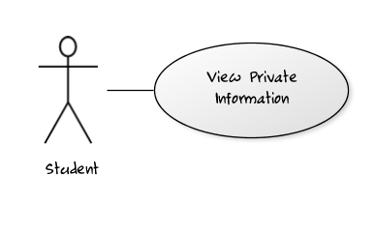

Fig\_2.37.1 View Private Information

##### Use Case Specification

|  |  |  |  |  |
| --- | --- | --- | --- | --- |
| **USE CASE – Edit Student’s Personal Information SPECIFICATION** | | | | |
| **Use-case No.** | UC001 | **Use-case Version** | | 0.1 |
| **Use-case Name** | View Private Information | | | |
| **Author** | TuanNA | | | |
| **Date** | 05/02/2012 | **Priority** | Normal | |
| **Actor:**  User: Student  **Summary:**  This use case allows student to view their personal information in this system.  **Goal:**  Allows student to view their personal information in this system.  **Triggers**  Access web system  **Preconditions:**  User logged into the system successfully.  **Post Conditions:**  N/A  **Main Success Scenario:**   |  |  |  | | --- | --- | --- | | Step | Actor Action | System Response | | 1 | On “Home Page” page student clicks to “Their name” hyperlink button on the welcome bar. | System redirects to “Student Information ” page |   **Alternative Scenario:**   |  |  |  | | --- | --- | --- | | No. | Actor Action | System Response | | 1 | On “Home Page” page student clicks to “Their name” hyperlink button on the welcome bar. | System redirects to “Student Information” page. | | 2 | Clicks to “Edit” button | Redirect to “Update Student” page. |   **Alternative Scenario:**   |  |  |  | | --- | --- | --- | | No. | Actor Action | System Response | | 1 | On “Home Page” page student clicks to “Their name” hyperlink button on the welcome bar. | System redirects to “Student Information” page. | | 2 | Clicks to “Close” button | Redirect to Home page. |   **Exceptions:**  N/A  **Relationships:**  Log in use case , Edit Student’s Information by Student  **Business Rules:**  N/A | | | | |
| **Description:**  This use case allows student to view their private information. | | | | |

**Screen**

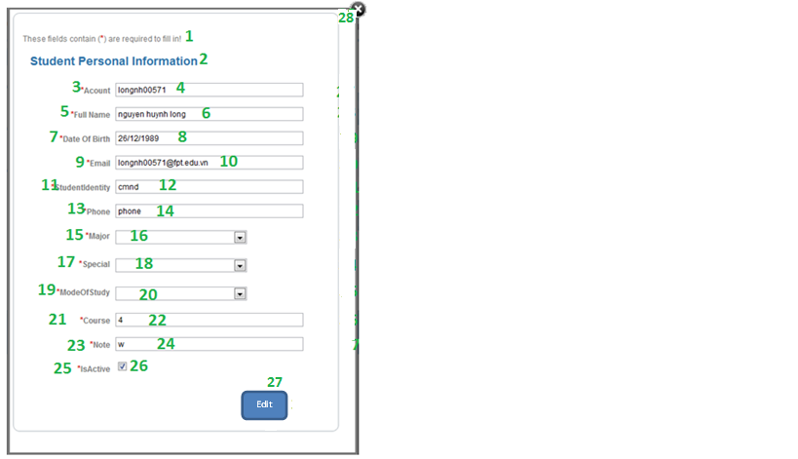

**Data Fields Definition – Attach Place Page**

|  |  |  |  |  |  |  |
| --- | --- | --- | --- | --- | --- | --- |
| **Field name** | **Description** | **Read**  **Only** | **Mandatory** | **Control Type** | **Data Type** | **Length** |
| (1)Instruction | This field contains instructions for edit a student | N/A | N/A | Label | Text | Fixed |
| (2)Basic information | The following fields will be surrounded by a border to allow logical grouping of data for the student. The border will have a heading titled “Student Personal Information” | N/A | N/A | Label | Text | Fixed |
| (3)Account label | A label with contents “Account” | N/A | N/A | Label | Text | Fixed |
| (4)Account text field | The account name of the student that to be edited. | Y | Y | Text Box | Text | 50 |
| (5)Full Name label | A label with contents “Full Name” | N/A | N/A | Label | Text | Fixed |
| (6)Full Name text field | The full name of the student that to be edited. | Y | Y | Text Box | Text | 200 |
| (7)Date Of Birth label | A label with contents “Date Of Birth” | N/A | N/A | Label | Text | Fixed |
| (8)Date Of Birth text field | The Date Of Birth of the student that to be edited. | Y | Y | Text Box | Date | 50 |
| (9)Email label | A label with contents “Email” | N/A | N/A | Label | Text | Fixed |
| (10)Email text field | The Email of the student that to be edited. | Y | Y | Text Box | Text | 200 |
| (11)Student Identity label | A label with contents “Student Identity” | N/A | N/A | Label | Text | Fixed |
| (12)Student Identity text field | The Student Identity of the student that to be edited. | Y | Y | Text Box | Text | 200 |
| (13)Phone label | A label with content “Phone” | N/A | N/A | Label | Text | Fixed |
| (14)Phone text field | The telephone of student that to be edited. | Y | N | Text Box | Text | 50 |
| (15)Major label | A label with content “Major” | N/A | N/A | Label | Text | Fixed |
| (16)Major dropdown list | The Major of student that to be edited. | Y | Y | Combo Box | Text |  |
| (17)Special label | A label with content “Special” | N/A | N/A | Label | Text | Fixed |
| (18)Special dropdown list | The Special of student that to be edited. | Y | Y | Combo Box | Text |  |
| (19)Mode Of Study label | A label with content “Mode Of Study” | N/A | N/A | Label | Text | Fixed |
| (20)Mode Of Study dropdown list | The Mode Of Study of student that to be edited. | Y | Y | Combo Box | Text |  |
| (21)Course label | A label with content “Course” | N/A | N/A | Label | Text | Fixed |
| (22)Course text field | The Course of student that to be edited. | Y | N | Text Box | Text | 50 |
| (23)Note label | A label with content “Note” | N/A | N/A | Label | Text | Fixed |
| (24)Note text field | The Note of student that to be edited. | Y | N | Text Box | Text | 200 |
| (25)Is Active label | A label with content “Is Active” | N/A | N/A | Label | Text | Fixed |
| (26)Is Active check box | The status of student that to be edited. | Y | N | Check Box | Boolean |  |

**Buttons / Hyper Links – Edit Student Information**

|  |  |  |  |  |
| --- | --- | --- | --- | --- |
| **Function** | **Description** | **Available Criteria** | **Validations** | **Outcome** |
| (27)Edit button | The button will allow the user to move to “Update Student” page. | Always available | No | Student gets redirected to the “Update Student” page for updating new information. |
| (28)Close image button | The button will allow the user to cancel editing | Always available | No | Student will be redirected back to the previous page |

##### Sequence Diagram

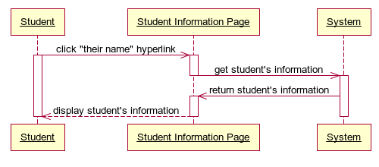

Fig\_2.37.3 Sequence Diagram View Private Information

#### <Student> Edit Student’s Information

##### Use Case Diagram

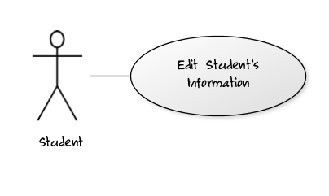

Fig\_2.38.1 Edit Student’s Information

##### Use Case Specification

|  |  |  |  |  |
| --- | --- | --- | --- | --- |
| **USE CASE – Edit Student’s Personal Information SPECIFICATION** | | | | |
| **Use-case No.** | UC002 | **Use-case Version** | | 0.1 |
| **Use-case Name** | Edit Student’s Information by Student | | | |
| **Author** | TuanNA | | | |
| **Date** | 05/02/2012 | **Priority** | Normal | |
| **Actor:**  User: Student  **Summary:**  This use case allows student to edit their personal information in this system whenever they need to update their newest personal information.  **Goal:**  Allows student to update their personal information.  **Triggers**  Access web system  **Preconditions:**  User logged into the system successfully.  **Post Conditions:**  Success: New information of student is updated and redirect back to the previous page with the alert message “Information was updated successfully!”  Fail: New information of student is updated and redirect back to the previous page with the alert message “Update information fail!”  **Main Success Scenario:**   |  |  |  | | --- | --- | --- | | Step | Actor Action | System Response | | 1 | On “Student Information” page student clicks to “Edit” button | System redirects to “Update Student” page to edit student’s information. | | 2 | Student modifies their information that allows. |  | | 4 | Student clicks to “Update” button | - System checks information input [Exception1] - System updates new information of student into database, then displays a successful message and redirect to “Student Information” page with new information |   **Alternative Scenario:**   |  |  |  | | --- | --- | --- | | No. | Actor Action | System Response | | 1 | On “Student Information” page student clicks to “Edit” button | System redirects to “Update Student” page to edit student’s information. | | 3 | Student modifies their information that allows. |  | | 4 | Clicks to “Close” button | Redirect to “Student Information” page, all information won’t change. |   **Exceptions:**   |  |  |  | | --- | --- | --- | | No | Actor Action | System Response | | 1 | Actor lefts ‘Full Name’ text field blank | System Display: ‘Please input Full Name’ | | 2 | Actor lefts ‘Date Of Birth’ text field blank | System Display: ‘Please input Date Of Birth’ | | 3 | Actor lefts ‘Email’ text field blank | System Display: ‘Please input Email’ | | 5 | Actor does not input ‘Date Of Birth text field in Number format. | System Display: ‘Format of Date Of Birth is wrong, input dd/MM/yyyy ’ | | 6 | Actor does not input ‘Email’ text field in email address format. | System Display: ‘Format of Email is wrong, the format is ….@fpt.edu.vn’ | | 7 | Actor does not input ‘Phone’ text field in Number format. | System Display: ‘Phone require number format’ |   **Relationships:**  Log in use case , View Private Information by Student  **Business Rules:**  N/A | | | | |
| **Description:**  This use case helps students manage and update newest personal information.  To edit student information, student needs to go to “Student Information” page first. After that, click to “Edit” button of the student that needs to be updated and the system will redirect student to “Update Student” page. At “Update Student” page, click to “Update” button to save all changes or click to “Close” button to go back to “Student Information” page. | | | | |

Screen

****

**Data Fields Definition – Attach Place Page**

|  |  |  |  |  |  |  |
| --- | --- | --- | --- | --- | --- | --- |
| **Field name** | **Description** | **Read**  **Only** | **Mandatory** | **Control Type** | **Data Type** | **Length** |
| (1)Instruction | This field contains instructions for edit a student | N/A | N/A | Label | Text | Fixed |
| (2)Basic information | The following fields will be surrounded by a border to allow logical grouping of data for the student. The border will have a heading titled “Student Personal Information” | N/A | N/A | Label | Text | Fixed |
| (3)Account label | A label with contents “Account” | N/A | N/A | Label | Text | Fixed |
| (4)Account text field | The account name of the student that to be edited. | Y | Y | Text Box | Text | 50 |
| (5)Full Name label | A label with contents “Full Name” | N/A | N/A | Label | Text | Fixed |
| (6)Full Name text field | The full name of the student that to be edited. | N | Y | Text Box | Text | 200 |
| (7)Date Of Birth label | A label with contents “Date Of Birth” | N/A | N/A | Label | Text | Fixed |
| (8)Date Of Birth text field | The Date Of Birth of the student that to be edited. | N | Y | Text Box | Date | 50 |
| (9)Email label | A label with contents “Email” | N/A | N/A | Label | Text | Fixed |
| (10)Email text field | The Email of the student that to be edited. | N | Y | Text Box | Text | 200 |
| (11)Student Identity label | A label with contents “Student Identity” | N/A | N/A | Label | Text | Fixed |
| (12)Student Identity text field | The Student Identity of the student that to be edited. | Y | Y | Text Box | Text | 200 |
| (13)Phone label | A label with content “Phone” | N/A | N/A | Label | Text | Fixed |
| (14)Phone text field | The telephone of student that to be edited. | N | N | Text Box | Text | 50 |
| (15)Major label | A label with content “Major” | N/A | N/A | Label | Text | Fixed |
| (16)Major dropdown list | The Major of student that to be edited. | Y | Y | Combo Box | Text |  |
| (17)Special label | A label with content “Special” | N/A | N/A | Label | Text | Fixed |
| (18)Special dropdown list | The Special of student that to be edited. | Y | Y | Combo Box | Text |  |
| (19)Mode Of Study label | A label with content “Mode Of Study” | N/A | N/A | Label | Text | Fixed |
| (20)Mode Of Study dropdown list | The Mode Of Study of student that to be edited. | Y | Y | Combo Box | Text |  |
| (21)Course label | A label with content “Course” | N/A | N/A | Label | Text | Fixed |
| (22)Course text field | The Course of student that to be edited. | Y | N | Text Box | Text | 50 |
| (23)Note label | A label with content “Note” | N/A | N/A | Label | Text | Fixed |
| (24)Note text field | The Note of student that to be edited. | Y | N | Text Box | Text | 200 |
| (25)Is Active label | A label with content “Is Active” | N/A | N/A | Label | Text | Fixed |
| (26)Is Active check box | The status of student that to be edited. | Y | N | Check Box | Boolean |  |

**Buttons / Hyper Links – Edit Student Information**

|  |  |  |  |  |
| --- | --- | --- | --- | --- |
| **Function** | **Description** | **Available Criteria** | **Validations** | **Outcome** |
| (38)Update button | The button will allow student to save the student information | Always available | Validate all mandatory fields and the format of Date Of Birth, Email and Phone. | New information is saved to database. Student gets redirected back to the previous page with a successful message. |
| (39)Close image button | The button will allow the user to cancel editing | Always available | No | student will be redirected back to the previous page |
| (27)-(37)Image buttons Undo edited fields | These buttons will allow students to get back the original information of each fields before they have updated | Always available | No | The original information of the text fields will be inserted into the text fields |

##### Sequence Diagram

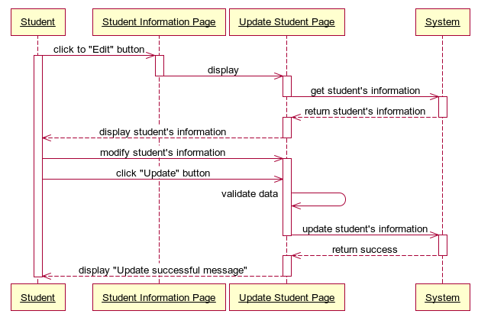

Fig\_2.38.3 Sequence Diagram Edit Student’s Information

#### <Student> Auto Suggest Semester

##### Use Case Diagram

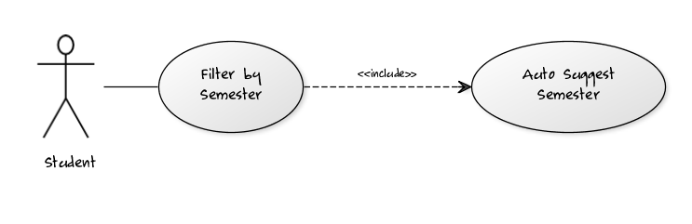

Fig\_2.39.1 Auto Suggest Semester

##### Use Case Specification

|  |  |  |  |  |
| --- | --- | --- | --- | --- |
| **USE CASE- Auto Suggest Semester SPECIFICATION** | | | | |
| **Use-case No.** | UC003 | **Use-case Version** | | 0.1 |
| **Use-case Name** | Auto Suggest Semester | | | |
| **Author** | TuanNA | | | |
| **Date** | 08/02/2012 | **Priority** | Normal | |
| **Actor:** Student  **Summary:** This use case supports students to choose the right semester in system by the auto suggest list of semesters whenever students types more than 2 characters in the text box Semester Filter.  **Goal:** This use case helps students does easily in selecting the right semester they want to use for filtering list of student’s subjects base on that semester.  **Triggers:** Click to “Semester Filter” textbox in “Student Report” page and type at least two characters.  **Preconditions:** Logged into the system successfully as student role and open “Student Report” page.  **Post Conditions:**  Success: List of semesters in the system will be showed in the list box appears right below the textbox Semester Filter for student to select.  Fail: The list box “No Result” appears right below the textbox Semester Filter.  **Main Success Scenario:**   |  |  |  | | --- | --- | --- | | Step | Actor Action | System Response | | 1 | On “Student Report” page, student clicks to “Semester Filter” textbox and types at least two characters. | Search the system and return 3 first semester results, which contains the characters student has typed, in the list box appears right below “Semester Filter” textbox. | | 2 | Student clicks to “Load More” hyperlink button at the end of the list result. | Search the system and return 3 next semester results, which contains the characters student has typed, in the list box appears right below “Semester Filter” textbox. | | 2 | Student selects the right semester that they want | Save information of the selected semester into memory to use for filtering student’s subjects later. |   **Alternative Scenario :**   |  |  |  | | --- | --- | --- | | Step | Actor Action | System Response | | 1 | On “Student Report” page, student clicks to “See All” hyperlink next to “Semester Filter” textbox. | Search the system and return 3 first semester results in the list box appears right below “Semester Filter” textbox. | | 2 | Student clicks to “Load More” hyperlink button at the end of the list result. | Search the system and return 3 next semester results in the list box appears right below “Semester Filter” textbox. | | 3 | Student selects the right semester that they want. | Save information of the selected semester into memory to use for filtering student’s subjects later. |   **Exceptions:** N/A  **Relationships:** Log in use case, Filter By Semester use case.  **Business Rules:** N/A | | | | |
| **Description:**  This use case is used to support student does easily in selecting the right semester for filtering list of student’s subjects in order to view student’s grade statistic report final student grade. Because of the University have a lot of semesters, student will hard to remember all of them. This function is the guide for him/her to select the right semester he/she wants by suggesting list of semesters for student to choose. It’s quick and save time.  Students only need to click to “Semester Filter” textbox and type at least two characters, the system will search and return 3 first semesters, which have a name contains these characters, in the list box result right below the “Semester Filter” textbox. If in 3 first results don’t include the semester student needs, he/she can view 3 next results by clicking “Load More” hyperlink button in the end of the list box result and the system will return the 3 next semester results for student. The finally action is just simply select the right semester in the list box result and system will save this semester information into memory for filtering student’s subjects later. | | | | |

**Screen**

**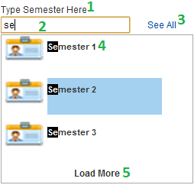**

**Data Fields Definition – Auto Suggest Semester**

|  |  |  |  |  |  |  |
| --- | --- | --- | --- | --- | --- | --- |
| **Field name** | **Description** | **Read**  **Only** | **Mandatory** | **Control Type** | **Data Type** | **Length** |
| (1) Semester label | A label contents “Type Semester Here” | N/A | N/A | Label | Text | Fixed |
| (2)Semester text field | The textbox for student to type name of semester he/she wants to choose. | N | N | Textbox | Text | 200 |
| (4) Semester Result label | A label contents the semester name result of suggesting. | N/A | N/A | Label | Text | Fixed |

**Buttons / Hyper Links – Auto Suggest Semester**

|  |  |  |  |  |
| --- | --- | --- | --- | --- |
| **Function** | **Description** | **Available Criteria** | **Validations** | **Outcome** |
| (3) See All Hyperlink Button | The button will allows the system to search all of the semesters and return into List Box result | Always available | No | The semester results will be loaded and display into the List Box Semester Result for student to choose. |
| (5) Load More Hyperlink Button | The button will allow the system to load next three semester results into List Box result. | Only available when the result of semester in return list is more than 3. | No | The next 3 semester results will be loaded and display into the List Box Semester Result for student to choose. |

##### Sequence Diagram

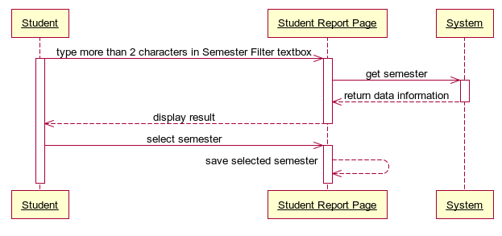 Fig\_2.39.3 Sequence Diagram Auto Suggest Semester

#### <Student> Filter by Semester

##### Use Case Diagram



Fig\_2.40.1 Filter by Semester

##### Use Case Specification

|  |  |  |  |  |
| --- | --- | --- | --- | --- |
| **USE CASE- Filter by Semester SPECIFICATION** | | | | |
| **Use-case No.** | UC004 | **Use-case Version** | | 0.1 |
| **Use-case Name** | Filter by Semester | | | |
| **Author** | TuanNA | | | |
| **Date** | 08/02/2012 | **Priority** | Normal | |
| **Actor:** Student  **Summary:** This use case allows student to filter semester for viewing their grades and subjects, which has been studied in that semester; he/she needs to see grade statistic and export reports later.  **Goal:** Display all students’ subjects with grade statistic which have been studied in the semester appropriate with the filter condition.  **Triggers:** Click to “Search” button in Student Report page.  **Preconditions:** Logged into the system successfully as student’s role and open “Student Report” page.  **Post Conditions:**  Success: List of student’s subjects and grade statistic in the system appropriate with the semester filter condition will be showed in the table student result in the right screen.  Fail: The table student result appears “No Result” text.  **Main Success Scenario:**   |  |  |  | | --- | --- | --- | | Step | Actor Action | System Response | | 1 | On “Student Report” page, student clicks to “Semester Filter” textbox and use “Auto Suggest Semester” function of the system to select the right semester name he/she wants to use for filtering list of student’s subjects. | Save information of the selected Semester into memory | | 2 | Student clicks to “Search” button. | Search through the system to get all students’ subjects which have been studied in the semester appropriate with the semester filter condition and display all these information results in the subject’s table. |   **Alternative Scenario 1:**   |  |  |  | | --- | --- | --- | | Step | Actor Action | System Response | | 1 | On “Student Report” page, student clicks to “Semester Filter” textbox and use “Auto Suggest Semester” function of the system to select the right semester name he/she wants to use for filtering list of student’s subjects. | Save information of the selected Semester into memory | | 2 | Student clicks to “Search” button. | Search through the system to get all student’s subjects which have been studied in the semester appropriate with the semester filter condition and display all student’s subjects results in the subject’s table. |   **Exceptions:** N/A  **Relationships:** Log in use case, Auto Suggest Semester use case.  **Business Rules:** N/A | | | | |
| **Description:**  This use case is the support operation for helping student to easily view the subjects’ status, statistic, and grade of a student which have been studied by this student in the filtered semester and show information in the table. Which this list of student’s subjects, student can easily have an overview about the studying status and grades by each semester or by the whole course of that student. Student also can export final grade reports and send email later for student.  Student only needs to type the semester name in “Semester Filter” textbox and click “Search” button, the whole student’s subjects list result will be showed in the subject’s table. | | | | |

**Screen**

**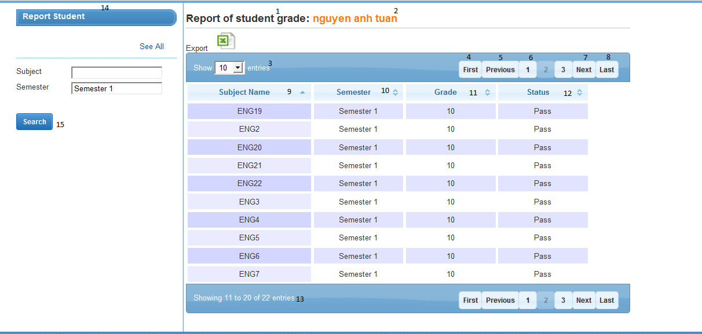Data Fields Definition – Filter by Semester**

|  |  |  |  |  |  |  |
| --- | --- | --- | --- | --- | --- | --- |
| **Field name** | **Description** | **Read**  **Only** | **Mandatory** | **Control Type** | **Data Type** | **Length** |
| (14)Filter Title label | A label which contains “Report Student” | N/A | N/A | Label | Text | Fixed |
| (15)Semester label | A label with contents “ Semester” | N/A | N/A | Label | Text | Fixed |
| (16)Semester text field | The Semester Name that student wants to select. | N | N | Textbox | Text | 200 |
| (1)Report title label | A label with contents “Report of student grade” | N/A | N/A | Label | Text | Fixed |
| (2)Student Name label | A label which contents the name of student | N/A | N/A | Label | Text | Fixed |
| (3)Number of results combo box | A combo box contains the numbers such as: 10, 25, 50, 100 options for student to select the number of rows display in table result. | N/A | N/A | Dropdown List | Integer | Fixed |
| (9)Subject Name label | A label contains “Subject Name” which is the title of column Subject Name in subjects table. | N/A | N/A | Label | Text | Fixed |
| (10) Semester label | A label contains “Semester” which is the title of column Semester in subjects table. | N/A | N/A | Label | Text | Fixed |
| (11) Grade label | A label contains “Grade” which is the title of column Grade in subjects table. | N/A | N/A | Label | Text | Fixed |
| (12) Status label | A label contains “Status” which is the title of column Status in subjects table. | N/A | N/A | Label | Text | Fixed |
| (13)Number of result label | A label contains “Showing ‘a number’ to ‘a number’ of ‘total number entries’ result” which show the total results in subjects table | N/A | N/A | Label | Text | Fixed |

**Buttons / Hyper Links – Filter By Semester**

|  |  |  |  |  |
| --- | --- | --- | --- | --- |
| **Function** | **Description** | **Available Criteria** | **Validations** | **Outcome** |
| (17)Search button which the filter condition | The button will allow students to get all students’ subjects they need which the selected semester. | Always available | No validation | Get list subjects within the filter semester condition |
| (4)First button | Allow students to navigate to the first page of the return list subjects in the table. | Only available if the return list subjects has data. | No validation | Go back to the first page of table list subjects. |
| (5)Previous button | Allow students to navigate to the previous page of the return list subjects in the table. | Only available if the return list students has data. | No validation | Go back to the previous page of table list subjects. |
| (7)Next button | Allow student to navigate to the next page of the return list subjects in the table. | Only available if the return list subjects has data. | No validation | Go to the next page of table list of subjects. |
| (8)Last button | Allow student to navigate to the last page of the return list subjects in the table. | Only available if the return list subjects has data. | No validation | Go to the last page of table list subjects. |
| (6)Number button | Allow student to navigate to the “number of the button” page of the return list subject in the table. | Only available if the return list subjects has data. | No validation | Go to “number of the button” page of table list subjects. |

##### Sequence Diagram

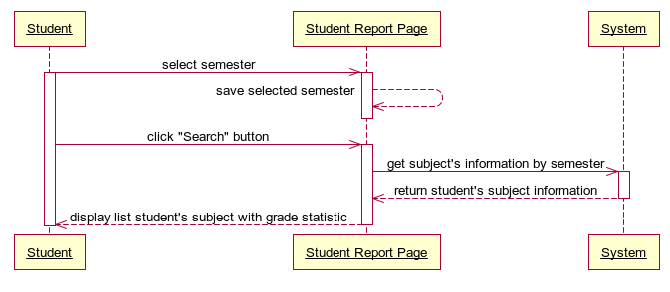

Fig\_2.40.3 Sequence Diagram Filter by Semester

#### <Student> Auto Suggest Subject

##### Use Case Diagram

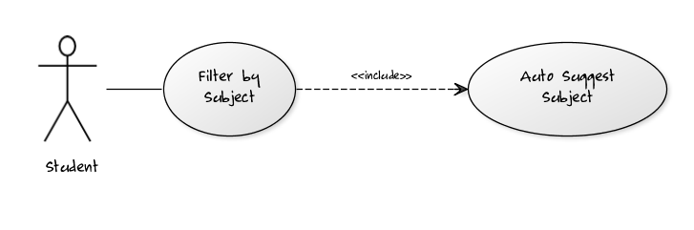

Fig\_2.41.1 Auto Suggest Subject

##### Use Case Specification

|  |  |  |  |  |
| --- | --- | --- | --- | --- |
| **USE CASE- Auto Suggest Subject SPECIFICATION** | | | | |
| **Use-case No.** | UC005 | **Use-case Version** | | 0.1 |
| **Use-case Name** | Auto Suggest Subject | | | |
| **Author** | TuanNA | | | |
| **Date** | 08/02/2012 | **Priority** | Normal | |
| **Actor:** Student  **Summary:** This use case supports student to choose the right subject in system by the auto suggest list of subjects whenever student types more than 2 characters in the text box Subject Filter.  **Goal:** This use case helps students does easily in selecting the right subject they want to use for filtering list of students’ base on that subject.  **Triggers:** Click to “Subject Filter” textbox in “Students Report” page and type at least two characters.  **Preconditions:** Logged into the system successfully as student role and open “Student Report” page.  **Post Conditions:**  Success: List of subjects in the system will be showed in the list box appears right below the textbox Subject Filter for student to select.  Fail: The list box “No Result” appears right below the textbox Subject Filter.  **Main Success Scenario:**   |  |  |  | | --- | --- | --- | | Step | Actor Action | System Response | | 1 | On “Students Report” page, student clicks to “Subject Filter” textbox and types at least two characters. | Search the system and return 3 first subject results, which contains the characters student has typed, in the list box appears right below “Subject Filter” textbox. | | 2 | Student clicks to “Load More” hyperlink button at the end of the list result. | Search the system and return 3 next subject results, which contains the characters student has typed, in the list box appears right below “Subject Filter” textbox. | | 2 | Student selects the right subject that he/she wants. | Save information of the selected subject into memory to use for filtering students later. |   **Alternative Scenario 1:**   |  |  |  | | --- | --- | --- | | Step | Actor Action | System Response | | 1 | On “Students Report” page, student clicks to “Subject Filter” textbox and types at least two characters. | Search the system and return 3 first subject results, which contains the characters student has typed, in the list box appears right below “Subject Filter” textbox. | | 2 | Student clicks to “Load More” hyperlink button at the end of the list result. | Search the system and return 3 next subject results, which contains the characters student has typed, in the list box appears right below “Subject Filter” textbox. | | 3 | Student selects the right subject that he/she wants. | Save information of the selected subject into memory to use for filtering students later. |   **Alternative Scenario 2:**   |  |  |  | | --- | --- | --- | | Step | Actor Action | System Response | | 1 | On “Students Report” page, student clicks to “See All” hyperlink next to “Subject Filter” textbox. | Search the system and return 3 first subject results in the list box appears right below “Subject Filter” textbox. | | 2 | Student clicks to “Load More” hyperlink button at the end of the list result. | Search the system and return 3 next subject results in the list box appears right below “Subject Filter” textbox. | | 3 | Student selects the right subject that he/she wants. | Save information of the selected subject into memory to use for filtering students later. |   **Exceptions:** N/A  **Relationships:** Log in use case, Filter By Subject use case.  **Business Rules:** N/A | | | | |
| **Description:**  This use case is used to support student does easily in selecting the right subject for filtering list of students in order to report final student grade. Because of the University have a lot of subjects, students will hard to remember all of them. This function is the guide for him/her to select the right subject he/she wants by suggesting list of subject for student to choose. It’s quick and save time.  Student only need to click to “Subject Filter” textbox and type at least two characters, the system will search and return 3 first subjects, which have a name contains these characters, in the list box result right below the “Subject Filter” textbox. If in 3 first results don’t include the subject student needs, he/she can view 3 next results by clicking “Load More” hyperlink button in the end of the list box result and the system will return the 3 next subject results for student. The finally action is just simply select the right subject in the list box result and system will save this subject information into memory for filtering students later. | | | | |

**Screen**

**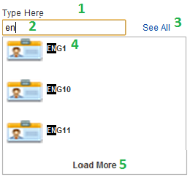**

**Data Fields Definition – Auto Suggest Subject**

|  |  |  |  |  |  |  |
| --- | --- | --- | --- | --- | --- | --- |
| **Field name** | **Description** | **Read**  **Only** | **Mandatory** | **Control Type** | **Data Type** | **Length** |
| (1) Subject label | A label contents “Type Subject Here” | N/A | N/A | Label | Text | Fixed |
| (2) Subject text field | The textbox for student to type name of subject he/she wants to choose. | N | N | Textbox | Text | 200 |
| (4) Subject Result label | A label contents the subject name result of suggesting. | N/A | N/A | Label | Text | Fixed |

**Buttons / Hyper Links – Auto Suggest Subject**

|  |  |  |  |  |
| --- | --- | --- | --- | --- |
| **Function** | **Description** | **Available Criteria** | **Validations** | **Outcome** |
| (3) See All Hyperlink Button | The button will allows the system to search all of the subjects and return into List Box result | Always available | No | The subject results will be loaded and display into the List Box Subject Result for student to choose. |
| (5) Load More Hyperlink Button | The button will allow the system to load next three subject results into List Box result. | Only available when the result of subject in return list is more than 3. | No | The next 3 subject results will be loaded and display into the List Box Subject Result for student to choose. |

##### Sequence Diagram

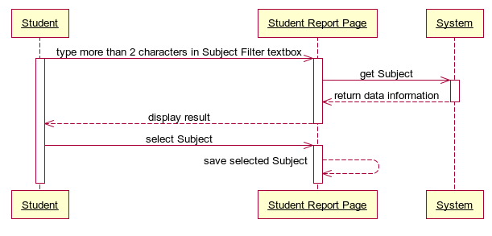

Fig\_2.41.3 Sequence Diagram Auto Suggest Subject

#### <Student> Filter by Subject

##### Use Case Diagram



Fig\_2.42.1 Filter by Subject

##### Use Case Specification

|  |  |  |  |  |
| --- | --- | --- | --- | --- |
| **USE CASE- Filter by Subject SPECIFICATION** | | | | |
| **Use-case No.** | UC004 | **Use-case Version** | | 0.1 |
| **Use-case Name** | Filter by Subject | | | |
| **Author** | TuanNA | | | |
| **Date** | 08/02/2012 | **Priority** | Normal | |
| **Actor:** Student  **Summary:** This use case allows student to filter subject for viewing specific subjects with grade statistic, he/she needs to see grade statistic and export reports later.  **Goal:** Display grade statistic for subject that is filtered.  **Triggers:**  Click to “Search” button in List Students Report page.  **Preconditions:** Logged into the system successfully as student’s role and open “List Students Report” page.  **Post Conditions:**  Success: List grade statistic of this subject which is filtered in the system appropriate with the subject filter condition will be showed in the table student result in the right screen.  Fail: The table student result appears “No Result” text.  **Main Success Scenario:**   |  |  |  | | --- | --- | --- | | Step | Actor Action | System Response | | 1 | On “List Students Report” page, student clicks to “Subject Filter” textbox and use “Auto Suggest Subject” function of the system to select the right Subject name he/she wants to use for filtering list of Students. | Save information of the selected Subject into memory. | | 2 | Student clicks to “Search” button. | Display the grade statistic with subject filter |   **Alternative Scenario 1:**   |  |  |  | | --- | --- | --- | | Step | Actor Action | System Response | | 1 | On “List Students Report” page, student clicks to “Subject Filter” textbox and types exactly the name of Subject that he/she wants to use for filtering list of Students. | Save information of the selected Subject into memory. | | 2 | Student clicks to “Search” button. | Display the grade statistic with subject filter. |   **Exceptions:** N/A  **Relationships:** Log in use case, Auto Suggest Subject use case.  **Business Rules:** N/A | | | | |
| **Description:**  This use case is the main operation for helping student to easily select object with grade statistic which they want to see.  Student only needs to type the Subject name in “Subject Filter” textbox and click “Search” button, the whole result will be showed in the table. | | | | |

**Screen**

**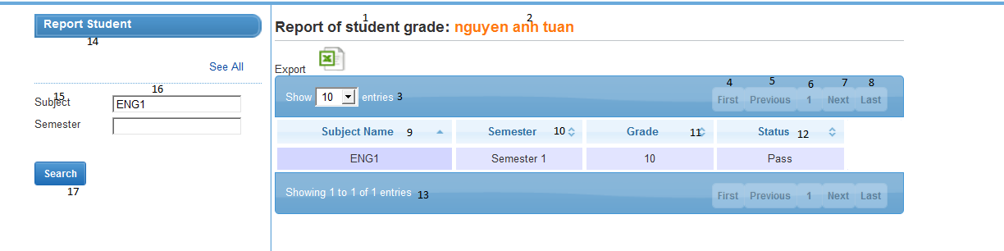**

**Data Fields Definition – Filter by Semester**

|  |  |  |  |  |  |  |
| --- | --- | --- | --- | --- | --- | --- |
| **Field name** | **Description** | **Read**  **Only** | **Mandatory** | **Control Type** | **Data Type** | **Length** |
| (14)Filter Title label | A label which contains “Report Student” | N/A | N/A | Label | Text | Fixed |
| (15)Subject label | A label with contents “ Subject” | N/A | N/A | Label | Text | Fixed |
| (16)Subject text field | The Subject Name that student wants to select. | N | N | Textbox | Text | 200 |
| (1)Report title label | A label with contents “Report of student grade” | N/A | N/A | Label | Text | Fixed |
| (2)Student Name label | A label which contents the name of student | N/A | N/A | Label | Text | Fixed |
| (3)Number of results combo box | A combo box contains the numbers such as: 10, 25, 50, 100 options for student to select the number of rows display in table result. | N/A | N/A | Dropdown List | Integer | Fixed |
| (9)Subject Name label | A label contains “Subject Name” which is the title of column Subject Name in subjects table. | N/A | N/A | Label | Text | Fixed |
| (10) Semester label | A label contains “Semester” which is the title of column Semester in subjects table. | N/A | N/A | Label | Text | Fixed |
| (11) Grade label | A label contains “Grade” which is the title of column Grade in subjects table. | N/A | N/A | Label | Text | Fixed |
| (12) Status label | A label contains “Status” which is the title of column Status in subjects table. | N/A | N/A | Label | Text | Fixed |
| (13)Number of result label | A label contains “Showing ‘a number’ to ‘a number’ of ‘total number entries’ result” which show the total results in subjects table | N/A | N/A | Label | Text | Fixed |

**Buttons / Hyper Links – Filter By Semester**

|  |  |  |  |  |
| --- | --- | --- | --- | --- |
| **Function** | **Description** | **Available Criteria** | **Validations** | **Outcome** |
| (17)Search button which the filter condition | The button will allow students to get all students’ subjects they need which the selected semester. | Always available | No validation | Get list subjects within the filter semester condition |
| (4)First button | Allow students to navigate to the first page of the return list subjects in the table. | Only available if the return list subjects has data. | No validation | Go back to the first page of table list subjects. |
| (5)Previous button | Allow students to navigate to the previous page of the return list subjects in the table. | Only available if the return list students has data. | No validation | Go back to the previous page of table list subjects. |
| (7)Next button | Allow student to navigate to the next page of the return list subjects in the table. | Only available if the return list subjects has data. | No validation | Go to the next page of table list of subjects. |
| (8)Last button | Allow student to navigate to the last page of the return list subjects in the table. | Only available if the return list subjects has data. | No validation | Go to the last page of table list subjects. |
| (6)Number button | Allow student to navigate to the “number of the button” page of the return list subject in the table. | Only available if the return list subjects has data. | No validation | Go to “number of the button” page of table list subjects. |

##### Sequence Diagram

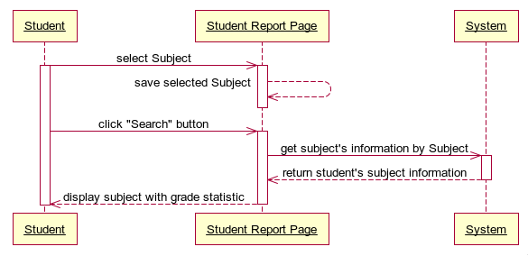

Fig\_2.42.3 Sequence Diagram Filter by Subject

#### <Student> Export Reports by Semester

##### Use Case Diagram

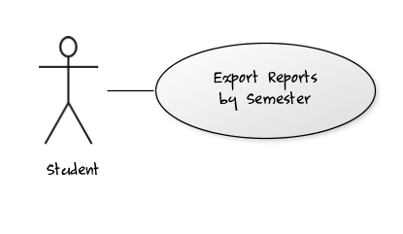

Fig\_2.43.1 Export Reports by Semester

##### Use Case Specification

|  |  |  |  |  |
| --- | --- | --- | --- | --- |
| **USE CASE- Export Report SPECIFICATION** | | | | |
| **Use-case No.** | UC007 | **Use-case Version** | | 0.1 |
| **Use-case Name** | Export Reports by Semester | | | |
| **Author** | TuanNA | | | |
| **Date** | 09/02/2012 | **Priority** | Normal | |
| **Actor:** Student  **Summary:** This use case allows student to export their grade reports by semester.  **Goal:** Export grade report for student by semester  **Triggers:** Click to the “Export” image button in “Student Report” page.  **Preconditions:**  Logged into the system successfully as student’s role and open “Student Report” page, filter semester need to export report in the table.  **Post Conditions:**  Success: return an excel report file which contents all grade and status information of student by semester then student can download it.  Fail: No file return to download.  **Main Success Scenario:**   |  |  |  | | --- | --- | --- | | Step | Actor Action | System Response | | 1 | On “Student Report” page after filter semester, student clicks to “Export” image button. | System get all student’s subjects information in the list, get students’ grade and create excel file grade report then system will send back to student. | | 2 | Student clicks to download excel file report to his/her computer. |  |   **Exceptions:** N/A  **Relationships:** Log in Use Case, Filter by Semester  **Business Rules:** N/A | | | | |
| **Description:**  This use case helps students quickly summarize, calculate grade study and make final grade report by semester which student have chosen. | | | | |

**Screen**

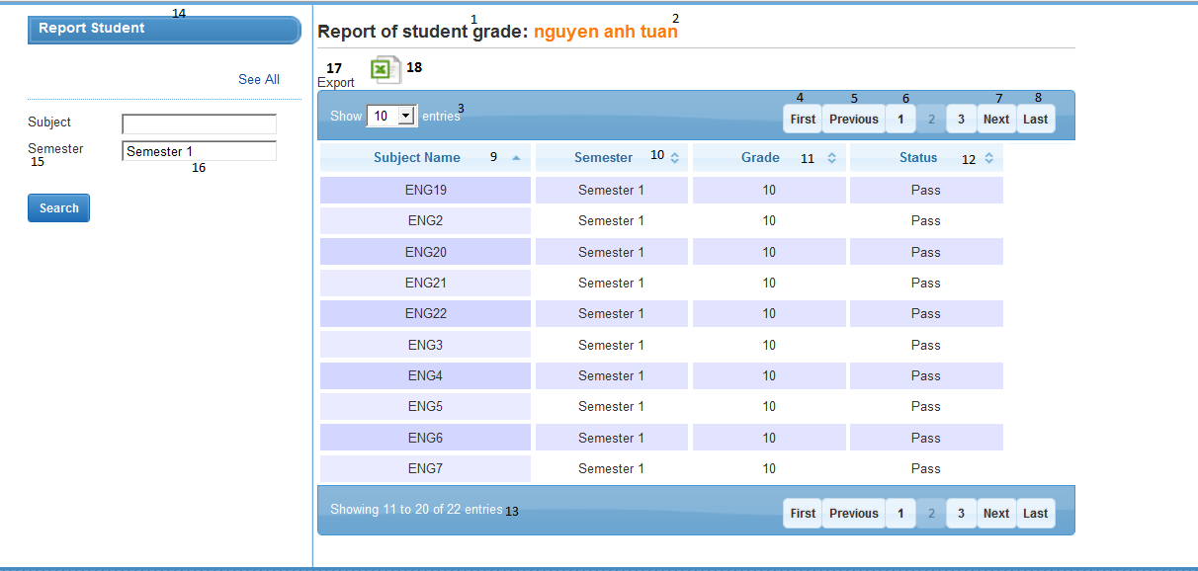

**Data Fields Definition – Export Report**

|  |  |  |  |  |  |  |
| --- | --- | --- | --- | --- | --- | --- |
| **Field name** | **Description** | **Read**  **Only** | **Mandatory** | **Control Type** | **Data Type** | **Length** |
| (17) Export label | A label which contents “Export” | N/A | N/A | Label | Text | Fixed |

**Buttons / Hyper Links – Export Report**

|  |  |  |  |  |
| --- | --- | --- | --- | --- |
| **Function** | **Description** | **Available Criteria** | **Validations** | **Outcome** |
| (18)Export Image Button | This button is for get all grade report from system to client computer. | Only available if the list of student’s subjects in table have data. | No validation | Return the grade reports of student. |

##### Sequence Diagram

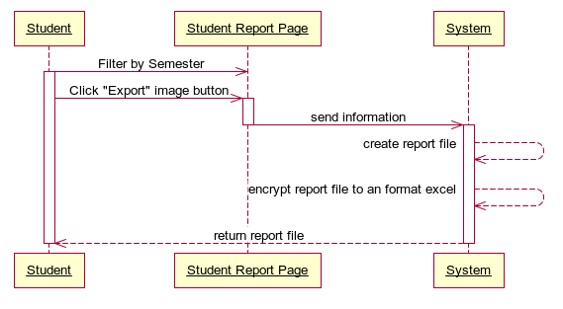

Fig\_2.43.3 Sequence Diagram Export Reports by Semester

#### <Student> Export All Collection Reports

##### Use Case Diagram

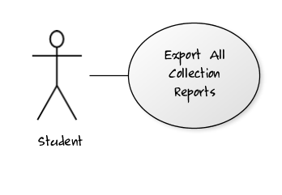

Fig\_2.44.1 Export All Collection Reports

##### Use Case Specification

|  |  |  |  |  |
| --- | --- | --- | --- | --- |
| **USE CASE- Export Report SPECIFICATION** | | | | |
| **Use-case No.** | UC008 | **Use-case Version** | | 0.1 |
| **Use-case Name** | Export All Collection Reports | | | |
| **Author** | TuanNA | | | |
| **Date** | 09/02/2012 | **Priority** | High | |
| **Actor:** Student  **Summary:** This use case allows student to export all their grade reports.  **Goal:** Export all grade reports for student.  **Triggers:** Click to the “Export” image button in “Student Report” page.  **Preconditions:**  Logged into the system successfully as student’s role and open “Student Report” page and click “See All” hyperlink.  **Post Conditions:**  Success: return all collection of reports file which contents all grade and status information of student then student can download it.  Fail: No file return to download.  **Main Success Scenario:**   |  |  |  | | --- | --- | --- | | Step | Actor Action | System Response | | 1 | Student click to “See All” hyper link on “Student Report” page | System will get student information and return all grade statistics in table. | | 2 | Student clicks to “Export” image button on “Student Report” page | System get all student’s subjects information in the list, get students’ grade and create excel file grade reports then system will convert to “rar” files and send back to student. | | 3 | Student clicks to download report file to his/her computer. |  |   **Exceptions:** N/A  **Relationships:** Log in Use Case  **Business Rules:** N/A | | | | |
| **Description:**  This use case helps students quickly summarize, calculate grade study and make final grade. | | | | |

**Screen**

**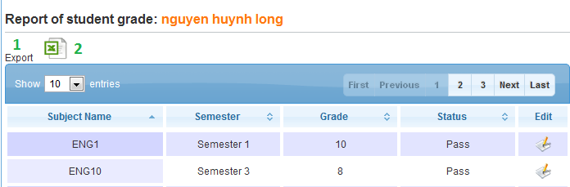**

**Data Fields Definition – Export Report**

|  |  |  |  |  |  |  |
| --- | --- | --- | --- | --- | --- | --- |
| **Field name** | **Description** | **Read**  **Only** | **Mandatory** | **Control Type** | **Data Type** | **Length** |
| (1) Export label | A label which contents “Export” | N/A | N/A | Label | Text | Fixed |

**Buttons / Hyper Links – Export Report**

|  |  |  |  |  |
| --- | --- | --- | --- | --- |
| **Function** | **Description** | **Available Criteria** | **Validations** | **Outcome** |
| (2)Export Image Button | This button is for get all grade report from system to client computer. | Only available if the list of student’s subjects in table have data. | No validation | Return the grade reports of student. |

##### Sequence Diagram

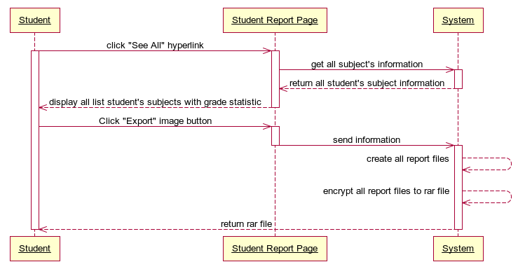

Fig\_2.44.3 Sequence Diagram Export All Collection Reports

#### <Staff> View List Students

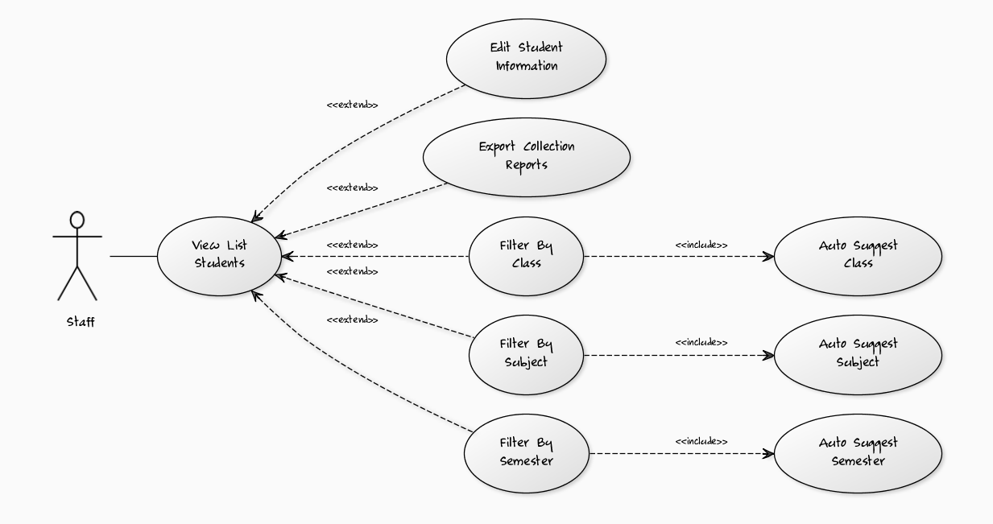

##### **<Staff> Auto Suggest Semester**

###### **Use Case Diagram**

###### **Use Case Specification**

|  |  |  |  |  |
| --- | --- | --- | --- | --- |
| **USE CASE- Auto Suggest Semester SPECIFICATION** | | | | |
| **Use-case No.** | UC001 | **Use-case Version** | | 1.0 |
| **Use-case Name** | Auto Suggest Semester | | | |
| **Author** | LongNH | | | |
| **Date** | 01/02/2012 | **Priority** | Normal | |
| **Actor:** Staff  **Summary:** This use case supports staff to choose the right semester in system by the auto suggest list of semesters whenever staff types more than 2 characters in the text box Semester Filter.  **Goal:** This use case helps staffs does easily in selecting the right semester they want to use for filtering list of students’ base on that semester.  **Triggers:** Click to “Semester Filter” textbox in “List Students Report” page and type at least two characters.  **Preconditions:** Logged into the system successfully as staff role and open “List Students Report” page.  **Post Conditions:**  Success: List of semesters in the system will be showed in the list box appears right below the textbox Semester Filter for staff to select.  Fail: The list box “No Result” appears right below the textbox Semester Filter.  **Main Success Scenario:**   |  |  |  | | --- | --- | --- | | Step | Actor Action | System Response | | 1 | On “List Students Report” page, staff clicks to “Semester Filter” textbox and types at least two characters. | Search the system and return 3 first semester results, which contains the characters staff has typed, in the list box appears right below “Semester Filter” textbox. | | 2 | Staff clicks to “Load More” hyperlink button at the end of the list result. | Search the system and return 3 next semester results, which contains the characters staff has typed, in the list box appears right below “Semester Filter” textbox. | | 2 | Staff selects the right semester that he/she wants. | Save information of the selected semester into memory to use for filtering students later. |   **Alternative Scenario 1:**   |  |  |  | | --- | --- | --- | | Step | Actor Action | System Response | | 1 | On “List Students Report” page, staff clicks to “Semester Filter” textbox and types at least two characters. | Search the system and return 3 first semester results, which contains the characters staff has typed, in the list box appears right below “Semester Filter” textbox. | | 2 | Staff clicks to “Load More” hyperlink button at the end of the list result. | Search the system and return 3 next semester results, which contains the characters staff has typed, in the list box appears right below “Semester Filter” textbox. | | 3 | Staff selects the right semester that he/she wants. | Save information of the selected semester into memory to use for filtering students later. |   **Alternative Scenario 2:**   |  |  |  | | --- | --- | --- | | Step | Actor Action | System Response | | 1 | On “List Students Report” page, staff clicks to “See All” hyperlink next to “Semester Filter” textbox. | Search the system and return 3 first semester results in the list box appears right below “Semester Filter” textbox. | | 2 | Staff clicks to “Load More” hyperlink button at the end of the list result. | Search the system and return 3 next semester results in the list box appears right below “Semester Filter” textbox. | | 3 | Staff selects the right semester that he/she wants. | Save information of the selected semester into memory to use for filtering students later. |   **Exceptions:** N/A  **Relationships:** Log in use case, View List Students use case, Filter By Semester use case.  **Business Rules:** N/A | | | | |
| **Description:**  This use case is used to support staff does easily in selecting the right semester for filtering list of students in order to report final student grade. Because of the University have a lot of semesters, staffs will hard to remember all of them. This function is the guide for him/her to select the right semester he/she wants by suggesting list of semesters for staff to choose. It’s quick and save time.  Staff only need to click to “Semester Filter” textbox and type at least two characters, the system will search and return 3 first semesters, which have a name contains these characters, in the list box result right below the “Semester Filter” textbox. If in 3 first results don’t include the semester staff needs, he/she can view 3 next results by clicking “Load More” hyperlink button in the end of the list box result and the system will return the 3 next semester results for staff. The finally action is just simply select the right semester in the list box result and system will save this semester information into memory for filtering students later. | | | | |

**Screen**

****

**Data Fields Definition – Auto Suggest Semester**

|  |  |  |  |  |  |  |
| --- | --- | --- | --- | --- | --- | --- |
| **Field name** | **Description** | **Read**  **Only** | **Mandatory** | **Control Type** | **Data Type** | **Length** |
| (1) Semester label | A label contents “Type Semester Here” | N/A | N/A | Label | Text | Fixed |
| (2)Semester textfield | The textbox for staff to type name of semester he/she wants to choose. | N | N | Textbox | Text | 200 |
| (4) Semester Result label | A label contents the semester name result of suggesting. | N/A | N/A | Label | Text | Fixed |

**Buttons / Hyper Links – Auto Suggest Semester**

|  |  |  |  |  |
| --- | --- | --- | --- | --- |
| **Function** | **Description** | **Available Criteria** | **Validations** | **Outcome** |
| (3) See All Hyperlink Button | The button will allows the system to search all of the semesters and return into List Box result | Always available | No | The semester results will be loaded and display into the List Box Semester Result for staff to choose. |
| (5) Load More Hyperlink Button | The button will allow the system to load next three semester results into List Box result. | Only available when the result of semester in return list is more than 3. | No | The next 3 semester results will be loaded and display into the List Box Semester Result for staff to choose. |

###### **Sequence Diagram**

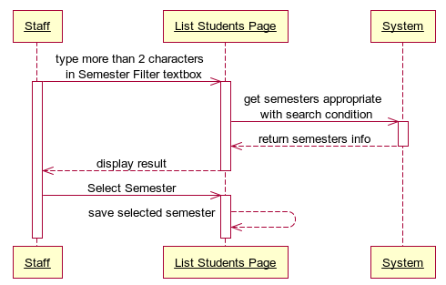



##### **<Staff> Filter by Semester**

###### **Use Case Diagram**

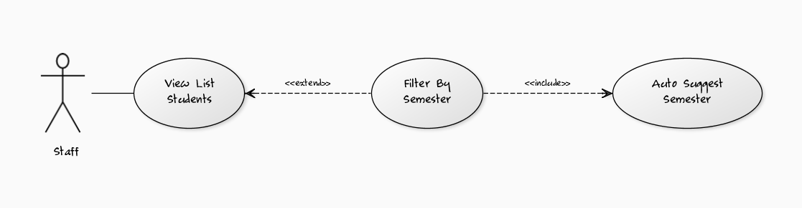

###### **Use Case Specification**

|  |  |  |  |  |
| --- | --- | --- | --- | --- |
| **USE CASE- Filter by Semester SPECIFICATION** | | | | |
| **Use-case No.** | UC002 | **Use-case Version** | | 1.0 |
| **Use-case Name** | Filter by Semester | | | |
| **Author** | LongNH | | | |
| **Date** | 01/02/2012 | **Priority** | Normal | |
| **Actor:** Staff  **Summary:** This use case allows staff to filter students of University by the semester for viewing all the appropriate students, who have studied in that semester; he/she needs to see grade statistic and export reports later.  **Goal:** Display all students in University who have studied in the semester appropriate with the filter condition.  **Triggers:** Click to “Search” button in List Students Report page.  **Preconditions:** Logged into the system successfully as role staff and open “List Students Report” page.  **Post Conditions:**  Success: List of Students in the system appropriate with the semester filter condition will be showed in the table student result in the right screen.  Fail: The table student result appears “No Result” text.  **Main Success Scenario:**   |  |  |  | | --- | --- | --- | | Step | Actor Action | System Response | | 1 | On “List Students Report” page, staff clicks to “Semester Filter” textbox and use “Auto Suggest Semester” function of the system to select the right semester name he/she wants to use for filtering list of Students. | Save information of the selected Semester into memory to use for filtering students later. | | 2 | Staff clicks to “Search” button. | Search through the system to get all students who have studied in the semester appropriate with the semester filter condition and display all student results in the student table. |   **Alternative Scenario 1:**   |  |  |  | | --- | --- | --- | | Step | Actor Action | System Response | | 1 | On “List Students Report” page, staff clicks to “Semester Filter” textbox and types exactly the name of semester that he/she wants to use for filtering list of Students. | Save information of the selected Semester into memory to use for filtering students later. | | 2 | Staff clicks to “Search” button. | Search through the system to get all students who have studied in the semester appropriate with the semester filter condition and display all student results in the student table. |   **Exceptions:** N/A  **Relationships:** Log in use case, View List Students use case, Auto Suggest Semester use case.  **Business Rules:** N/A | | | | |
| **Description:**  This use case is the main operation for helping staff to easily select list of students who have studied in the filtered semester and show information of all student results in the table.  Which this list of students, staff can easily select which group of students in which semesters is choosen for exporting final grade reports and send email later. Such as list students of Semester B will be sent final grade report email. Also, staff can filter to see which students have highest grade in this semester, have lowest grade in this semester…  Staff only needs to type the semester name in “Semester Filter” textbox and click “Search” button, the whole student’s list result will be showed in the student table. | | | | |

**Screen**

**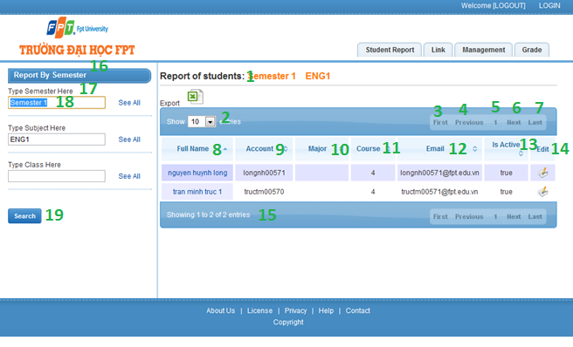**

**Data Fields Definition – Filter by Semester**

|  |  |  |  |  |  |  |
| --- | --- | --- | --- | --- | --- | --- |
| **Field name** | **Description** | **Read**  **Only** | **Mandatory** | **Control Type** | **Data Type** | **Length** |
| (21)-(27)Image buttons Undo edited fields | These buttons will allow staffs to get back the original information of each fields before they have updated | N/A | N/A | Label | Text | Fixed |
| (17)Semester label | A label with contents “Type Semester Here” | N/A | N/A | Label | Text | Fixed |
| (18)Semester textfield | The Semester Name that staff wants to select. | N | N | Textbox | Text | 200 |
| (1)Report title label | A label with contents “Report of Students” | N/A | N/A | Label | Text | Fixed |
| (2)Number of results combobox | A combobox contains the numbers such as: 10, 25, 50, 100 options for staff to select the number of rows display in table student result. | N/A | N/A | Dropdown List | Integer | Fixed |
| (8)Full Name label | A label contains “Full Name” which is the title of column Full Name in student table. | N/A | N/A | Label | Text | Fixed |
| (9) Account label | A label contains “Account” which is the title of column Account in student table. | N/A | N/A | Label | Text | Fixed |
| (10) Major label | A label contains “Major” which is the title of column Major in student table. | N/A | N/A | Label | Text | Fixed |
| (11) Course label | A label contains “Course” which is the title of column Course in student table. | N/A | N/A | Label | Text | Fixed |
| (12) Email label | A label contains “Email” which is the title of column Course in student table. | N/A | N/A | Label | Text | Fixed |
| (13) Is Active label | A label contains “Is Active” which is the title of column Is Active in student table. | N/A | N/A | Label | Text | Fixed |
| (14) Edit label | A label contains “Edit” which is the title of column Edit in student table. | N/A | N/A | Label | Text | Fixed |
| (15)Number of result label | A label contains “Showing ‘a number’ to ‘a number’ of ‘total number results’entries” which show the total results in student table | N/A | N/A | Label | Text | Fixed |

**Buttons / Hyper Links – Filter By Semester**

|  |  |  |  |  |
| --- | --- | --- | --- | --- |
| **Function** | **Description** | **Available Criteria** | **Validations** | **Outcome** |
| (19)Search button which the filter condition | The button will allow staffs to get all students they need which the selected semester. | Always available | No validation | Get list students within the filter semester condition |
| (3)First button | Allow staff to navigate to the first page of the return list student in the table. | Only available if the return list students has data. | No validation | Go back to the first page of table list students. |
| (4)Previous button | Allow staff to navigate to the previous page of the return list student in the table. | Only available if the return list students has data. | No validation | Go back to the previous page of table list students. |
| (6)Next button | Allow staff to navigate to the next page of the return list student in the table. | Only available if the return list students has data. | No validation | Go to the next page of table list of students. |
| (7)Last button | Allow staff to navigate to the last page of the return list student in the table. | Only available if the return list students has data. | No validation | Go to the last page of table list students. |
| (5)Number button | Allow staff to navigate to the “number of the button” page of the return list student in the table. | Only available if the return list students has data. | No validation | Go to “number of the button” page of table list students. |

###### **Sequence Diagram**

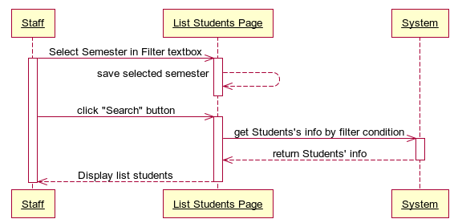



##### **<Staff> Auto Suggest Subject**

###### **Use Case Diagram**

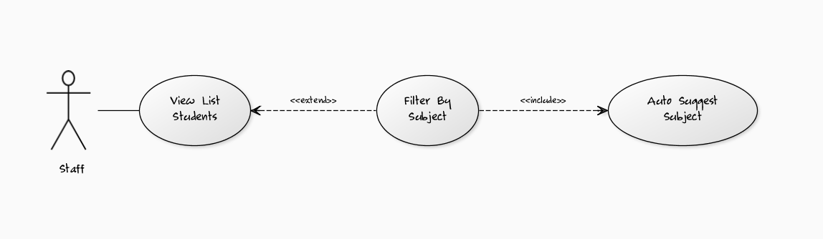

###### **Use Case Specification**

|  |  |  |  |  |
| --- | --- | --- | --- | --- |
| **USE CASE- Auto Suggest Subject SPECIFICATION** | | | | |
| **Use-case No.** | UC003 | **Use-case Version** | | 1.0 |
| **Use-case Name** | Auto Suggest Subject | | | |
| **Author** | LongNH | | | |
| **Date** | 01/02/2012 | **Priority** | Normal | |
| **Actor:** Staff  **Summary:** This use case supports staff to choose the right subject in system by the auto suggest list of subjects whenever staff types more than 2 characters in the text box Subject Filter.  **Goal:** This use case helps staffs does easily in selecting the right subject they want to use for filtering list of students’ base on that subject.  **Triggers:** Click to “Subject Filter” textbox in “List Students Report” page and type at least two characters.  **Preconditions:** Logged into the system successfully as staff role and open “List Students Report” page.  **Post Conditions:**  Success: List of subjects in the system will be showed in the list box appears right below the textbox Subject Filter for staff to select.  Fail: The list box “No Result” appears right below the textbox Subject Filter.  **Main Success Scenario:**   |  |  |  | | --- | --- | --- | | Step | Actor Action | System Response | | 1 | On “List Students Report” page, staff clicks to “Subject Filter” textbox and types at least two characters. | Search the system and return 3 first subject results, which contains the characters staff has typed, in the list box appears right below “Subject Filter” textbox. | | 2 | Staff clicks to “Load More” hyperlink button at the end of the list result. | Search the system and return 3 next subject results, which contains the characters staff has typed, in the list box appears right below “Subject Filter” textbox. | | 2 | Staff selects the right subject that he/she wants. | Save information of the selected subject into memory to use for filtering students later. |   **Alternative Scenario 1:**   |  |  |  | | --- | --- | --- | | Step | Actor Action | System Response | | 1 | On “List Students Report” page, staff clicks to “Subject Filter” textbox and types at least two characters. | Search the system and return 3 first subject results, which contains the characters staff has typed, in the list box appears right below “Subject Filter” textbox. | | 2 | Staff clicks to “Load More” hyperlink button at the end of the list result. | Search the system and return 3 next subject results, which contains the characters staff has typed, in the list box appears right below “Subject Filter” textbox. | | 3 | Staff selects the right subject that he/she wants. | Save information of the selected subject into memory to use for filtering students later. |   **Alternative Scenario 2:**   |  |  |  | | --- | --- | --- | | Step | Actor Action | System Response | | 1 | On “List Students Report” page, staff clicks to “See All” hyperlink next to “Subject Filter” textbox. | Search the system and return 3 first subject results in the list box appears right below “Subject Filter” textbox. | | 2 | Staff clicks to “Load More” hyperlink button at the end of the list result. | Search the system and return 3 next subject results in the list box appears right below “Subject Filter” textbox. | | 3 | Staff selects the right subject that he/she wants. | Save information of the selected subject into memory to use for filtering students later. |   **Exceptions:** N/A  **Relationships:** Log in use case, View List Students use case, Filter By Subject use case.  **Business Rules:** N/A | | | | |
| **Description:**  This use case is used to support staff does easily in selecting the right subject for filtering list of students in order to report final student grade. Because of the University have a lot of subjects, staffs will hard to remember all of them. This function is the guide for him/her to select the right subject he/she wants by suggesting list of subjects for staff to choose. It’s quick and save time.  Staff only need to click to “Subject Filter” textbox and type at least two characters, the system will search and return 3 first subjects, which have a name contains these characters, in the list box result right below the “Subject Filter” textbox. If in 3 first results don’t include the subject staff needs, he/she can view 3 next results by clicking “Load More” hyperlink button in the end of the list box result and the system will return the 3 next subject results for staff. The finally action is just simply select the right subject in the list box result and system will save this subject information into memory for filtering students later. | | | | |

**Screen**

**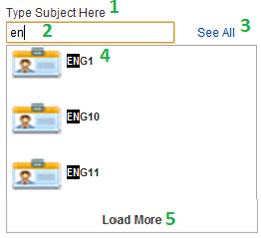**

**Data Fields Definition – Auto Suggest Subject**

|  |  |  |  |  |  |  |
| --- | --- | --- | --- | --- | --- | --- |
| **Field name** | **Description** | **Read**  **Only** | **Mandatory** | **Control Type** | **Data Type** | **Length** |
| (1) Subject label | A label contents “Type Subject Here” | N/A | N/A | Label | Text | Fixed |
| (2) Subject textfield | The textbox for staff to type name of subject he/she wants to choose. | N | N | Textbox | Text | 200 |
| (4) Subject Result label | A label contents the subject name result of suggesting. | N/A | N/A | Label | Text | Fixed |

**Buttons / Hyper Links – Auto Suggest Subject**

|  |  |  |  |  |
| --- | --- | --- | --- | --- |
| **Function** | **Description** | **Available Criteria** | **Validations** | **Outcome** |
| (3) See All Hyperlink Button | The button will allows the system to search all of the subjects and return into List Box result | Always available | No | The subject results will be loaded and display into the List Box Subject Result for staff to choose. |
| (5) Load More Hyperlink Button | The button will allow the system to load next three subject results into List Box result. | Only available when the result of subject in return list is more than 3. | No | The next 3 subject results will be loaded and display into the List Box Subject Result for staff to choose. |

###### **Sequence Diagram**

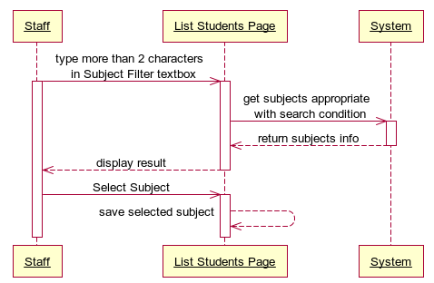



##### **<Staff> Filter by Subject**

###### **Use Case Diagram**



###### **Use Case Specification**

|  |  |  |  |  |
| --- | --- | --- | --- | --- |
| **USE CASE- Filter by Subject SPECIFICATION** | | | | |
| **Use-case No.** | UC004 | **Use-case Version** | | 1.0 |
| **Use-case Name** | Filter by Subject | | | |
| **Author** | LongNH | | | |
| **Date** | 01/02/2012 | **Priority** | Normal | |
| **Actor:** Staff  **Summary:** This use case allows staff to filter students of University by the Subject for viewing all the appropriate students, who have studied in that Subject, he/she needs to see grade statistic and export reports later.  **Goal:** Display all students in University who have studied in the Subject appropriate with the filter condition.  **Triggers:**  Click to “Search” button in List Students Report page.  **Preconditions:** Logged into the system successfully as role staff and open “List Students Report” page.  **Post Conditions:**  Success: List of Students in the system appropriate with the Subject filter condition will be showed in the table student result in the right screen.  Fail: The table student result appears “No Result” text.  **Main Success Scenario:**   |  |  |  | | --- | --- | --- | | Step | Actor Action | System Response | | 1 | On “List Students Report” page, staff clicks to “Subject Filter” textbox and use “Auto Suggest Subject” function of the system to select the right Subject name he/she wants to use for filtering list of Students. | Save information of the selected Subject into memory to use for filtering students later. | | 2 | Staff clicks to “Search” button. | Search through the system to get all students who have studied in the Subject appropriate with the Subject filter condition and display all student results in the student table. |   **Alternative Scenario 1:**   |  |  |  | | --- | --- | --- | | Step | Actor Action | System Response | | 1 | On “List Students Report” page, staff clicks to “Subject Filter” textbox and types exactly the name of Subject that he/she wants to use for filtering list of Students. | Save information of the selected Subject into memory to use for filtering students later. | | 2 | Staff clicks to “Search” button. | Search through the system to get all students who have studied in the Subject appropriate with the Subject filter condition and display all student results in the student table. |   **Exceptions:** N/A  **Relationships:** Log in use case, View List Students use case, Auto Suggest Subject use case.  **Business Rules:** N/A | | | | |
| **Description:**  This use case is the main operation for helping staff to easily select list of students who have studied in the filtered Subject and show information of all student results in the table.  Which this list of students, staff can easily select which group of students in which Subjects is choosen for exporting final grade reports and send email later. Such as list students of Subject B will be sent final grade report email. Also, staff can filter to see which students have highest grade in this subject, have lowest grade in this subject…  Staff only needs to type the Subject name in “Subject Filter” textbox and click “Search” button, the whole student’s list result will be showed in the student table. | | | | |

**Screen**

**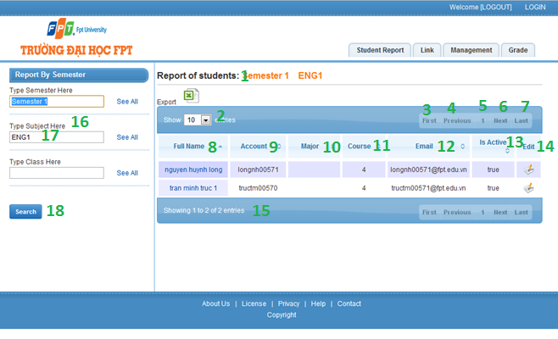**

**Data Fields Definition – Filter by Subject**

|  |  |  |  |  |  |  |
| --- | --- | --- | --- | --- | --- | --- |
| **Field name** | **Description** | **Read**  **Only** | **Mandatory** | **Control Type** | **Data Type** | **Length** |
| (16)Subject label | A label with contents “Type Subject Here” | N/A | N/A | Label | Text | Fixed |
| (17)Subject textfield | The Subject Name that staff wants to select. | N | N | Textbox | Text | 200 |
| (1)Report title label | A label with contents “Report of Students” | N/A | N/A | Label | Text | Fixed |
| (2)Number of results combobox | Acombobox contains the numbers such as: 10, 25, 50, 100 options for staff to select the number of rows display in table student result. | N/A | N/A | Dropdown List | Integer | Fixed |
| (8)Full Name label | A label contains “Full Name” which is the title of column Full Name in student table. | N/A | N/A | Label | Text | Fixed |
| (9) Account label | A label contains “Account” which is the title of column Account in student table. | N/A | N/A | Label | Text | Fixed |
| (10) Major label | A label contains “Major” which is the title of column Major in student table. | N/A | N/A | Label | Text | Fixed |
| (11) Course label | A label contains “Course” which is the title of column Course in student table. | N/A | N/A | Label | Text | Fixed |
| (12) Email label | A label contains “Email” which is the title of column Course in student table. | N/A | N/A | Label | Text | Fixed |
| (13) Is Active label | A label contains “Is Active” which is the title of column Is Active in student table. | N/A | N/A | Label | Text | Fixed |
| (14) Edit label | A label contains “Edit” which is the title of column Edit in student table. | N/A | N/A | Label | Text | Fixed |
| (15)Number of result label | A label contains “Showing ‘a number’ to ‘a number’ of ‘total number results’entries” which show the total results in student table | N/A | N/A | Label | Text | Fixed |

**Buttons / Hyper Links – Filter By Subject**

|  |  |  |  |  |
| --- | --- | --- | --- | --- |
| **Function** | **Description** | **Available Criteria** | **Validations** | **Outcome** |
| (18)Search button which the filter condition | The button will allow staffs to get all students they need which the selected Subject. | Always available | No validation | Get list students within the filter Subject condition |
| (3)First button | Allow staff to navigate to the first page of the return list student in the table. | Only available if the return list students has data. | No validation | Go back to the first page of table list students. |
| (4)Previous button | Allow staff to navigate to the previous page of the return list student in the table. | Only available if the return list students has data. | No validation | Go back to the previous page of table list students. |
| (6)Next button | Allow staff to navigate to the next page of the return list student in the table. | Only available if the return list students has data. | No validation | Go to the next page of table list of students. |
| (7)Last button | Allow staff to navigate to the last page of the return list student in the table. | Only available if the return list students has data. | No validation | Go to the last page of table list students. |
| (5)Number button | Allow staff to navigate to the “number of the button” page of the return list student in the table. | Only available if the return list students has data. | No validation | Go to “number of the button” page of table list students. |

###### **Sequence Diagram**

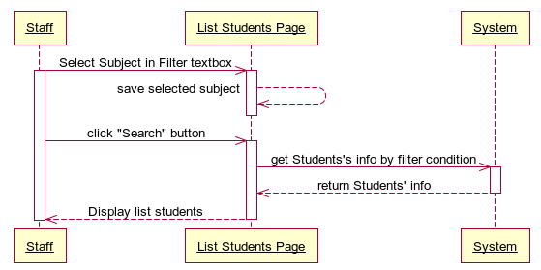



##### **<Staff> Auto Suggest Class**

###### **Use Case Diagram**

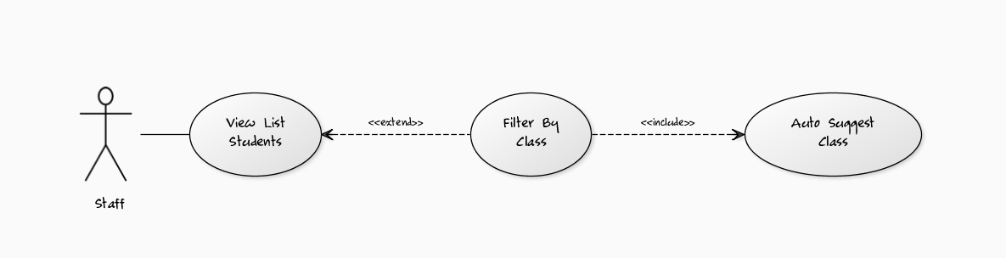

###### **Use Case Specification**

|  |  |  |  |  |
| --- | --- | --- | --- | --- |
| **USE CASE- Auto Suggest Class SPECIFICATION** | | | | |
| **Use-case No.** | UC005 | **Use-case Version** | | 1.0 |
| **Use-case Name** | Auto Suggest Subject | | | |
| **Author** | LongNH | | | |
| **Date** | 01/02/2012 | **Priority** | Normal | |
| **Actor:** Staff  **Summary:** This use case supports staff to choose the right Class in system by the auto suggest list of subjects whenever staff types more than 2 characters in the text box Class Filter.  **Goal:** This use case helps staffs does easily in selecting the right Class they want to use for filtering list of students’ base on that Class.  **Triggers:** Click to “Class Filter” textbox in “List Students Report” page and type at least two characters.  **Preconditions:** Logged into the system successfully as staff role and open “List Students Report” page.  **Post Conditions:**  Success: List of Classes in the system will be showed in the list box appears right below the textbox Class Filter for staff to select.  Fail: The list box “No Result” appears right below the textbox Class Filter.  **Main Success Scenario:**   |  |  |  | | --- | --- | --- | | Step | Actor Action | System Response | | 1 | On “List Students Report” page, staff clicks to “Class Filter” textbox and types at least two characters. | Search the system and return 3 first Class results, which contains the characters staff has typed, in the list box appears right below “Class Filter” textbox. | | 2 | Staff clicks to “Load More” hyperlink button at the end of the list result. | Search the system and return 3 next Class results, which contains the characters staff has typed, in the list box appears right below “Class Filter” textbox. | | 2 | Staff selects the right Class that he/she wants. | Save information of the selected Class into memory to use for filtering students later. |   **Alternative Scenario 1:**   |  |  |  | | --- | --- | --- | | Step | Actor Action | System Response | | 1 | On “List Students Report” page, staff clicks to “Class Filter” textbox and types at least two characters. | Search the system and return 3 first Class results, which contains the characters staff has typed, in the list box appears right below “Class Filter” textbox. | | 2 | Staff clicks to “Load More” hyperlink button at the end of the list result. | Search the system and return 3 next Class results, which contains the characters staff has typed, in the list box appears right below “Class Filter” textbox. | | 3 | Staff selects the right Class that he/she wants. | Save information of the selected Class into memory to use for filtering students later. |   **Alternative Scenario 2:**   |  |  |  | | --- | --- | --- | | Step | Actor Action | System Response | | 1 | On “List Students Report” page, staff clicks to “See All” hyperlink next to “Class Filter” textbox. | Search the system and return 3 first Class results in the list box appears right below “Class Filter” textbox. | | 2 | Staff clicks to “Load More” hyperlink button at the end of the list result. | Search the system and return 3 next Class results in the list box appears right below “Class Filter” textbox. | | 3 | Staff selects the right Class that he/she wants. | Save information of the selected Class into memory to use for filtering students later. |   **Exceptions:** N/A  **Relationships:** Log in use case, View List Students use case, Filter By Class use case.  **Business Rules:** N/A | | | | |
| **Description:**  This use case is used to support staff does easily in selecting the right Class for filtering list of students in order to report final student grade. Because of the University have a lot of Classes, staffs will hard to remember all of them. This function is the guide for him/her to select the right Class he/she wants by suggesting list of Classes for staff to choose. It’s quick and save time.  Staff only need to click to “Class Filter” textbox and type at least two characters, the system will search and return 3 first Classes, which have a name contains these characters, in the list box result right below the “Class Filter” textbox. If in 3 first results don’t include the Class staff needs, he/she can view 3 next results by clicking “Load More” hyperlink button in the end of the list box result and the system will return the 3 next Class results for staff. The finally action is just simply select the right Class in the list box result and system will save this Class information into memory for filtering students later. | | | | |

**Screen**

**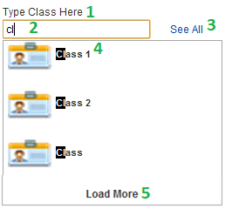**

**Data Fields Definition – Auto Suggest Class**

|  |  |  |  |  |  |  |
| --- | --- | --- | --- | --- | --- | --- |
| **Field name** | **Description** | **Read**  **Only** | **Mandatory** | **Control Type** | **Data Type** | **Length** |
| (1) Class label | A label contents “Type Class Here” | N/A | N/A | Label | Text | Fixed |
| (2) Class textfield | The textbox for staff to type name of Class he/she wants to choose. | N | N | Textbox | Text | 200 |
| (4) Class Result label | A label contents the Class name result of suggesting. | N/A | N/A | Label | Text | Fixed |

**Buttons / Hyper Links – Auto Suggest Class**

|  |  |  |  |  |
| --- | --- | --- | --- | --- |
| **Function** | **Description** | **Available Criteria** | **Validations** | **Outcome** |
| (3) See All Hyperlink Button | The button will allows the system to search all of the Classes and return into List Box result | Always available | No | The Class results will be loaded and display into the List Box Class Result for staff to choose. |
| (5) Load More Hyperlink Button | The button will allow the system to load next three Class results into List Box result. | Only available when the result of Class in return list is more than 3. | No | The next 3 Class results will be loaded and display into the List Box Class Result for staff to choose. |

###### **Sequence Diagram**

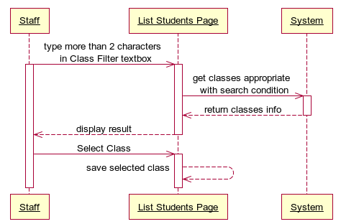



##### **<Staff> Filter by Class**

###### **Use Case Diagram**



###### **Use Case Specification**

|  |  |  |  |  |
| --- | --- | --- | --- | --- |
| **USE CASE- Filter by Class SPECIFICATION** | | | | |
| **Use-case No.** | UC006 | **Use-case Version** | | 1.0 |
| **Use-case Name** | Filter by Class | | | |
| **Author** | LongNH | | | |
| **Date** | 01/02/2012 | **Priority** | Normal | |
| **Actor:** Staff  **Summary:** This use case allows staff to filter students of University by the Class for viewing all the appropriate students, who have studied in that Class, he/she needs to see grade statistic and export reports later.  **Goal:** Display all students in University who have studied in the Class appropriate with the filter condition.  **Triggers:** Click to “Search” button in List Students Report page.  **Preconditions:** Logged into the system successfully as role staff and open “List Students Report” page.  **Post Conditions:**  Success: List of Students in the system appropriate with the Class filter condition will be showed in the table student result in the right screen.  Fail: The table student result appears “No Result” text.  **Main Success Scenario:**   |  |  |  | | --- | --- | --- | | Step | Actor Action | System Response | | 1 | On “List Students Report” page, staff clicks to “Class Filter” textbox and use “Auto Suggest Class” function of the system to select the right Class name he/she wants to use for filtering list of Students. | Save information of the selected Class into memory to use for filtering students later. | | 2 | Staff clicks to “Search” button. | Search through the system to get all students who have studied in the Class appropriate with the Class filter condition and display all student results in the student table. |   **Alternative Scenario 1:**   |  |  |  | | --- | --- | --- | | Step | Actor Action | System Response | | 1 | On “List Students Report” page, staff clicks to “Class Filter” textbox and types exactly the name of Class that he/she wants to use for filtering list of Students. | Save information of the selected Class into memory to use for filtering students later. | | 2 | Staff clicks to “Search” button. | Search through the system to get all students who have studied in the Class appropriate with the Class filter condition and display all student results in the student table. |   **Exceptions:** N/A  **Relationships:** Log in use case, View List Students use case, Auto Suggest Class use case.  **Business Rules:** N/A | | | | |
| **Description:**  This use case is the main operation for helping staff to easily select list of students who have studied in the filtered Class and show information of all student results in the table.  Which this list of students, staff can easily select which group of students in which Classes is choosen for exporting final grade reports and send email later. Such as list students of Class B will be sent final grade report email. Also, staff can filter to see which students have highest grade in this class, have lowest grade in this class…  Staff only needs to type the Class name in “Class Filter” textbox and click “Search” button, the whole student’s list result will be showed in the student table. | | | | |

**Screen**

**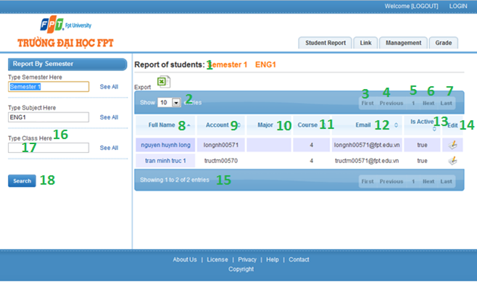**

**Data Fields Definition – Filter by Class**

|  |  |  |  |  |  |  |
| --- | --- | --- | --- | --- | --- | --- |
| **Field name** | **Description** | **Read**  **Only** | **Mandatory** | **Control Type** | **Data Type** | **Length** |
| (16) Class label | A label with contents “Type Class Here” | N/A | N/A | Label | Text | Fixed |
| (17) Class textfield | The Class Name that staff wants to select. | N | N | Textbox | Text | 200 |
| (1)Report title label | A label with contents “Report of Students” | N/A | N/A | Label | Text | Fixed |
| (2)Number of results combobox | Acombobox contains the numbers such as: 10, 25, 50, 100 options for staff to select the number of rows display in table student result. | N/A | N/A | Dropdown List | Integer | Fixed |
| (8)Full Name label | A label contains “Full Name” which is the title of column Full Name in student table. | N/A | N/A | Label | Text | Fixed |
| (9) Account label | A label contains “Account” which is the title of column Account in student table. | N/A | N/A | Label | Text | Fixed |
| (10) Major label | A label contains “Major” which is the title of column Major in student table. | N/A | N/A | Label | Text | Fixed |
| (11) Course label | A label contains “Course” which is the title of column Course in student table. | N/A | N/A | Label | Text | Fixed |
| (12) Email label | A label contains “Email” which is the title of column Course in student table. | N/A | N/A | Label | Text | Fixed |
| (13) Is Active label | A label contains “Is Active” which is the title of column Is Active in student table. | N/A | N/A | Label | Text | Fixed |
| (14) Edit label | A label contains “Edit” which is the title of column Edit in student table. | N/A | N/A | Label | Text | Fixed |
| (15)Number of result label | A label contains “Showing ‘a number’ to ‘a number’ of ‘total number results’entries” which show the total results in student table | N/A | N/A | Label | Text | Fixed |

**Buttons / Hyper Links – Filter By Subject**

|  |  |  |  |  |
| --- | --- | --- | --- | --- |
| **Function** | **Description** | **Available Criteria** | **Validations** | **Outcome** |
| (18)Search button which the filter condition | The button will allow staffs to get all students they need which the selected Class. | Always available | No validation | Get list students within the filter Class condition |
| (3)First button | Allow staff to navigate to the first page of the return list student in the table. | Only available if the return list students has data. | No validation | Go back to the first page of table list students. |
| (4)Previous button | Allow staff to navigate to the previous page of the return list student in the table. | Only available if the return list students has data. | No validation | Go back to the previous page of table list students. |
| (6)Next button | Allow staff to navigate to the next page of the return list student in the table. | Only available if the return list students has data. | No validation | Go to the next page of table list of students. |
| (7)Last button | Allow staff to navigate to the last page of the return list student in the table. | Only available if the return list students has data. | No validation | Go to the last page of table list students. |
| (5)Number button | Allow staff to navigate to the “number of the button” page of the return list student in the table. | Only available if the return list students has data. | No validation | Go to “number of the button” page of table list students. |

###### **Sequence Diagram**

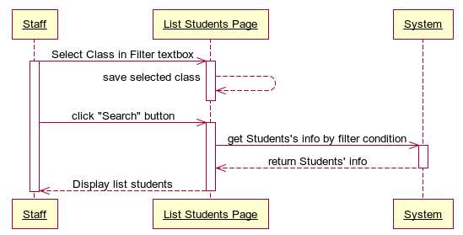

##### **<Staff> Export Collection Reports**

###### **Use Case Diagram**

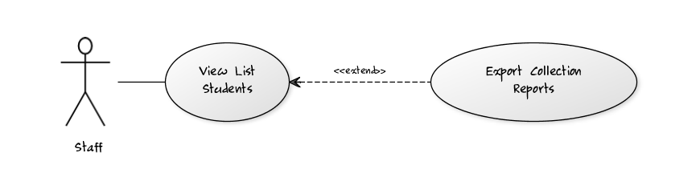

###### **Use Case Specification**

|  |  |  |  |  |
| --- | --- | --- | --- | --- |
| **USE CASE- Export Collection Reports SPECIFICATION** | | | | |
| **Use-case No.** | UC007 | **Use-case Version** | | 1.0 |
| **Use-case Name** | Export Collection Reports | | | |
| **Author** | LongNH | | | |
| **Date** | 02/02/2012 | **Priority** | High | |
| **Actor:** Staff  **Summary:** This use case allows staff to export collection of grade reports for list students which has been filtered by Semester, Subject, and Class before.  **Goal:** Export collection of grade reports for list students.  **Triggers:** Click to the “Export” image button in “List Students Report” page.  **Preconditions:** Logged into the system successfully as staff role and open “List Students Report” page, Filter list students need to export report in the table.  **Post Conditions:**  Success: return an encrypted rar file which contents all reports of list students in the table for staff to download.  Fail: No file return to download.  **Main Success Scenario:**   |  |  |  | | --- | --- | --- | | Step | Actor Action | System Response | | 1 | On “List Student Report” page after search list students, staff clicks to “Export” image button. | System get all students in the list, get students’ grade and create excel file grade report for each student, after that, system encrypt into rar file within all the excel files and send back to staff. | | 2 | Staff clicks to download rar file report to his/her computer. |  |   **Exceptions:** N/A  **Relationships:** Log in Use Case, View List Students use case.  **Business Rules:** N/A | | | | |
| **Description:**  This use case helps staffs quickly summarize, calculate grade study and make final grade reports for all students in the list filter by semester, subject and class just by a mouse click.  These excel reports file of each student will be encrypted in a rar file and send back for staff to download to their computer. | | | | |

**Screen**

**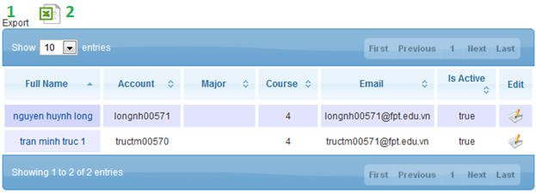**

**Data Fields Definition – Export Collection Reports**

|  |  |  |  |  |  |  |
| --- | --- | --- | --- | --- | --- | --- |
| **Field name** | **Description** | **Read**  **Only** | **Mandatory** | **Control Type** | **Data Type** | **Length** |
| (1) Export label | A label which contents “Export” | N/A | N/A | Label | Text | Fixed |

**Buttons / Hyper Links – Export Collection Reports**

|  |  |  |  |  |
| --- | --- | --- | --- | --- |
| **Function** | **Description** | **Available Criteria** | **Validations** | **Outcome** |
| (2)Export Image Button | This button is for get all grade reports from system to client computer. | Only available if the list of students in table have data. | No validation | Return the grade reports of all students in the table to staff. |



###### **Sequence Diagram**

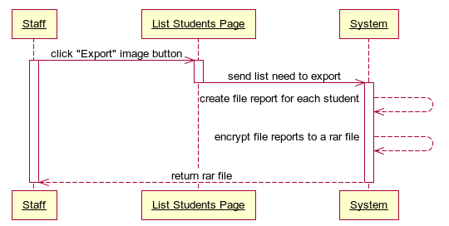

##### **<Staff> Edit Student’s Information**

###### **Use Case Diagram**

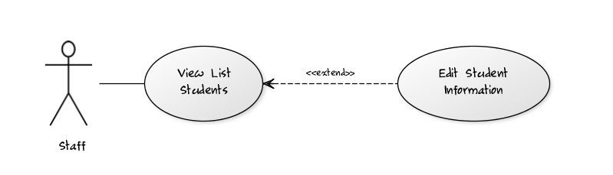

###### **Use Case Specification**

|  |  |  |  |  |
| --- | --- | --- | --- | --- |
| **USE CASE- Edit Student’s Information SPECIFICATION** | | | | |
| **Use-case No.** | UC008 | **Use-case Version** | | 1.0 |
| **Use-case Name** | Edit Student’s Information | | | |
| **Author** | LongNH | | | |
| **Date** | 02/02/2012 | **Priority** | Normal | |
| **Actor:**Staff  **Summary:** When staff needs to edit some personal information of a student like Full Name, Date Of Birth, or Email…, staff can easily make it by click to “Edit” image button in the student table of “List Students Report” page.  **Goal:** This use case allows staff edits information of a student.  **Triggers:** Click the “Edit” hyperlink image button in the student table of “List Students Report” page.  **Preconditions:** Already logged into the system successfully as staff role, open “List Students Report” page and filter list students.  **Post Conditions:**  Success: New information of student is updated and redirect back to “List Students Report” page with the alert message “Information was updated successfully!”  Fail: New information of student is not updated and redirect back to “List Students Report” page with the alert message “Update information fail!”  **Main Success Scenario:**   |  |  |  | | --- | --- | --- | | Step | Actor Action | System Response | | 1 | On “Student Detail” page staff clicks to “Edit” hyperlink image button in the student table of student that needs to be updated | System opens “Update Student” page to edit student’s information. | | 2 | Staff modifies information |  | | 3 | Staff clicks to “Update” button | - System checks information input [Exception1] - System updates new information of student into database, then displays a successful message.  - System redirects to the “List Students Report” page with the up-to-date data. |   **Alternative Scenario 1:**   |  |  |  | | --- | --- | --- | | Step | Actor Action | System Response | | 1 | On “List Students Report” page staff clicks to “Edit” hyperlink image button of student that needs to be updated | System opens “Update Student” page to edit student’s information. | | 2 | Staff modifies information |  | | 3 | Staff clicks to “Close” button | System will redirect to the “List Students Report”page and the data still is as before. |   **Exceptions:**   |  |  |  | | --- | --- | --- | | No | Actor Action | System Response | | 1 | Actor lefts ‘Account’ textfield blank | System Display: ‘Please input Account’ | | 2 | Actor lefts ‘Full Name’ textfield blank | System Display: ‘Please input Full Name’ | | 3 | Actor lefts ‘Date Of Birth’ textfield blank | System Display: ‘Please input Date Of Birth’ | | 4 | Actor lefts ‘Email’ textfield blank | System Display: ‘Please input Email’ | | 5 | Actor does not select ‘Major’ combo box | System Display: ‘Please select Major’ | | 6 | Actor does not select ‘Special’ combo box | System Display: ‘Please select Special’ | | 7 | Actor does not select ‘Mode of Study’ combo box | System Display: ‘Please select Mode of Study’ | | 8 | Actor does not input ‘Date Of Birth textfield in Number format. | System Display: ‘Format of Date Of Birth is wrong, input dd/MM/yyyy ’ | | 9 | Actor does not input ‘Email’ textfield in email address format. | System Display: ‘Format of Email is wrong, the format is ….@fpt.edu.vn’ | | 10 | Actor does not input ‘Student Identity’ textfield in Number format. | System Display: ‘Student Identity require number format’ | | 11 | Actor does not input ‘Phone’ textfield in Number format. | System Display: ‘Phone require number format’ |   **Relationships:** Log in use case, View List Students use case  **Business Rules:** N/A | | | | |
| **Description:**  Edit Student information helps staffs or instructors manage and update newest personal information about a student whenever they need.  To edit student information, staff needs to go to its detail page first. After that, click to “Edit” button of the student that needs to be updated and the system will redirect staff to “Update Student” page. At “Update Student” page, click to “Update” button to save all changes or click to “Close” button to go back to Detail page. All validations for input data will take effect as creating a new student. | | | | |

**Screen**

****

**Data Fields Definition – Attach Place Page**

|  |  |  |  |  |  |  |
| --- | --- | --- | --- | --- | --- | --- |
| **Field name** | **Description** | **Read**  **Only** | **Mandatory** | **Control Type** | **Data Type** | **Length** |
| (1)Instruction | This field contains instructions for edit a student | N/A | N/A | Label | Text | Fixed |
| (2)Basic information | The following fields will be surrounded by a border to allow logical grouping of data for the student. The border will have a heading titled “Student Personal Information” | N/A | N/A | Label | Text | Fixed |
| (3)Account label | A label with contents “Account” | N/A | N/A | Label | Text | Fixed |
| (4)Account textfield | The account name of the student that to be edited. | N | Y | Text Box | Text | 50 |
| (5)Full Name label | A label with contents “Full Name” | N/A | N/A | Label | Text | Fixed |
| (6)Full Name textfield | The full name of the student that to be edited. | N | Y | Text Box | Text | 200 |
| (7)Date Of Birth label | A label with contents “Date Of Birth” | N/A | N/A | Label | Text | Fixed |
| (8)Date Of Birth textfield | The Date Of Birth of the student that to be edited. | N | Y | Text Box | Date | 50 |
| (9)Email label | A label with contents “Email” | N/A | N/A | Label | Text | Fixed |
| (10)Email textfield | The Email of the student that to be edited. | N | Y | Text Box | Text | 200 |
| (11)Student Identity label | A label with contents “Student Identity” | N/A | N/A | Label | Text | Fixed |
| (12)Student Identity textfield | The Student Identity of the student that to be edited. | N | Y | Text Box | Text | 200 |
| (13)Phone label | A label with content “Phone” | N/A | N/A | Label | Text | Fixed |
| (14)Phone textfield | The telephone of student that to be edited. | N | N | Text Box | Text | 50 |
| (15)Major label | A label with content “Major” | N/A | N/A | Label | Text | Fixed |
| (16)Major dropdown list | The Major of student that to be edited. | N | Y | Combo Box | Text |  |
| (17)Special label | A label with content “Special” | N/A | N/A | Label | Text | Fixed |
| (18)Special dropdown list | The Special of student that to be edited. | N | Y | Combo Box | Text |  |
| (19)Mode Of Study label | A label with content “Mode Of Study” | N/A | N/A | Label | Text | Fixed |
| (20)Mode Of Study dropdown list | The Mode Of Study of student that to be edited. | N | Y | Combo Box | Text |  |
| (21)Course label | A label with content “Course” | N/A | N/A | Label | Text | Fixed |
| (22)Course textfield | The Course of student that to be edited. | N | N | Text Box | Text | 50 |
| (23)Note label | A label with content “Note” | N/A | N/A | Label | Text | Fixed |
| (24)Note textfield | The Note of student that to be edited. | N | N | Text Box | Text | 200 |
| (25)Is Active label | A label with content “Is Active” | N/A | N/A | Label | Text | Fixed |
| (26)Is Active check box | The status of student that to be edited. | N | N | Check Box | Boolean |  |

**Buttons / Hyper Links – Edit Student Information**

|  |  |  |  |  |
| --- | --- | --- | --- | --- |
| **Function** | **Description** | **Available Criteria** | **Validations** | **Outcome** |
| (38)Save button | The button will allow staff to save the student information | Always available | Validate all mandatory fields and the format of Date Of Birth, Email and Phone. | New information is saved to database. Staff gets redirected back to the previous page with a successful message. |
| (39)Close imag button | The button will allow the user to cancel editing | Always available | No | staff will be redirected back to the previous page |
| (27)-(37)Image buttons Undo edited fields | These buttons will allow staffs to get back the original information of each fields before they have updated | Always available | No | The original information of the textfields will be inserted into the textfields |

###### **Sequence Diagram**

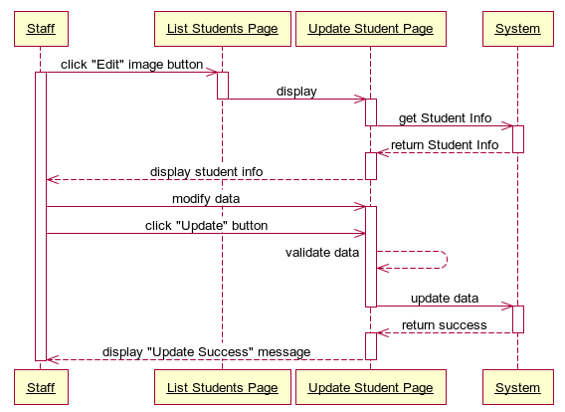



#### <Staff> View List Subjects of Student

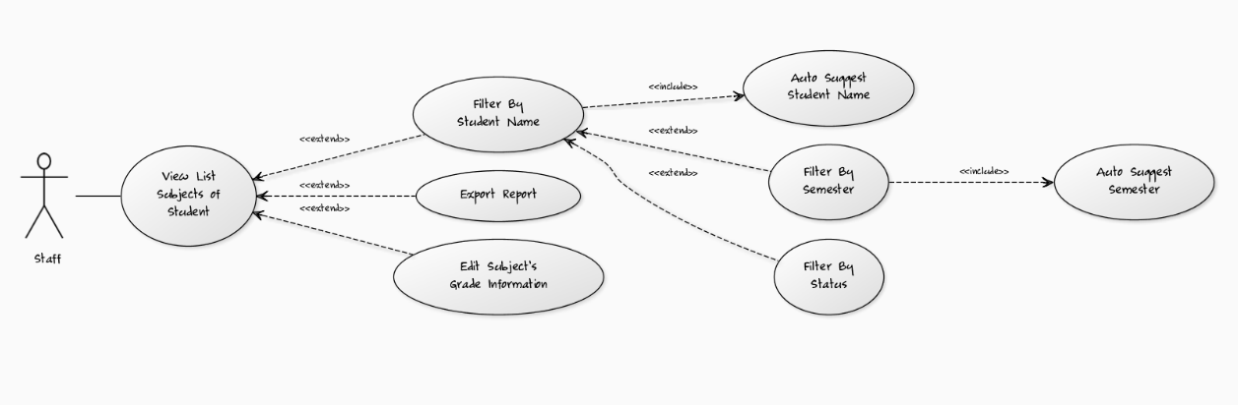

##### **<Staff> Auto Suggest Student Name**

###### **Use Case Diagram**

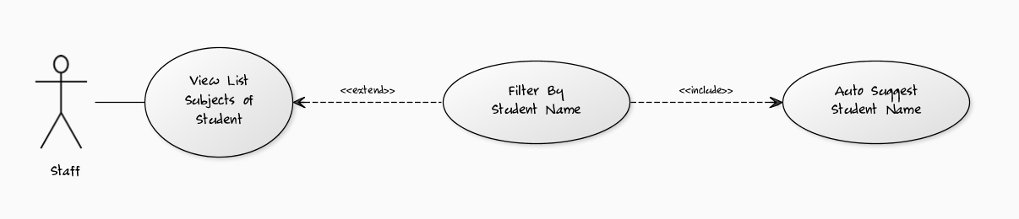

###### **Use Case Specification**

|  |  |  |  |  |
| --- | --- | --- | --- | --- |
| **USE CASE- Auto Suggest Student Name SPECIFICATION** | | | | |
| **Use-case No.** | UC011 | **Use-case Version** | | 1.0 |
| **Use-case Name** | Auto Suggest Student Name | | | |
| **Author** | LongNH | | | |
| **Date** | 02/02/2012 | **Priority** | Normal | |
| **Actor:** Staff  **Summary:** This use case supports staff to choose the right student name in system by the auto suggest list of student names whenever staff types more than 2 characters in the text box Student Name Filter.  **Goal:** This use case helps staffs does easily in selecting the right student name they want to use for filtering list of this student’s subjects base on that student name.  **Triggers:** Click to “Student Name Filter” textbox in “Student Report” page and type at least two characters.  **Preconditions:** Logged into the system successfully as staff role and open “Student Report” page.  **Post Conditions:**  Success: List of student names in the system will be showed in the list box appears right below the textbox Student Name Filter for staff to select.  Fail: The list box “No Result” appears right below the textbox Student Name Filter.  **Main Success Scenario:**   |  |  |  | | --- | --- | --- | | Step | Actor Action | System Response | | 1 | On “Student Report” page, staff clicks to “Student Name Filter” textbox and types at least two characters. | Search the system and return 3 first subject results, which contains the characters staff has typed, in the list box appears right below “Student Name Filter” textbox. | | 2 | Staff clicks to “Load More” hyperlink button at the end of the list result. | Search the system and return 3 next subject results, which contains the characters staff has typed, in the list box appears right below “Student Name Filter” textbox. | | 2 | Staff selects the right student name that he/she wants. | Save information of the selected student name into memory to use for filtering student’s subjects later. |   **Alternative Scenario 1:**   |  |  |  | | --- | --- | --- | | Step | Actor Action | System Response | | 1 | On “Student Report” page, staff clicks to “Student Name Filter” textbox and types at least two characters. | Search the system and return 3 first subject results, which contains the characters staff has typed, in the list box appears right below “Student Name Filter” textbox. | | 2 | Staff clicks to “Load More” hyperlink button at the end of the list result. | Search the system and return 3 next subject results, which contains the characters staff has typed, in the list box appears right below “Student Name Filter” textbox. | | 3 | Staff selects the right student name that he/she wants. | Save information of the selected student name into memory to use for filtering student’s subjects later. |   **Alternative Scenario 2:**   |  |  |  | | --- | --- | --- | | Step | Actor Action | System Response | | 1 | On “Student Report” page, staff clicks to “See All” hyperlink next to “Student Name Filter” textbox. | Search the system and return 3 first subject results in the list box appears right below “Student Name Filter” textbox. | | 2 | Staff clicks to “Load More” hyperlink button at the end of the list result. | Search the system and return 3 next subject results in the list box appears right below “Student Name Filter” textbox. | | 3 | Staff selects the right student name that he/she wants. | Save information of the selected student name into memory to use for filtering student’s subjects later. |   **Exceptions:** N/A  **Relationships:** Log in use case, View List Subjects of Student use case, Filter By Student Name use case.  **Business Rules:** N/A | | | | |
| **Description:**  This use case is used to support staff does easily in selecting the right student name for filtering list of student’s subjects in order to report final student grade and view subjects’ status, statistic of that student. Because of the University have a lot of students, staffs will hard to remember all of them. This function is the guide for him/her to select the right subject he/she wants by suggesting list of student names for staff to choose. It’s quick and save time.  Staff only need to click to “Student Name Filter” textbox and type at least two characters, the system will search and return 3 first student names, which have a name contains these characters, in the list box result right below the “Student Name Filter” textbox. If in 3 first results don’t include the student name staff needs, he/she can view 3 next results by clicking “Load More” hyperlink button in the end of the list box result and the system will return the 3 next students name results for staff. The finally action is just simply select the right student name in the list box result and system will save this student name information into memory for filtering student’s subjects later. | | | | |

**Screen**

****

**Data Fields Definition – Auto Suggest Student Name**

|  |  |  |  |  |  |  |
| --- | --- | --- | --- | --- | --- | --- |
| **Field name** | **Description** | **Read**  **Only** | **Mandatory** | **Control Type** | **Data Type** | **Length** |
| (1) Student Name label | A label contents “Type Student Name Here” | N/A | N/A | Label | Text | Fixed |
| (2) Student Name textfield | The textbox for staff to type name of student he/she wants to choose. | N | N | Textbox | Text | 200 |
| (4) Student Name Result label | A label contents the Student Name result of suggesting. | N/A | N/A | Label | Text | Fixed |

**Buttons / Hyper Links – Auto Suggest Student Name**

|  |  |  |  |  |
| --- | --- | --- | --- | --- |
| **Function** | **Description** | **Available Criteria** | **Validations** | **Outcome** |
| (3) See All Hyperlink Button | The button will allows the system to search all of the Student Names and return into List Box result | Always available | No | The Student Name results will be loaded and display into the List Box Student Name Result for staff to choose. |
| (5) Load More Hyperlink Button | The button will allow the system to load next three Student Name results into List Box result. | Only available when the result of Student Name in return list is more than 3. | No | The next 3 Student Name results will be loaded and display into the List Box Student Name Result for staff to choose. |

###### **Sequence Diagram**

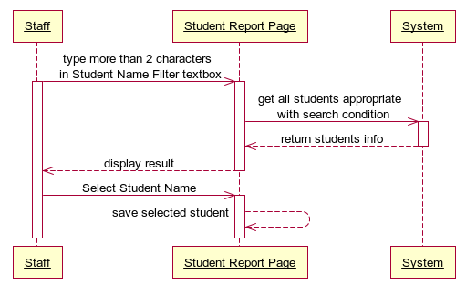



##### **<Staff> Filter by Student Name**

###### **Use Case Diagram**



###### **Use Case Specification**

|  |  |  |  |  |
| --- | --- | --- | --- | --- |
| **USE CASE- Filter by Student Name SPECIFICATION** | | | | |
| **Use-case No.** | UC0012 | **Use-case Version** | | 1.0 |
| **Use-case Name** | Filter by Student Name | | | |
| **Author** | LongNH | | | |
| **Date** | 02/02/2012 | **Priority** | Normal | |
| **Actor:** Staff  **Summary:** This use case allows staff to filter student’s subjects of University by the Student Name for viewing the entire appropriate student’s subjects, which have been studied by this student; he/she needs to see grade statistic and export reports later.  **Goal:** Display all students’ subjects in University which have been studied by this student appropriate with the filter condition.  **Triggers:** Click to “Search” button in Student Report page.  **Preconditions:** Logged into the system successfully as role staff and open “Student Report” page.  **Post Conditions:**  Success: List of Student’s Subjects in the system appropriate with the Student Name filter condition will be showed in the table student result in the right screen.  Fail: The table student result appears “No Result” text.  **Main Success Scenario:**   |  |  |  | | --- | --- | --- | | Step | Actor Action | System Response | | 1 | On “Student Report” page, staff clicks to “Student Name Filter” textbox and use “Auto Suggest Student Name” function of the system to select the right Student Name he/she wants to use for filtering list of Student’s Subjects. | Save information of the selected Student Name into memory to use for filtering student’s subjects later. | | 2 | Staff clicks to “Search” button. | Search through the system to get all student’s subjects which have been studied by this student appropriate with the Student Name filter condition and display all student’s subjects results in the student table. |   **Alternative Scenario 1:**   |  |  |  | | --- | --- | --- | | Step | Actor Action | System Response | | 1 | On “Student Report” page, staff clicks to “Student Name Filter” textbox and types exactly the name of Student that he/she wants to use for filtering list of Student’s Subjects. | Save information of the selected Student Name into memory to use for filtering student’s subjects later. | | 2 | Staff clicks to “Search” button. | Search through the system to get all student’s subjects which have been studied by this student appropriate with the Student Name filter condition and display all student’s subjects results in the student table. |   **Exceptions:** N/A  **Relationships:** Log in use case, View List Subjects of Student use case, Auto Suggest Student Name use case.  **Business Rules:** N/A | | | | |
| **Description:**  This use case is the main operation for helping staff to easily view the subjects’ status, statistic, and grade of a selected student and show information in the table. Which this list of student’s subjects, staff can easily have an overview about the studying status and grades by the whole course of that student. Beside that, staff also can export final grade reports and send email later for student.  Staff only needs to select the student name in “Student Name Filter” textbox and click “Search” button, the whole student’s subjects list result will be showed in the subject’s table. | | | | |

**Screen**

**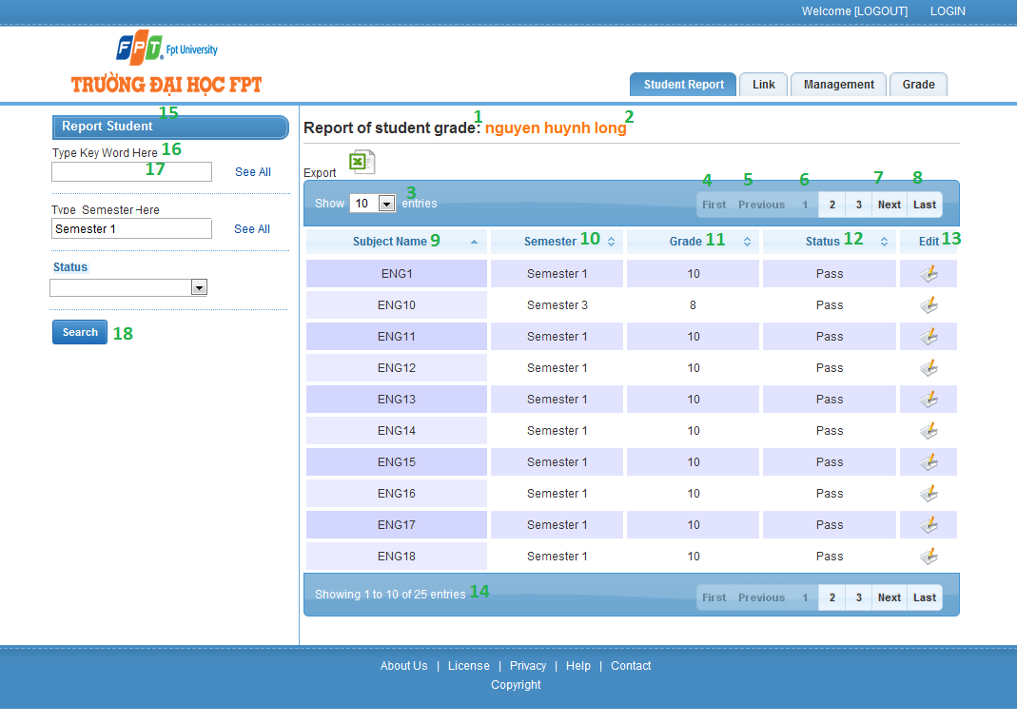**

**Data Fields Definition – Filter by Subject**

|  |  |  |  |  |  |  |
| --- | --- | --- | --- | --- | --- | --- |
| **Field name** | **Description** | **Read**  **Only** | **Mandatory** | **Control Type** | **Data Type** | **Length** |
| (15)Filter Title label | A label which contains “Report Student” | N/A | N/A | Label | Text | Fixed |
| (16)Student Name label | A label with contents “Type Key Word Here” | N/A | N/A | Label | Text | Fixed |
| (17) Student Name textfield | The Student Name that staff wants to select. | N | N | Textbox | Text | 200 |
| (1)Report title label | A label with contents “Report of student grade” | N/A | N/A | Label | Text | Fixed |
| (2)Student Name label | A label which contents the name of student | N/A | N/A | Label | Text | Fixed |
| (3)Number of results combobox | Acombobox contains the numbers such as: 10, 25, 50, 100 options for staff to select the number of rows display in table subject’s result. | N/A | N/A | Dropdown List | Integer | Fixed |
| (9)Subject Name label | A label contains “Subject Name” which is the title of column Subject Name in subjects table. | N/A | N/A | Label | Text | Fixed |
| (10) Semester label | A label contains “Semester” which is the title of column Semester in subjects table. | N/A | N/A | Label | Text | Fixed |
| (11) Grade label | A label contains “Grade” which is the title of column Grade in subjects table. | N/A | N/A | Label | Text | Fixed |
| (12) Status label | A label contains “Status” which is the title of column Status in subjects table. | N/A | N/A | Label | Text | Fixed |
| (13) Edit label | A label contains “Edit” which is the title of column Edit in subjects table. | N/A | N/A | Label | Text | Fixed |
| (14)Number of result label | A label contains “Showing ‘a number’ to ‘a number’ of ‘total number results’entries” which show the total results in subjects table | N/A | N/A | Label | Text | Fixed |

**Buttons / Hyper Links – Filter By Subject**

|  |  |  |  |  |
| --- | --- | --- | --- | --- |
| **Function** | **Description** | **Available Criteria** | **Validations** | **Outcome** |
| (18)Search button which the filter condition | The button will allow staffs to get all students’ subjects they need which the selected student name. | Always available | No validation | Get list subjects within the filter student name condition |
| (4)First button | Allow staff to navigate to the first page of the return list subjects in the table. | Only available if the return list subjects has data. | No validation | Go back to the first page of table list subjects. |
| (5)Previous button | Allow staff to navigate to the previous page of the return list subjects in the table. | Only available if the return list students has data. | No validation | Go back to the previous page of table list subjects. |
| (7)Next button | Allow staff to navigate to the next page of the return list subjects in the table. | Only available if the return list subjects has data. | No validation | Go to the next page of table list of subjects. |
| (8)Last button | Allow staff to navigate to the last page of the return list subjects in the table. | Only available if the return list subjects has data. | No validation | Go to the last page of table list subjects. |
| (6)Number button | Allow staff to navigate to the “number of the button” page of the return list subject in the table. | Only available if the return list subjects has data. | No validation | Go to “number of the button” page of table list subjects. |

###### **Sequence Diagram**

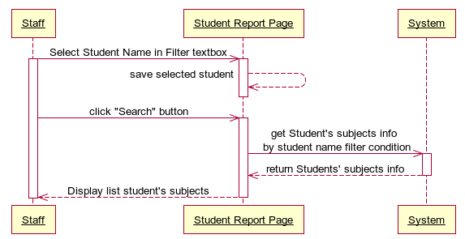



##### **<Staff> Auto Suggest Semester**

###### **Use Case Diagram**

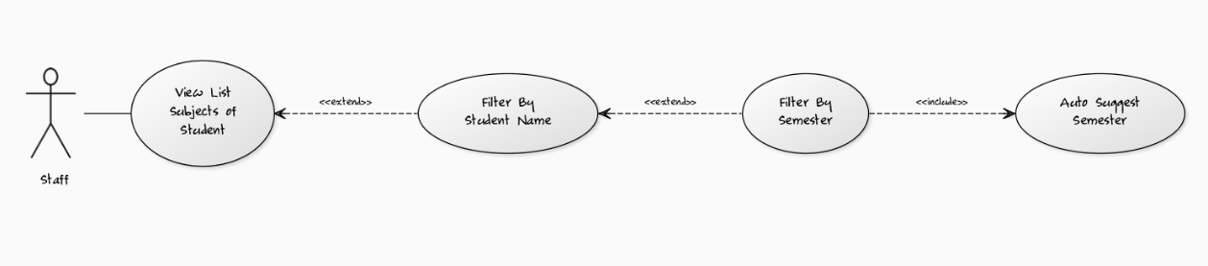

###### **Use Case Specification**

|  |  |  |  |  |
| --- | --- | --- | --- | --- |
| **USE CASE- Auto Suggest Semester SPECIFICATION** | | | | |
| **Use-case No.** | UC009 | **Use-case Version** | | 1.0 |
| **Use-case Name** | Auto Suggest Semester | | | |
| **Author** | LongNH | | | |
| **Date** | 02/02/2012 | **Priority** | Normal | |
| **Actor:** Staff  **Summary:** This use case supports staff to choose the right semester in system by the auto suggest list of semesters whenever staff types more than 2 characters in the text box Semester Filter.  **Goal:** This use case helps staffs does easily in selecting the right semester they want to use for filtering list of student’s subjects base on that semester.  **Triggers:** Click to “Semester Filter” textbox in “Student Report” page and type at least two characters.  **Preconditions:** Logged into the system successfully as staff role and open “Student Report” page.  **Post Conditions:**  Success: List of semesters in the system will be showed in the list box appears right below the textbox Semester Filter for staff to select.  Fail: The list box “No Result” appears right below the textbox Semester Filter.  **Main Success Scenario:**   |  |  |  | | --- | --- | --- | | Step | Actor Action | System Response | | 1 | On “Student Report” page, staff clicks to “Semester Filter” textbox and types at least two characters. | Search the system and return 3 first semester results, which contains the characters staff has typed, in the list box appears right below “Semester Filter” textbox. | | 2 | Staff clicks to “Load More” hyperlink button at the end of the list result. | Search the system and return 3 next semester results, which contains the characters staff has typed, in the list box appears right below “Semester Filter” textbox. | | 2 | Staff selects the right semester that he/she wants. | Save information of the selected semester into memory to use for filtering student’s subjects later. |   **Alternative Scenario 1:**   |  |  |  | | --- | --- | --- | | Step | Actor Action | System Response | | 1 | On “Student Report” page, staff clicks to “Semester Filter” textbox and types at least two characters. | Search the system and return 3 first semester results, which contains the characters staff has typed, in the list box appears right below “Semester Filter” textbox. | | 2 | Staff clicks to “Load More” hyperlink button at the end of the list result. | Search the system and return 3 next semester results, which contains the characters staff has typed, in the list box appears right below “Semester Filter” textbox. | | 3 | Staff selects the right semester that he/she wants. | Save information of the selected semester into memory to use for filtering student’s subjects later. |   **Alternative Scenario 2:**   |  |  |  | | --- | --- | --- | | Step | Actor Action | System Response | | 1 | On “Student Report” page, staff clicks to “See All” hyperlink next to “Semester Filter” textbox. | Search the system and return 3 first semester results in the list box appears right below “Semester Filter” textbox. | | 2 | Staff clicks to “Load More” hyperlink button at the end of the list result. | Search the system and return 3 next semester results in the list box appears right below “Semester Filter” textbox. | | 3 | Staff selects the right semester that he/she wants. | Save information of the selected semester into memory to use for filtering student’s subjects later. |   **Exceptions:** N/A  **Relationships:** Log in use case, Filter By Student Name use case, Filter By Semester use case.  **Business Rules:** N/A | | | | |
| **Description:**  This use case is used to support staff does easily in selecting the right semester for filtering list of student’s subjects in order to view student’s grade statistic report final student grade. Because of the University have a lot of semesters, staffs will hard to remember all of them. This function is the guide for him/her to select the right semester he/she wants by suggesting list of semesters for staff to choose. It’s quick and save time.  Staff only need to click to “Semester Filter” textbox and type at least two characters, the system will search and return 3 first semesters, which have a name contains these characters, in the list box result right below the “Semester Filter” textbox. If in 3 first results don’t include the semester staff needs, he/she can view 3 next results by clicking “Load More” hyperlink button in the end of the list box result and the system will return the 3 next semester results for staff. The finally action is just simply select the right semester in the list box result and system will save this semester information into memory for filtering student’s subjects later. | | | | |

**Screen**

****

**Data Fields Definition – Auto Suggest Semester**

|  |  |  |  |  |  |  |
| --- | --- | --- | --- | --- | --- | --- |
| **Field name** | **Description** | **Read**  **Only** | **Mandatory** | **Control Type** | **Data Type** | **Length** |
| (1) Semester label | A label contents “Type Semester Here” | N/A | N/A | Label | Text | Fixed |
| (2)Semester textfield | The textbox for staff to type name of semester he/she wants to choose. | N | N | Textbox | Text | 200 |
| (4) Semester Result label | A label contents the semester name result of suggesting. | N/A | N/A | Label | Text | Fixed |

**Buttons / Hyper Links – Auto Suggest Semester**

|  |  |  |  |  |
| --- | --- | --- | --- | --- |
| **Function** | **Description** | **Available Criteria** | **Validations** | **Outcome** |
| (3) See All Hyperlink Button | The button will allows the system to search all of the semesters and return into List Box result | Always available | No | The semester results will be loaded and display into the List Box Semester Result for staff to choose. |
| (5) Load More Hyperlink Button | The button will allow the system to load next three semester results into List Box result. | Only available when the result of semester in return list is more than 3. | No | The next 3 semester results will be loaded and display into the List Box Semester Result for staff to choose. |

###### **Sequence Diagram**

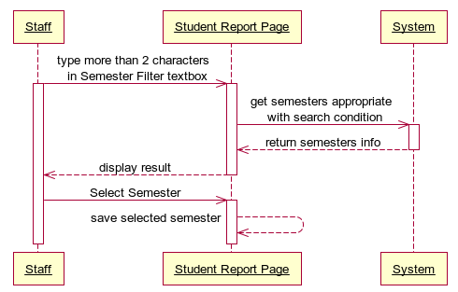



##### **<Staff> Filter by Semester**

###### **Use Case Diagram**



###### **Use Case Specification**

|  |  |  |  |  |
| --- | --- | --- | --- | --- |
| **USE CASE- Filter by Semester SPECIFICATION** | | | | |
| **Use-case No.** | UC010 | **Use-case Version** | | 1.0 |
| **Use-case Name** | Filter by Semester | | | |
| **Author** | LongNH | | | |
| **Date** | 02/02/2012 | **Priority** | Normal | |
| **Actor:** Staff  **Summary:** This use case allows staff to filter student’s subjects of University by the semester for viewing the entire appropriate student’s information, which has been studied in that semester; he/she needs to see grade statistic and export reports later.  **Goal:** Display all students’ subjects which have been studied in the semester appropriate with the filter condition.  **Triggers:** Click to “Search” button in Student Report page.  **Preconditions:** Logged into the system successfully as role staff and open “Student Report” page.  **Post Conditions:**  Success: List of student’s subjects in the system appropriate with the semester filter condition will be showed in the table student result in the right screen.  Fail: The table student result appears “No Result” text.  **Main Success Scenario:**   |  |  |  | | --- | --- | --- | | Step | Actor Action | System Response | | 1 | On “Student Report” page, after select student, staff clicks to “Semester Filter” textbox and use “Auto Suggest Semester” function of the system to select the right semester name he/she wants to use for filtering list of student’s subjects. | Save information of the selected Semester into memory to use for filtering student’s subjects later. | | 2 | Staff clicks to “Search” button. | Search through the system to get all students’ subjects which have been studied in the semester appropriate with the semester filter condition and display all these information results in the subject’s table. |   **Alternative Scenario 1:**   |  |  |  | | --- | --- | --- | | Step | Actor Action | System Response | | 1 | On “Student Report” page, after select student, staff clicks to “Semester Filter” textbox and types exactly the name of semester that he/she wants to use for filtering list of student’s subjects. | Save information of the selected Semester into memory to use for filtering student’s subjects later. | | 2 | Staff clicks to “Search” button. | Search through the system to get all student’s subjects which have been studied in the semester appropriate with the semester filter condition and display all student’s subjects results in the subject’s table. |   **Exceptions:** N/A  **Relationships:** Log in use case, Filter By Student Name use case, Auto Suggest Semester use case.  **Business Rules:** N/A | | | | |
| **Description:**  This use case is the support operation for helping staff to easily view the subjects’ status, statistic, and grade of a student which have been studied by this student in the filtered semester and show information in the table. Which this list of student’s subjects, staff can easily have an overview about the studying status and grades by each semester or by the whole course of that student. Beside that, staff also can export final grade reports and send email later for student.  Staff only needs to type the semester name in “Semester Filter” textbox and click “Search” button, the whole student’s subjects list result will be showed in the subject’s table. | | | | |

**Screen**

**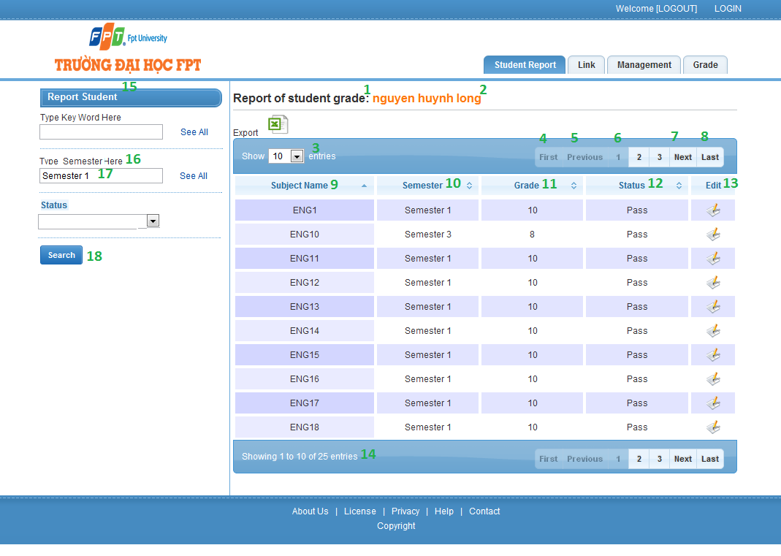**

**Data Fields Definition – Filter by Semester**

|  |  |  |  |  |  |  |
| --- | --- | --- | --- | --- | --- | --- |
| **Field name** | **Description** | **Read**  **Only** | **Mandatory** | **Control Type** | **Data Type** | **Length** |
| (15)Filter Title label | A label which contains “Report Student” | N/A | N/A | Label | Text | Fixed |
| (16)Semester label | A label with contents “Type Semester Here” | N/A | N/A | Label | Text | Fixed |
| (17)Semester textfield | The Semester Name that staff wants to select. | N | N | Textbox | Text | 200 |
| (1)Report title label | A label with contents “Report of student grade” | N/A | N/A | Label | Text | Fixed |
| (2)Student Name label | A label which contents the name of student | N/A | N/A | Label | Text | Fixed |
| (3)Number of results combobox | Acombobox contains the numbers such as: 10, 25, 50, 100 options for staff to select the number of rows display in table subjects result. | N/A | N/A | Dropdown List | Integer | Fixed |
| (9)Subject Name label | A label contains “Subject Name” which is the title of column Subject Name in subjects table. | N/A | N/A | Label | Text | Fixed |
| (10) Semester label | A label contains “Semester” which is the title of column Semester in subjects table. | N/A | N/A | Label | Text | Fixed |
| (11) Grade label | A label contains “Grade” which is the title of column Grade in subjects table. | N/A | N/A | Label | Text | Fixed |
| (12) Status label | A label contains “Status” which is the title of column Status in subjects table. | N/A | N/A | Label | Text | Fixed |
| (13) Edit label | A label contains “Edit” which is the title of column Edit in subjects table. | N/A | N/A | Label | Text | Fixed |
| (14)Number of result label | A label contains “Showing ‘a number’ to ‘a number’ of ‘total number results’entries” which show the total results in subjects table | N/A | N/A | Label | Text | Fixed |

**Buttons / Hyper Links – Filter By Semester**

|  |  |  |  |  |
| --- | --- | --- | --- | --- |
| **Function** | **Description** | **Available Criteria** | **Validations** | **Outcome** |
| (18)Search button which the filter condition | The button will allow staffs to get all students’ subjects they need which the selected semester. | Always available | No validation | Get list subjects within the filter semester condition |
| (4)First button | Allow staff to navigate to the first page of the return list subjects in the table. | Only available if the return list subjects has data. | No validation | Go back to the first page of table list subjects. |
| (5)Previous button | Allow staff to navigate to the previous page of the return list subjects in the table. | Only available if the return list students has data. | No validation | Go back to the previous page of table list subjects. |
| (7)Next button | Allow staff to navigate to the next page of the return list subjects in the table. | Only available if the return list subjects has data. | No validation | Go to the next page of table list of subjects. |
| (8)Last button | Allow staff to navigate to the last page of the return list subjects in the table. | Only available if the return list subjects has data. | No validation | Go to the last page of table list subjects. |
| (6)Number button | Allow staff to navigate to the “number of the button” page of the return list subject in the table. | Only available if the return list subjects has data. | No validation | Go to “number of the button” page of table list subjects. |

###### **Sequence Diagram**

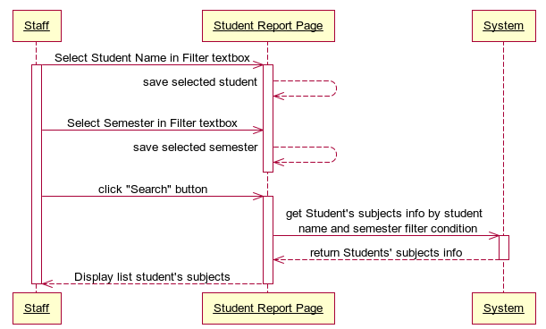



##### **<Staff> Filter by Status**

###### **Use Case Diagram**

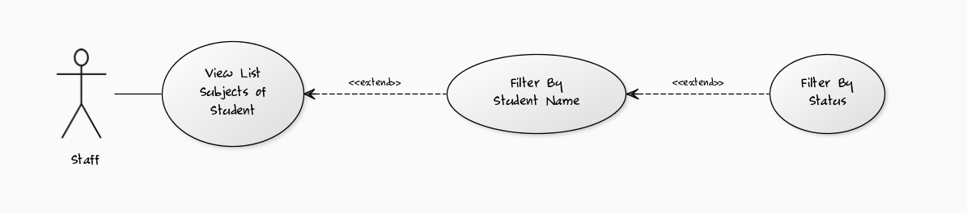

###### **Use Case Specification**

|  |  |  |  |  |
| --- | --- | --- | --- | --- |
| **USE CASE- Filter by Status SPECIFICATION** | | | | |
| **Use-case No.** | UC013 | **Use-case Version** | | 1.0 |
| **Use-case Name** | Filter by Status | | | |
| **Author** | LongNH | | | |
| **Date** | 02/02/2012 | **Priority** | Normal | |
| **Actor:** Staff  **Summary:** This use case allows staff to filter student’s subjects of University by the Status for viewing the entire appropriate student’s subjects, which have the status equal with the filter condition; he/she needs to see grade statistic and export reports later.  **Goal:** Display all students’ subjects in University which have the status equal with the filter condition.  **Triggers:** Click to “Search” button in Student Report page.  **Preconditions:** Logged into the system successfully as role staff and open “Student Report” page.  **Post Conditions:**  Success: List of Student’s Subject in the system appropriate with the Status filter condition will be showed in the table student result in the right screen.  Fail: The table student result appears “No Result” text.  **Main Success Scenario:**   |  |  |  | | --- | --- | --- | | Step | Actor Action | System Response | | 1 | On “Student Report” page, after select student, staff clicks to “Status Filter” dropdownlist and select the Status he/she wants to use for filtering list of Student’s Subjects. | Save information of the selected status into memory to use for filtering student’s subjects later. | | 2 | Staff clicks to “Search” button. | Search through the system to get all students’ subjects which have the status equal with the filter condition and display all these results in the student table. |   **Alternative Scenario:** N/A  **Exceptions:** N/A  **Relationships:** Log in use case, Filter By Student Name use case  **Business Rules:** N/A | | | | |
| **Description:**  This use case is the support operation for helping staff to easily view the subject’s statistic, grade of a student which have status equal with the filter status condition staff has selected and show information in the table. Such as staff can choose the view list subjects with status “Pass” for one student to view his/her studying information. Which this list of student’s subjects, staff can easily have an overview about the studying grades by status of each subjects of a student. Beside that, staff also can export final grade reports and send email later for student.  Staff only needs to clicks to the Status dropdown list and select the right status he/she wants to use for filtering, after that staff clicks “Search” button, the whole student’s subjects appropriate with the status filter condition list result will be showed in the subject’s table. | | | | |

**Screen**

**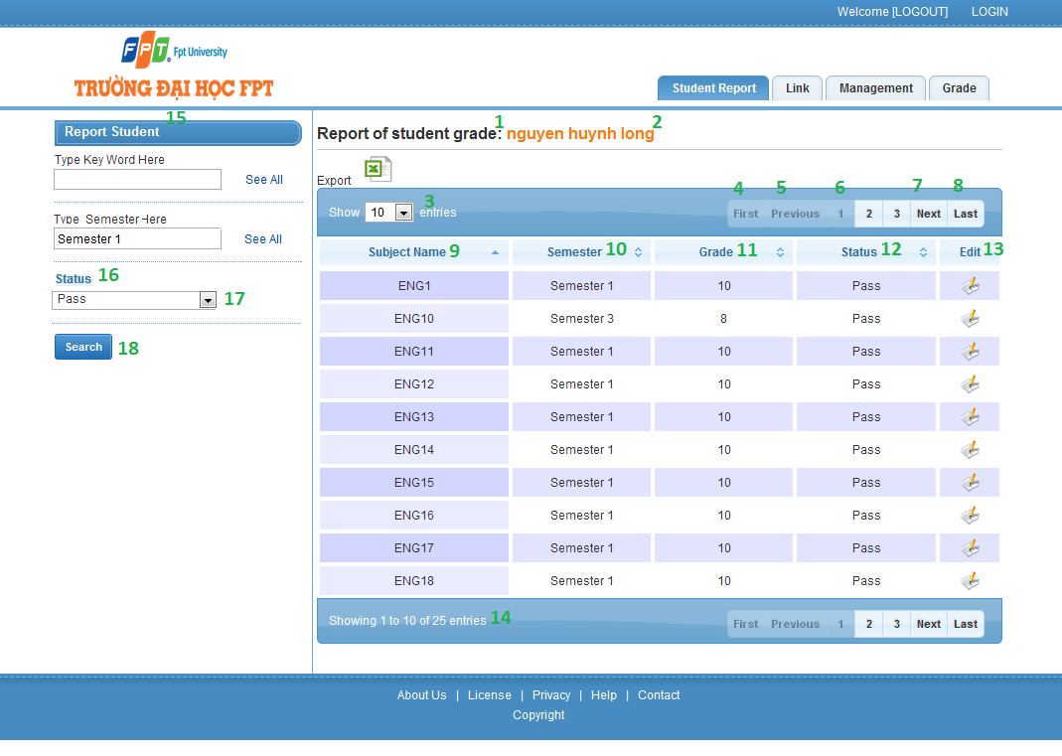**

**Data Fields Definition – Filter by Status**

|  |  |  |  |  |  |  |
| --- | --- | --- | --- | --- | --- | --- |
| **Field name** | **Description** | **Read**  **Only** | **Mandatory** | **Control Type** | **Data Type** | **Length** |
| (15)Filter Title label | A label which contains “Report Student” | N/A | N/A | Label | Text | Fixed |
| (16)Status label | A label with contents “Status” | N/A | N/A | Label | Text | Fixed |
| (17) Status combo box | The Status that staff wants to select. | N | N | Textbox | Text | 200 |
| (1)Report title label | A label with contents “Report of student grade” | N/A | N/A | Label | Text | Fixed |
| (2)Student Name label | A label which contents the name of student | N/A | N/A | Label | Text | Fixed |
| (3)Number of results combobox | Acombobox contains the numbers such as: 10, 25, 50, 100 options for staff to select the number of rows display in table subject’s result. | N/A | N/A | Dropdown List | Integer | Fixed |
| (9)Subject Name label | A label contains “Subject Name” which is the title of column Subject Name in subjects table. | N/A | N/A | Label | Text | Fixed |
| (10) Semester label | A label contains “Semester” which is the title of column Semester in subjects table. | N/A | N/A | Label | Text | Fixed |
| (11) Grade label | A label contains “Grade” which is the title of column Grade in subjects table. | N/A | N/A | Label | Text | Fixed |
| (12) Status label | A label contains “Status” which is the title of column Status in subjects table. | N/A | N/A | Label | Text | Fixed |
| (13) Edit label | A label contains “Edit” which is the title of column Edit in subjects table. | N/A | N/A | Label | Text | Fixed |
| (14)Number of result label | A label contains “Showing ‘a number’ to ‘a number’ of ‘total number results’entries” which show the total results in subjects table | N/A | N/A | Label | Text | Fixed |

**Buttons / Hyper Links – Filter By Status**

|  |  |  |  |  |
| --- | --- | --- | --- | --- |
| **Function** | **Description** | **Available Criteria** | **Validations** | **Outcome** |
| (18)Search button which the filter condition | The button will allow staffs to get all students’ subjects they need which the selected status. | Always available | No validation | Get list subjects within the filter status condition |
| (4)First button | Allow staff to navigate to the first page of the return list subjects in the table. | Only available if the return list subjects has data. | No validation | Go back to the first page of table list subjects. |
| (5)Previous button | Allow staff to navigate to the previous page of the return list subjects in the table. | Only available if the return list students has data. | No validation | Go back to the previous page of table list subjects. |
| (7)Next button | Allow staff to navigate to the next page of the return list subjects in the table. | Only available if the return list subjects has data. | No validation | Go to the next page of table list of subjects. |
| (8)Last button | Allow staff to navigate to the last page of the return list subjects in the table. | Only available if the return list subjects has data. | No validation | Go to the last page of table list subjects. |
| (6)Number button | Allow staff to navigate to the “number of the button” page of the return list subject in the table. | Only available if the return list subjects has data. | No validation | Go to “number of the button” page of table list subjects. |

###### **Sequence Diagram**

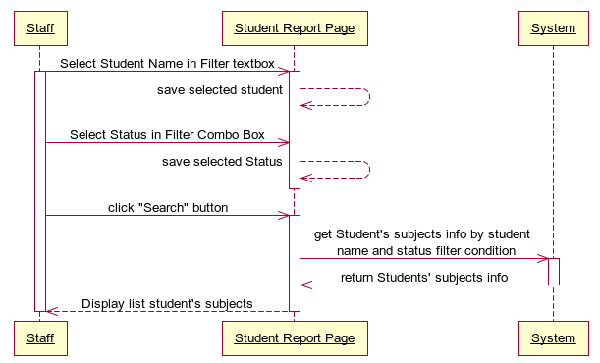



##### **<Staff> Export Report**

###### **Use Case Diagram**

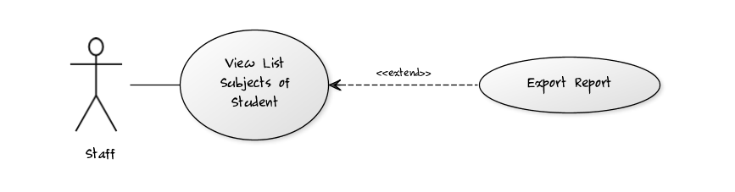

###### **Use Case Specification**

|  |  |  |  |  |
| --- | --- | --- | --- | --- |
| **USE CASE- Export Report SPECIFICATION** | | | | |
| **Use-case No.** | UC014 | **Use-case Version** | | 1.0 |
| **Use-case Name** | Export Report | | | |
| **Author** | LongNH | | | |
| **Date** | 02/02/2012 | **Priority** | High | |
| **Actor:** Staff  **Summary:** This use case allows staff to export grade reports for student which has been filtered by Student Name before.  **Goal:** Export grade report for student.  **Triggers:** Click to the “Export” image button in “Student Report” page.  **Preconditions:**  Logged into the system successfully as staff role and open “Student Report” page, select student need to export report in the table.  **Post Conditions:**  Success: return an excel report file which contents all grade and status information of student for staff to download.  Fail: No file return to download.  **Main Success Scenario:**   |  |  |  | | --- | --- | --- | | Step | Actor Action | System Response | | 1 | On “Student Report” page after search student, staff clicks to “Export” image button. | System get all student’s subjects information in the list, get students’ grade and create excel file grade report for this student, after that, system send back to staff. | | 2 | Staff clicks to download excel file report to his/her computer. |  |   **Exceptions:** N/A  **Relationships:** Log in Use Case, View List Subjects of Student use case.  **Business Rules:** N/A | | | | |
| **Description:**  This use case helps staffs quickly summarize, calculate grade study and make final grade reports for student in the list filter by Student Name just by a mouse click.  These reports file of student will be made in a form of excel file and send back for staff to download to their computer. | | | | |

**Screen**

****

**Data Fields Definition – Export Report**

|  |  |  |  |  |  |  |
| --- | --- | --- | --- | --- | --- | --- |
| **Field name** | **Description** | **Read**  **Only** | **Mandatory** | **Control Type** | **Data Type** | **Length** |
| (1) Export label | A label which contents “Export” | N/A | N/A | Label | Text | Fixed |

**Buttons / Hyper Links – Export Report**

|  |  |  |  |  |
| --- | --- | --- | --- | --- |
| **Function** | **Description** | **Available Criteria** | **Validations** | **Outcome** |
| (2)Export Image Button | This button is for get all grade report from system to client computer. | Only available if the list of student’s subjects in table have data. | No validation | Return the grade reports of student in the table to staff. |



###### **Sequence Diagram**

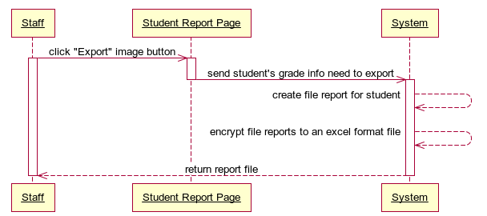

##### **<Staff> Edit Subject’s Grade Information**

###### **Use Case Diagram**

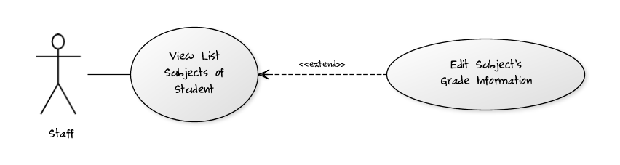

###### **Use Case Specification**

|  |  |  |  |  |
| --- | --- | --- | --- | --- |
| **USE CASE- Edit Subject’s Grade Information SPECIFICATION** | | | | |
| **Use-case No.** | UC015 | **Use-case Version** | | 1.0 |
| **Use-case Name** | Edit Subject’s Grade Information | | | |
| **Author** | LongNH | | | |
| **Date** | 02/02/2012 | **Priority** | Normal | |
| **Actor:** Staff  **Summary:** When staff needs to modify studying information of student like Status, Grade, Rank, Semester of a subject… he/she can easily make it by click to “Edit” image button in the subjects table of “Student Report” page.  **Goal:** This use case allows staff modifies studying information of student.  **Triggers: C**lick the “Edit” image button in the subjects table of “Student Report” page.  **Preconditions:** Already logged into the system successfully as staff role, open “Student Report” page and filter list student’s subjects.  **Post Conditions:**  Success: New studying information of student is updated and redirect back to “Student Report” page with the alert message “Information was updated successfully!”  Fail: New information of student is not updated and redirect back to “Student Report” page with the alert message “Update information fail!”  **Main Success Scenario:**   |  |  |  | | --- | --- | --- | | Step | Actor Action | System Response | | 1 | On “Student Report” page staff clicks to “Edit” image button in the subjects table of subject that needs to be updated | System opens “Update StudentSubject” page to edit subject’s information. | | 2 | Staff modifies information |  | | 3 | Staff clicks to “Update” button | - System checks information input [Exception1] - System updates new information of student’s subject into database, then displays a successful message.  - System redirects to the “Student Report” page with the up-to-date data. |   **Alternative Scenario 1:**   |  |  |  | | --- | --- | --- | | Step | Actor Action | System Response | | 1 | On “Student Report” page staff clicks to “Edit” image button in the subjects table of subject that needs to be updated | System opens “Update StudentSubject” page to edit subject’s information. | | 2 | Staff modifies information |  | | 3 | Staff clicks to “Close” button | System will redirect to the “Student Report”page and the data still is as before. |   **Exceptions:**   |  |  |  | | --- | --- | --- | | No | Actor Action | System Response | | 1 | Actor does not select ‘Subject’ combo box | System Display: ‘Please select Subject’ | | 2 | Actor does not select ‘Student’ combo box | System Display: ‘Please select Student’ | | 3 | Actor does not select ‘Semester’ combo box | System Display: ‘Please select Semester’ | | 4 | Actor lefts ‘Grade’ textfield blank | System Display: ‘Please input Grade’ | | 5 | Actor lefts ‘Rank’ textfield blank | System Display: ‘Please input Rank’ | | 6 | Actor does not select ‘Class’ combo box | System Display: ‘Please select Class’ | | 7 | Actor does not input ‘Grade’ textfield in Number format. | System Display: ‘Grade require number format’ |   **Relationships:** Log in use case, View List Subjects of Student use case  **Business Rules:** N/A | | | | |
| **Description:**  Edit Studying information helps staffs or instructors manage and update newest subjects’ studying information of a student whenever they need.  To edit studying information, staff needs to go to Student Report page first. After select a student and display this student’s subject’s information, staff clicks to “Edit” image button of the subject that needs to be updated and the system will redirect staff to “Update StudentSubject” page. At “Update StudentSubject” page, after modify data, clicks to “Update” button to save all changes or click to “Close” button to go back to the previous page. All validations for input data will take effect. | | | | |

**Screen**

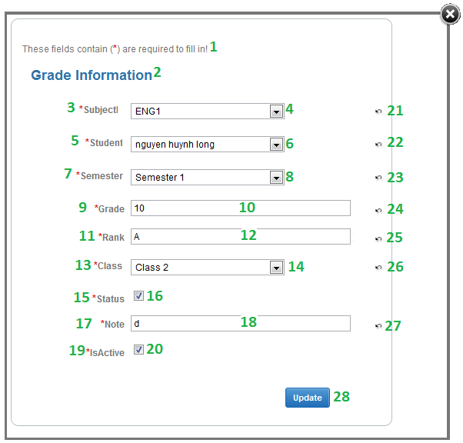

**Data Fields Definition – Edit Subject’s Grade Information**

|  |  |  |  |  |  |  |
| --- | --- | --- | --- | --- | --- | --- |
| **Field name** | **Description** | **Read**  **Only** | **Mandatory** | **Control Type** | **Data Type** | **Length** |
| (1)Instruction | This field contains instructions for edit a student’s subject information | N/A | N/A | Label | Text | Fixed |
| (2)Basic information | The following fields will be surrounded by a border to allow logical grouping of data for the subject. The border will have a heading titled “Grade Information” | N/A | N/A | Label | Text | Fixed |
| (3)Subject label | A label with contents “Subject” | N/A | N/A | Label | Text | Fixed |
| (4) Subject Combobox | The subject name of the student that to be edited. | N | Y | Combo Box | Text |  |
| (5)Student label | A label with contents “Student ” | N/A | N/A | Label | Text | Fixed |
| (6) Student Combobox | The full name of the student that to be edited. | N | Y | Combo Box | Text |  |
| (7)Semester label | A label with contents “Semester” | N/A | N/A | Label | Text | Fixed |
| (8) Semester Combobox | The Semester which the student studied that subject to be edited. | N | Y | Combo Box | Text |  |
| (9)Grade label | A label with contents “Grade” | N/A | N/A | Label | Text | Fixed |
| (10)Grade textfield | The Subject’s Grade of the student in Semester that to be edited. | N | Y | Text Box | Text | 20 |
| (11)Rank label | A label with contents “Rank Identity” | N/A | N/A | Label | Text | Fixed |
| (12) Rank textfield | The Rank of the student that to be edited. | N | Y | Text Box | Text | 20 |
| (13)Class label | A label with contents “Class” | N/A | N/A | Label | Text | Fixed |
| (14) Class Combobox | The Class name of the student that to be edited. | N | Y | Combo Box | Text |  |
| (15)Status label | A label with content “Status” | N/A | N/A | Label | Text | Fixed |
| (16) Status check box | The Subject’s Status of student that to be edited. | N | Y | Check Box | Boolean |  |
| (17)Note label | A label with content “Note” | N/A | N/A | Label | Text | Fixed |
| (18)Note textfield | The Note of student that to be edited. | N | N | Text Box | Text | 200 |
| (19)Is Active label | A label with content “Is Active” | N/A | N/A | Label | Text | Fixed |
| (20)Is Active check box | The activevate status of student that to be edited. | N | N | Check Box | Boolean |  |

**Buttons / Hyper Links – Edit Subject’s Grade Information**

|  |  |  |  |  |
| --- | --- | --- | --- | --- |
| **Function** | **Description** | **Available Criteria** | **Validations** | **Outcome** |
| (28)Update button | The button will allow staff to update the student’s subject information | Always available | Validate all mandatory fields and the format of Date Of Birth, Email and Phone. | New information is saved to database. Staff gets redirected back to the previous page with a successful message. |
| (29)Close image button | The button will allow the user to cancel editing | Always available | No | staff will be redirected back to previous page |
| (21)-(27)Image buttons Undo edited fields | These buttons will allow staffs to get back the original information of each fields before they have updated | Always available | No | The original information of the textfields will be inserted into the textfields |

###### **Sequence Diagram**

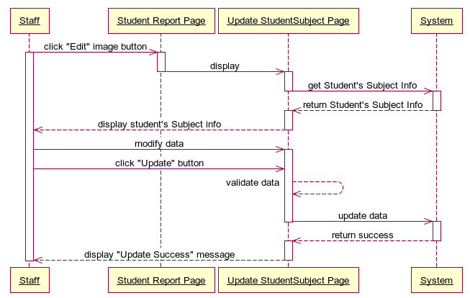

#### <Staff> Edit Staff’s Personal Information

##### **Use Case Diagram**

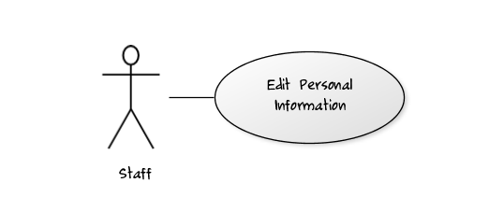

##### **Use Case Specification**

|  |  |  |  |  |
| --- | --- | --- | --- | --- |
| **USE CASE – Edit Staff’s Personal Information SPECIFICATION** | | | | |
| **Use-case No.** | UC016 | **Use-case Version** | | 1.0 |
| **Use-case Name** | Edit Staff’s Personal Information | | | |
| **Author** | LongNH | | | |
| **Date** | 02/02/2012 | **Priority** | Normal | |
| **Actor:** Staff  **Summary:** This use case allows staff to edit their personal information in this system whenever they need to update their newest personal information such as address, phone number, full name…  **Goal:** Allows staffs update their personal information.  **Triggers:** Click to “Their name” in Welcome bar at home page  **Preconditions:** Staff logged into the system successfully as role staff.  **Post Conditions:**  Success: New information of staff is updated and redirect back to the previous page with the alert message “Information was updated successfully!”  Fail: New information of staff is updated and redirect back to the previous page with the alert message “Update information fail!”  **Main Success Scenario:**   |  |  |  | | --- | --- | --- | | Step | Actor Action | System Response | | 1 | On “Home Page” page staff clicks to “Their name” hyperlink on the welcome bar. | System redirects to “Update Staff” page to edit staff’s information. | | 2 | Staff modifies his/her information |  | | 3 | Staff clicks to “Update” button | - System checks information input [Exception1] - System updates new information of staff into database, then displays a successful message.  - System redirects to the previous page with the up-to-date data. |   **Alternative Scenario:**   |  |  |  | | --- | --- | --- | | Step | Actor Action | System Response | | 1 | On “Home Page” page staff clicks to “Their name” hyperlink on the welcome bar. | System redirects to “Update Staff” page to edit staff’s information. | | 2 | Staff modifies his/her information |  | | 3 | Staff clicks to “Close” button. | System will redirect to the previous page and the data still is as before. |   **Exceptions:**   |  |  |  | | --- | --- | --- | | No | Actor Action | System Response | | 1 | Actor lefts ‘Full Name’ textfield blank | System Display: ‘Please input Full Name’ | | 2 | Actor lefts ‘Email’ textfield blank | System Display: ‘Please input Email’ | | 3 | Actor does not input ‘Email’ textfield in email address format. | System Display: ‘Format of Email is wrong, the format is ….@fpt.edu.vn’ | | 4 | Actor does not input ‘Identity’ textfield in Number format. | System Display: ‘Student Identity require number format’ | | 5 | Actor does not input ‘Phone’ textfield in Number format. | System Display: ‘Phone require number format’ |   **Relationships:** Log in use case  **Business Rules:** N/A | | | | |
| **Description:**  Whenever staffs need to update their personal information, they click to “Their name” hyperlink on the welcome bar and get redirect to Staff Update page to edit their information. In order to update their information, staffs need enter their full name.  When staffs click to “Update” button, the system will update the new information to database. By click to “Close” button, staffs will go back to previous page. | | | | |

**Screen**

****

**Data Fields Definition – Edit Staff Personal Information**

|  |  |  |  |  |  |  |
| --- | --- | --- | --- | --- | --- | --- |
| **Field name** | **Description** | **Read**  **Only** | **Mandatory** | **Control Type** | **Data Type** | **Length** |
| (1)Instruction | This field contains instructions for edit a staff | N/A | N/A | Label | Text | Fixed |
| (2)Basic information | The following fields will be surrounded by a border to allow logical grouping of data for the staff. The border will have a heading titled “Staff Personal Information” | N/A | N/A | Label | Text | Fixed |
| (4)Full Name label | A label with contents “Full Name” | N/A | N/A | Label | Text | Fixed |
| (5)Full Name textfield | The full name of the staff that to be edited. | N | Y | Text Box | Text | 200 |
| (6)Email label | A label with contents “Email” | N/A | N/A | Label | Text | Fixed |
| (7)Email textfield | The Email of the staff that to be edited. | N | Y | Text Box | Text | 200 |
| (8) Identity label | A label with contents “Identity” | N/A | N/A | Label | Text | Fixed |
| (9) Identity textfield | The Student Identity of the staff that to be edited. | N | Y | Text Box | Text | 200 |
| (10)Phone label | A label with content “Phone” | N/A | N/A | Label | Text | Fixed |
| (11)Phone textfield | The telephone of staff that to be edited. | N | N | Text Box | Text | 50 |
| (12)Note label | A label with content “Note” | N/A | N/A | Label | Text | Fixed |
| (13)Note textfield | The Note of staff that to be edited. | N | N | Text Box | Text | 200 |
| (14)Is Active label | A label with content “Is Active” | N/A | N/A | Label | Text | Fixed |
| (15)Is Active check box | The status of staff that to be edited. | N | N | Check Box | Boolean |  |

**Buttons / Hyper Links – Edit Staff Personal Information**

|  |  |  |  |  |
| --- | --- | --- | --- | --- |
| **Function** | **Description** | **Available Criteria** | **Validations** | **Outcome** |
| (21)Update information | The button will allow staffs to update their personal information in the system | Always available | Validate all mandatory fields. | The record will be updated and staffs will be navigated to the previous page. |
| (16)-(20)Image buttons Undo edited fields | These buttons will allow staffs to get back the original information of each fields before they have updated | Always available | No | The original information of the textfields will be inserted into the textfields |
| (3)Close editing | The button will allow staffs cancel editing their personal information. | Always available | No | Staffs will be navigated to the previous page. |

##### **Sequence Diagram**

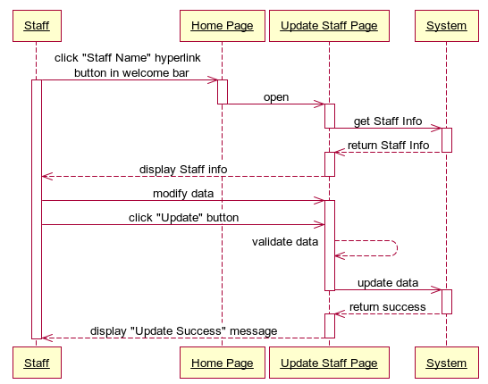

#### <System> Send Report Mail for Student

##### **Use Case Diagram**

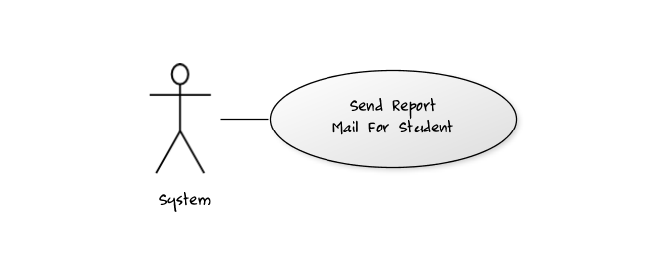

##### **Use Case Specification**

|  |  |  |  |  |
| --- | --- | --- | --- | --- |
| **USE CASE – Send Report Mail for Student SPECIFICATION** | | | | |
| **Use-case No.** | UC018 | **Use-case Version** | | 1.0 |
| **Use-case Name** | Send Report Mail for Student | | | |
| **Author** | LongNH | | | |
| **Date** | 03/02/2012 | **Priority** | High | |
| **Actor:** System  **Summary:** This use case allows system to auto check student’s final grade reports every 10 minutes and sends them for students via Fpt University e-mail.  **Goal:** Allows system auto attaches final grade report if have into e-mail and send for its student.  **Triggers:** After every 10 minutes, system will auto activate and check file to send e-mail.  **Preconditions:** Student’s grade report was exported and the file path location was updated into database.  **Post Conditions:**  Success: The Final Grade Report will be sent for student via his/her e-mail.  Fail: The Final Grade Report sending via email fail. System will try to send again after 10 minutes.  **Main Success Scenario:**   |  |  |  | | --- | --- | --- | | Step | Actor Action | System Response | | 1 | System access Database after every 10 minutes to check file report location | Return location path of the report file | | 2 | System get email address of student who’s this report belongs to. | Return email address of this student. | | 3 | System gets file report to attach to e-mail content and send this email for student. |  |   **Alternative Scenario:**   |  |  |  | | --- | --- | --- | | Step | Actor Action | System Response | | 1 | System access Database after every 10 minutes to check file report location | Return null | | 2 | System terminates the process of auto emailing. |  |   **Exceptions:**   |  |  |  | | --- | --- | --- | | No | Actor Action | System Response | | 1 | No file report was found by following the location file path. | Log Error on file and terminate process. | | 2 | The email address of student is wrong | Try to send email after 10 minutes later. | | 3 | The internet connection is lost | Log Error and try to send email after 10 minutes later. |   **Relationships:** N/A  **Business Rules:** N/A | | | | |
| **Description:** This use case allows the system provides an important function to support staff send final grade report for student automatically. Staff now does not need to do lots of things in preparing grade report for student, write email and send for each student. Now this task will be covered by auto mail window service system and help increase productivity for the university in manage student training process.  Staff just needs to export final grade report for student or list of students by functions exporting, the entire jobs such as checking which student need to send email or send email for list student with attach report file will be taken by the system. | | | | |

**Screen:** N/A

**Data Fields Definition – Send Report Mail for Student:** N/A

**Buttons / Hyper Links – Send Report Mail for Student:** N/A

##### **Sequence Diagram**

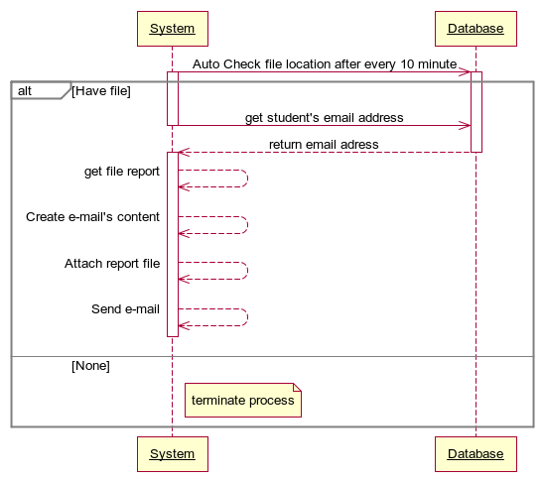

#### <Staff>Import Excel Data File

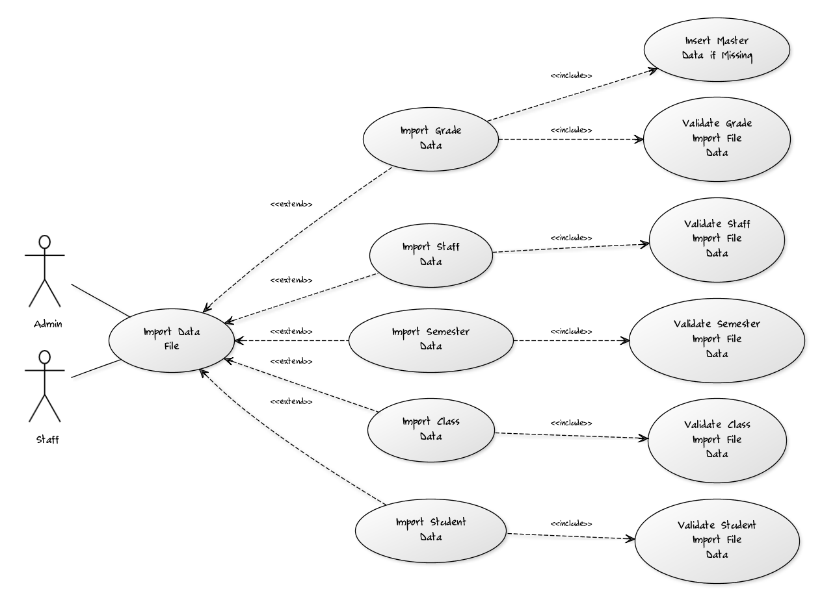



##### **Validate Student Import File Data**

###### **Use Case Diagram**

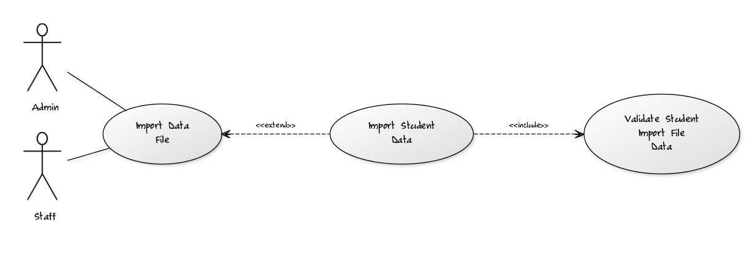

###### **Use Case Specification**

|  |  |  |  |  |
| --- | --- | --- | --- | --- |
| **USE CASE- Validate Student Import File Data SPECIFICATION** | | | | |
| **Use-case No.** | UC001 | **Use-case Version** | | 1.0 |
| **Use-case Name** | Validate Student Import File Data | | | |
| **Author** | KhuongPD | | | |
| **Date** | 01/02/2012 | **Priority** | Normal | |
| **Actor:** Admin, Staff  **Summary:** This use case supports admin and staff to validate template and data of student import file which are chosen in the input file component.  **Goal:** This use case helps staff and admin to validate template base on these conditions:   * Header Column of upload file must exactly like ones in template file. * Type of data field must be validated before import the data to system database.   **Triggers:** Select file in “Select Import File” input file component in “Import Student File Data” page and click “Import Student”  **Preconditions:**  Logged into the system successfully as staff or admin role and open “Import Student File Data” page.  **Post Conditions:**  Success: Data is validate, means system can move to import this Student File into database, after import successfully, system shows message “Import Student Successfully”  Fail: The highlight message like “Data is not validated. Errors happen in line 2 Column AB” appears right below the input file component.  **Main Success Scenario:**   |  |  |  | | --- | --- | --- | | Step | Actor Action | System Response | | 1 | On “Import Student File Data” page, staff or admin click “Select Import File” input file component and select file that they want to import. | Show the url of selected file in input file component url box | | 2 | Staff and admin click “Import Student” button after select import file. | Show confirm message for user to assure they want to import these data into system. | |  |  |  |   **Exceptions:**   * Header Columns is not exactly the same of template file. * Field data type is not corrected. * Import file is missing or its URL has been changed.   **Relationships:**  Log in use case, Import Student Data use case.  **Business Rules:**  N/A | | | | |
| **Description:**  This use case is used to validate excel file that user want to import Student data inside into FMTP data for using. A validated excel file is defined clearly above and need to be absolutely followed to prevent system data from corruption or error.  Staff and admin do not need to care about file validation, FMTP automatically do it before import an excel file into system database. The validation’s result is warned to user if error happens. | | | | |

**Screen**

**Not Avail now**

**Data Fields Definition – Validate Student Import File Data**

|  |  |  |  |  |  |  |
| --- | --- | --- | --- | --- | --- | --- |
| **Field name** | **Description** | **Read**  **Only** | **Mandatory** | **Control Type** | **Data Type** | **Length** |
| (1) Input file label | A label contents “Select Student Excel file to import” | N/A | N/A | Label | Text | Fixed |
| (2) Import Student File Data Result label | A label contents the result of validation and import | N/A | N/A | Label | Text | Fixed |

**Buttons / Hyper Links – Validate Student Import File Data**

|  |  |  |  |  |
| --- | --- | --- | --- | --- |
| **Function** | **Description** | **Available Criteria** | **Validations** | **Outcome** |
| (3) Import Student Button | The button will validate the excel file then import data into database | Always available | No | Student data will be imported into database, user can view theses data in view pages. |

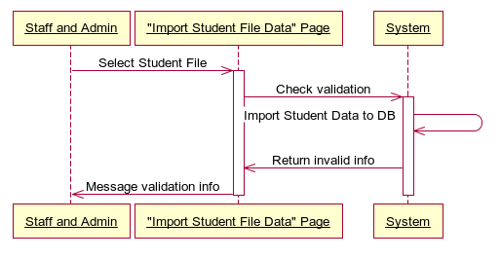

##### **Validate Class Import File Data**



###### **Use Case Diagram**

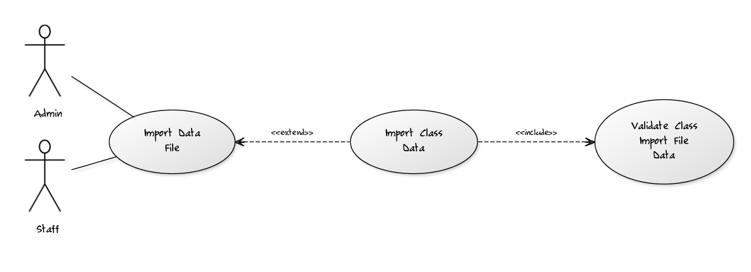

###### **Use Case Specification**

|  |  |  |  |  |
| --- | --- | --- | --- | --- |
| **USE CASE- Validate Class Import File Data SPECIFICATION** | | | | |
| **Use-case No.** | UC001 | **Use-case Version** | | 1.0 |
| **Use-case Name** | Validate Class Import File Data | | | |
| **Author** | KhuongPD | | | |
| **Date** | 01/02/2012 | **Priority** | Normal | |
| **Actor:** Admin, Staff  **Summary:** This use case supports admin and staff to validate template and data of class import file which are chosen in the input file component.  **Goal:** This use case helps staff and admin to validate template base on these conditions:   * Header Column of upload file must exactly like ones in template file. * Type of data field must be validated before import the data to system database.   **Triggers:** Select file in “Select Import File” input file component in “Import Class File Data” page and click “Import Class”  **Preconditions:**  Logged into the system successfully as staff or admin role and open “Import Class File Data” page.  **Post Conditions:**  Success: Data is validate, means system can move to import this Class File into database, after import successfully, system shows message “Import Class Successfully”  Fail: The highlight message like “Data is not validated. Errors happen in line 2 Column AB” appears right below the input file component.  **Main Success Scenario:**   |  |  |  | | --- | --- | --- | | Step | Actor Action | System Response | | 1 | On “Import Class File Data” page, staff or admin click “Select Import File” input file component and select file that they want to import. | Show the url of selected file in input file component url box | | 2 | Staff and admin click “Import Class” button after select import file. | Show confirm message for user to assure they want to import these data into system. | |  |  |  |   **Exceptions:**   * Header Columns is not exactly the same of template file. * Field data type is not corrected. * Import file is missing or its URL has been changed.   **Relationships:**  Log in use case, Import Class Data use case.  **Business Rules:**  N/A | | | | |
| **Description:**  This use case is used to validate excel file that user want to import Class data inside into FMTP data for using. A validated excel file is defined clearly above and need to be absolutely followed to prevent system data from corruption or error.  Staff and admin do not need to care about file validation, FMTP automatically do it before import an excel file into system database. The validation’s result is warned to user if error happens. | | | | |

**Screen**

**Not Avail now**

**Data Fields Definition – Validate Class Import File Data**

|  |  |  |  |  |  |  |
| --- | --- | --- | --- | --- | --- | --- |
| **Field name** | **Description** | **Read**  **Only** | **Mandatory** | **Control Type** | **Data Type** | **Length** |
| (1) Input file label | A label contents “Select Class Excel file to import” | N/A | N/A | Label | Text | Fixed |
| (2) Import Class File Data Result label | A label contents the result of validation and import | N/A | N/A | Label | Text | Fixed |

**Buttons / Hyper Links – Validate Class Import File Data**

|  |  |  |  |  |
| --- | --- | --- | --- | --- |
| **Function** | **Description** | **Available Criteria** | **Validations** | **Outcome** |
| (3) Import Classs Button | The button will validate the excel file then import data into database | Always available | No | Class data will be imported into database, user can view theses data in view pages. |

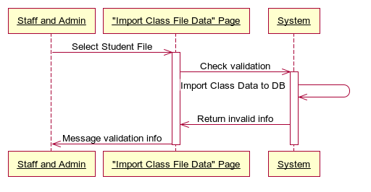

##### ***Validate Semester Import File Data***



###### **Use Case Diagram**

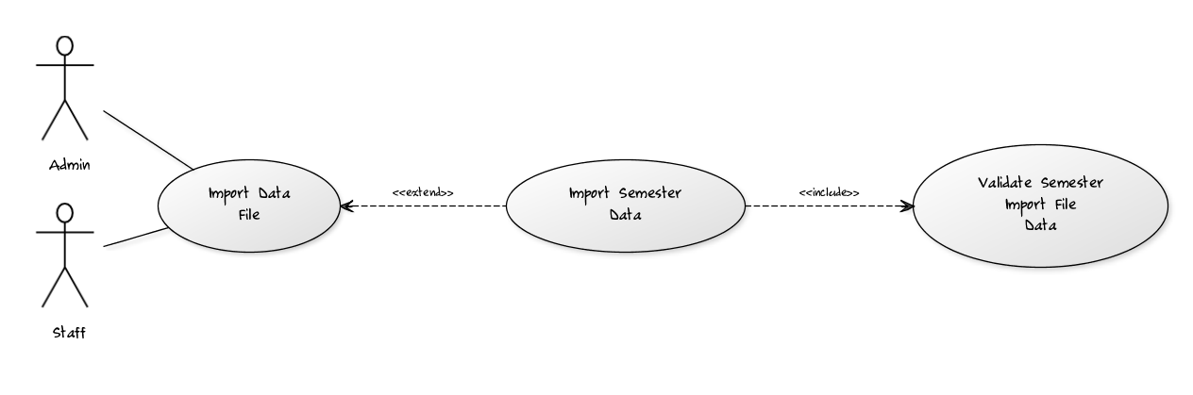

###### **Use Case Specification**

|  |  |  |  |  |
| --- | --- | --- | --- | --- |
| **USE CASE- Validate Semester Import File Data SPECIFICATION** | | | | |
| **Use-case No.** | UC001 | **Use-case Version** | | 1.0 |
| **Use-case Name** | Validate Semester Import File Data | | | |
| **Author** | KhuongPD | | | |
| **Date** | 01/02/2012 | **Priority** | Normal | |
| **Actor:** Admin, Staff  **Summary:** This use case supports admin and staff to validate template and data of Semester import file which are chosen in the input file component.  **Goal:** This use case helps staff and admin to validate template base on these conditions:   * Header Column of upload file must exactly like ones in template file. * Type of data field must be validated before import the data to system database.   **Triggers:** Select file in “Select Import File” input file component in “Import Semester File Data” page and click “Import Semester”  **Preconditions:**  Logged into the system successfully as staff or admin role and open “Import Semester File Data” page.  **Post Conditions:**  Success: Data is validate, means system can move to import this Semester File into database, after import successfully, system shows message “Import Semester Successfully”  Fail: The highlight message like “Data is not validated. Errors happen in line 2 Column AB” appears right below the input file component.  **Main Success Scenario:**   |  |  |  | | --- | --- | --- | | Step | Actor Action | System Response | | 1 | On “Import Semester File Data” page, staff or admin click “Select Import File” input file component and select file that they want to import. | Show the url of selected file in input file component url box | | 2 | Staff and admin click “Import Semester” button after select import file. | Show confirm message for user to assure they want to import these data into system. | |  |  |  |   **Exceptions:**   * Header Columns is not exactly the same of template file. * Field data type is not corrected. * Import file is missing or its URL has been changed.   **Relationships:**  Log in use case, Import Semester Data use case.  **Business Rules:**  N/A | | | | |
| **Description:**  This use case is used to validate excel file that user want to import Semester data inside into FMTP data for using. A validated excel file is defined clearly above and need to be absolutely followed to prevent system data from corruption or error.  Staff and admin do not need to care about file validation, FMTP automatically do it before import an excel file into system database. The validation’s result is warned to user if error happens. | | | | |

**Screen**

**Not Avail now**

**Data Fields Definition – Validate Semester Import File Data**

|  |  |  |  |  |  |  |
| --- | --- | --- | --- | --- | --- | --- |
| **Field name** | **Description** | **Read**  **Only** | **Mandatory** | **Control Type** | **Data Type** | **Length** |
| (1) Input file label | A label contents “Select Semester Excel file to import” | N/A | N/A | Label | Text | Fixed |
| (2) Import Semester File Data Result label | A label contents the result of validation and import | N/A | N/A | Label | Text | Fixed |

**Buttons / Hyper Links – Validate Semester Import File Data**

|  |  |  |  |  |
| --- | --- | --- | --- | --- |
| **Function** | **Description** | **Available Criteria** | **Validations** | **Outcome** |
| (3) Import Semester Button | The button will validate the excel file then import data into database | Always available | No | Semester data will be imported into database, user can view theses data in view pages. |

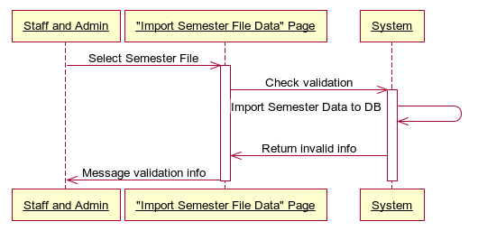

##### **Validate Staff Import File Data**



###### **Use Case Diagram**

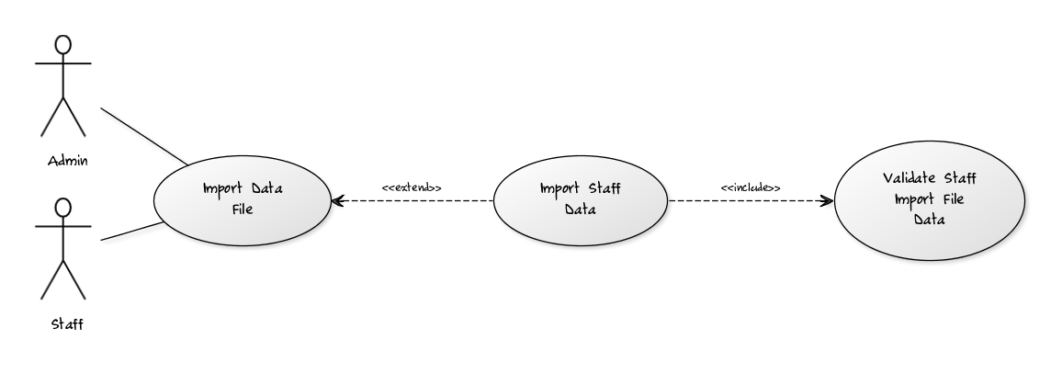

###### **Use Case Specification**

|  |  |  |  |  |
| --- | --- | --- | --- | --- |
| **USE CASE- Validate Staff Import File Data SPECIFICATION** | | | | |
| **Use-case No.** | UC001 | **Use-case Version** | | 1.0 |
| **Use-case Name** | Validate Staff Import File Data | | | |
| **Author** | KhuongPD | | | |
| **Date** | 01/02/2012 | **Priority** | Normal | |
| **Actor:** Admin, Staff  **Summary:** This use case supports admin and staff to validate template and data of Staff import file which are chosen in the input file component.  **Goal:** This use case helps staff and admin to validate template base on these conditions:   * Header Column of upload file must exactly like ones in template file. * Type of data field must be validated before import the data to system database.   **Triggers:** Select file in “Select Import File” input file component in “Import Staff File Data” page and click “Import Staff”  **Preconditions:**  Logged into the system successfully as staff or admin role and open “Import Staff File Data” page.  **Post Conditions:**  Success: Data is validate, means system can move to import this Staff File into database, after import successfully, system shows message “Import Staff Successfully”  Fail: The highlight message like “Data is not validated. Errors happen in line 2 Column AB” appears right below the input file component.  **Main Success Scenario:**   |  |  |  | | --- | --- | --- | | Step | Actor Action | System Response | | 1 | On “Import Staff File Data” page, staff or admin click “Select Import File” input file component and select file that they want to import. | Show the url of selected file in input file component url box | | 2 | Staff and admin click “Import Staff” button after select import file. | Show confirm message for user to assure they want to import these data into system. | |  |  |  |   **Exceptions:**   * Header Columns is not exactly the same of template file. * Field data type is not corrected. * Import file is missing or its URL has been changed.   **Relationships:**  Log in use case, Import Staff Data use case.  **Business Rules:**  N/A | | | | |
| **Description:**  This use case is used to validate excel file that user want to import Semester data inside into FMTP data for using. A validated excel file is defined clearly above and need to be absolutely followed to prevent system data from corruption or error.  Staff and admin do not need to care about file validation, FMTP automatically do it before import an excel file into system database. The validation’s result is warned to user if error happens. | | | | |

**Screen**

**Not Avail now**

**Data Fields Definition – Validate Staff Import File Data**

|  |  |  |  |  |  |  |
| --- | --- | --- | --- | --- | --- | --- |
| **Field name** | **Description** | **Read**  **Only** | **Mandatory** | **Control Type** | **Data Type** | **Length** |
| (1) Input file label | A label contents “Select Staff Excel file to import” | N/A | N/A | Label | Text | Fixed |
| (2) Import Staff File Data Result label | A label contents the result of validation and import | N/A | N/A | Label | Text | Fixed |

**Buttons / Hyper Links – Validate Staff Import File Data**

|  |  |  |  |  |
| --- | --- | --- | --- | --- |
| **Function** | **Description** | **Available Criteria** | **Validations** | **Outcome** |
| (3) Import Staff Button | The button will validate the excel file then import data into database | Always available | No | Staff data will be imported into database, user can view theses data in view pages. |

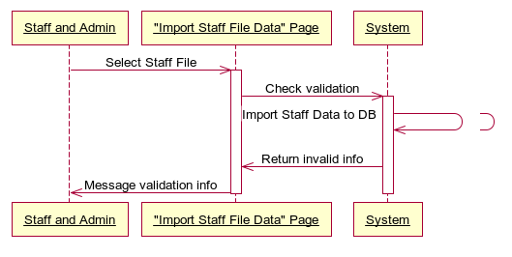

##### ***Import Student Data***

###### **Use Case Diagram**



###### **Use Case Specification**

|  |  |  |  |  |
| --- | --- | --- | --- | --- |
| **USE CASE- Import Student Data SPECIFICATION** | | | | |
| **Use-case No.** | UC001 | **Use-case Version** | | 1.0 |
| **Use-case Name** | Import Student Data | | | |
| **Author** | KhuongPD | | | |
| **Date** | 01/02/2012 | **Priority** | Normal | |
| **Actor:** Admin, Staff  **Summary:** This use case allows admin and staff to import data inside excel file into database for later using. Excel data file will be imported field by field after validation phase.  **Goal:** This use case helps staff and admin to import data into database using excel file with corrected template.  **Triggers:** Select file in “Select Import File” input file component in “Import Student File Data” page and click “Import Student”  **Preconditions:**  Logged into the system successfully as staff or admin role and open “Import Student File Data” page.  **Post Conditions:**  Success: Data is imported, means data is copy into database field by field, then system shows message “Import Student Successfully”  Fail: The highlight message like “Error while importing into database” appears right below the input file component.  **Main Success Scenario:**   |  |  |  | | --- | --- | --- | | Step | Actor Action | System Response | | 1 | On “Import Student File Data” page, staff or admin click “Select Import File” input file component and select file that they want to import. | Show the url of selected file in input file component url box | | 2 | Staff and admin click “Import Student” button after select import file. | Show confirm message for user to assure they want to import these data into system. | |  |  |  |   **Exceptions:**   * SQL Connection information is not true * Other Exception happens while importing data in to SQL database   **Relationships:**  Log in use case, Validate Student Import File Data use case.  **Business Rules:**  N/A | | | | |
| **Description:**  This use case is used to import excel data into SQL data. In this, validated excel file will then be stored into class, and system using function to import these classes into SQL database.  Staff and admin do not need to care about file validation, FMTP automatically do it before import an excel file into system database. The import’s result is warned to user if error happens. | | | | |

**Screen**

**Not Avail now**

**Data Fields Definition – Validate Student Import File Data**

|  |  |  |  |  |  |  |
| --- | --- | --- | --- | --- | --- | --- |
| **Field name** | **Description** | **Read**  **Only** | **Mandatory** | **Control Type** | **Data Type** | **Length** |
| (1) Input file label | A label contents “Select Student Excel file to import” | N/A | N/A | Label | Text | Fixed |
| (2) Import Student File Data Result label | A label contents the result of validation and import | N/A | N/A | Label | Text | Fixed |

**Buttons / Hyper Links – Validate Student Import File Data**

|  |  |  |  |  |
| --- | --- | --- | --- | --- |
| **Function** | **Description** | **Available Criteria** | **Validations** | **Outcome** |
| (3) Import Student Button | The button will validate the excel file then import data into database | Always available | No | Student data will be imported into database, user can view theses data in view pages. |



##### **Import Class Data**



###### **Use Case Diagram**



###### **Use Case Specification**

|  |  |  |  |  |
| --- | --- | --- | --- | --- |
| **USE CASE- Import Class Data SPECIFICATION** | | | | |
| **Use-case No.** | UC001 | **Use-case Version** | | 1.0 |
| **Use-case Name** | Import Class Data | | | |
| **Author** | KhuongPD | | | |
| **Date** | 01/02/2012 | **Priority** | Normal | |
| **Actor:** Admin, Staff  **Summary:** This use case allows admin and staff to import data inside excel file into database for later using. Excel data file will be imported field by field after validation phase.  **Goal:** This use case helps staff and admin to import data into database using excel file with corrected template.  **Triggers:** Select file in “Select Import File” input file component in “Import Class File Data” page and click “Import Class”  **Preconditions:**  Logged into the system successfully as staff or admin role and open “Import Class File Data” page.  **Post Conditions:**  Success: Data is imported, means data is copy into database field by field, then system shows message “Import Class Successfully”  Fail: The highlight message like “Error while importing into database” appears right below the input file component.  **Main Success Scenario:**   |  |  |  | | --- | --- | --- | | Step | Actor Action | System Response | | 1 | On “Import Class File Data” page, staff or admin click “Select Import File” input file component and select file that they want to import. | Show the url of selected file in input file component url box | | 2 | Staff and admin click “Import Class” button after select import file. | Show confirm message for user to assure they want to import these data into system. | |  |  |  |   **Exceptions:**   * SQL Connection information is not true * Other Exception happens while importing data in to SQL database   **Relationships:**  Log in use case, Validate Class Import File Data use case.  **Business Rules:**  N/A | | | | |
| **Description:**  This use case is used to import excel data into SQL data. In this, validated excel file will then be stored into class, and system using function to import these classes into SQL database.  Staff and admin do not need to care about file validation, FMTP automatically do it before import an excel file into system database. The import’s result is warned to user if error happens. | | | | |

**Screen**

**Not Avail now**

**Data Fields Definition – Validate Class Import File Data**

|  |  |  |  |  |  |  |
| --- | --- | --- | --- | --- | --- | --- |
| **Field name** | **Description** | **Read**  **Only** | **Mandatory** | **Control Type** | **Data Type** | **Length** |
| (1) Input file label | A label contents “Select Class Excel file to import” | N/A | N/A | Label | Text | Fixed |
| (2) Import Class File Data Result label | A label contents the result of validation and import | N/A | N/A | Label | Text | Fixed |

**Buttons / Hyper Links – Validate Class Import File Data**

|  |  |  |  |  |
| --- | --- | --- | --- | --- |
| **Function** | **Description** | **Available Criteria** | **Validations** | **Outcome** |
| (3) Import Class Button | The button will validate the excel file then import data into database | Always available | No | Class data will be imported into database, user can view theses data in view pages. |



##### ***Import Semester Data***



###### **Use Case Diagram**



###### **Use Case Specification**

|  |  |  |  |  |
| --- | --- | --- | --- | --- |
| **USE CASE- Import Semester Data SPECIFICATION** | | | | |
| **Use-case No.** | UC001 | **Use-case Version** | | 1.0 |
| **Use-case Name** | Import Semester Data | | | |
| **Author** | KhuongPD | | | |
| **Date** | 01/02/2012 | **Priority** | Normal | |
| **Actor:** Admin, Staff  **Summary:** This use case allows admin and staff to import data inside excel file into database for later using. Excel data file will be imported field by field after validation phase.  **Goal:** This use case helps staff and admin to import data into database using excel file with corrected template.  **Triggers:** Select file in “Select Import File” input file component in “Import Semester File Data” page and click “Import Semester”  **Preconditions:**  Logged into the system successfully as staff or admin role and open “Import Semester File Data” page.  **Post Conditions:**  Success: Data is imported, means data is copy into database field by field, then system shows message “Import Semester Successfully”  Fail: The highlight message like “Error while importing into database” appears right below the input file component.  **Main Success Scenario:**   |  |  |  | | --- | --- | --- | | Step | Actor Action | System Response | | 1 | On “Import Semester File Data” page, staff or admin click “Select Import File” input file component and select file that they want to import. | Show the url of selected file in input file component url box | | 2 | Staff and admin click “Import Semester” button after select import file. | Show confirm message for user to assure they want to import these data into system. | |  |  |  |   **Exceptions:**   * SQL Connection information is not true * Other Exception happens while importing data in to SQL database   **Relationships:**  Log in use case, Validate Semester Import File Data use case.  **Business Rules:**  N/A | | | | |
| **Description:**  This use case is used to import excel data into SQL data. In this, validated excel file will then be stored into class, and system using function to import these classes into SQL database.  Staff and admin do not need to care about file validation, FMTP automatically do it before import an excel file into system database. The import’s result is warned to user if error happens. | | | | |

**Screen**

**Not Avail now**

**Data Fields Definition – Validate Semester Import File Data**

|  |  |  |  |  |  |  |
| --- | --- | --- | --- | --- | --- | --- |
| **Field name** | **Description** | **Read**  **Only** | **Mandatory** | **Control Type** | **Data Type** | **Length** |
| (1) Input file label | A label contents “Select Semester Excel file to import” | N/A | N/A | Label | Text | Fixed |
| (2) Import Semester File Data Result label | A label contents the result of validation and import | N/A | N/A | Label | Text | Fixed |

**Buttons / Hyper Links – Validate Semester Import File Data**

|  |  |  |  |  |
| --- | --- | --- | --- | --- |
| **Function** | **Description** | **Available Criteria** | **Validations** | **Outcome** |
| (3) Import Semester Button | The button will validate the excel file then import data into database | Always available | No | Semester data will be imported into database, user can view theses data in view pages. |



##### **Import Staff Data**



###### **Use Case Diagram**



###### **Use Case Specification**

|  |  |  |  |  |
| --- | --- | --- | --- | --- |
| **USE CASE- Import Staff Data SPECIFICATION** | | | | |
| **Use-case No.** | UC001 | **Use-case Version** | | 1.0 |
| **Use-case Name** | Import Staff Data | | | |
| **Author** | KhuongPD | | | |
| **Date** | 01/02/2012 | **Priority** | Normal | |
| **Actor:** Admin, Staff  **Summary:** This use case allows admin and staff to import data inside excel file into database for later using. Excel data file will be imported field by field after validation phase.  **Goal:** This use case helps staff and admin to import data into database using excel file with corrected template.  **Triggers:** Select file in “Select Import File” input file component in “Import Staff File Data” page and click “Import Staff”  **Preconditions:**  Logged into the system successfully as staff or admin role and open “Import Staff File Data” page.  **Post Conditions:**  Success: Data is imported, means data is copy into database field by field, then system shows message “Import Staff Successfully”  Fail: The highlight message like “Error while importing into database” appears right below the input file component.  **Main Success Scenario:**   |  |  |  | | --- | --- | --- | | Step | Actor Action | System Response | | 1 | On “Import Staff File Data” page, staff or admin click “Select Import File” input file component and select file that they want to import. | Show the url of selected file in input file component url box | | 2 | Staff and admin click “Import Staff” button after select import file. | Show confirm message for user to assure they want to import these data into system. | |  |  |  |   **Exceptions:**   * SQL Connection information is not true * Other Exception happens while importing data in to SQL database   **Relationships:**  Log in use case, Validate Staff Import File Data use case.  **Business Rules:**  N/A | | | | |
| **Description:**  This use case is used to import excel data into SQL data. In this, validated excel file will then be stored into class, and system using function to import these classes into SQL database.  Staff and admin do not need to care about file validation, FMTP automatically do it before import an excel file into system database. The import’s result is warned to user if error happens. | | | | |

**Screen**

**Not Avail now**

**Data Fields Definition – Validate Staff Import File Data**

|  |  |  |  |  |  |  |
| --- | --- | --- | --- | --- | --- | --- |
| **Field name** | **Description** | **Read**  **Only** | **Mandatory** | **Control Type** | **Data Type** | **Length** |
| (1) Input file label | A label contents “Select Staff Excel file to import” | N/A | N/A | Label | Text | Fixed |
| (2) Import Staff File Data Result label | A label contents the result of validation and import | N/A | N/A | Label | Text | Fixed |

**Buttons / Hyper Links – Validate Staff Import File Data**

|  |  |  |  |  |
| --- | --- | --- | --- | --- |
| **Function** | **Description** | **Available Criteria** | **Validations** | **Outcome** |
| (3) Import Staff Button | The button will validate the excel file then import data into database | Always available | No | Staff data will be imported into database, user can view theses data in view pages. |



##### ***Validate Grade Import File Data***



###### **Use Case Diagram**

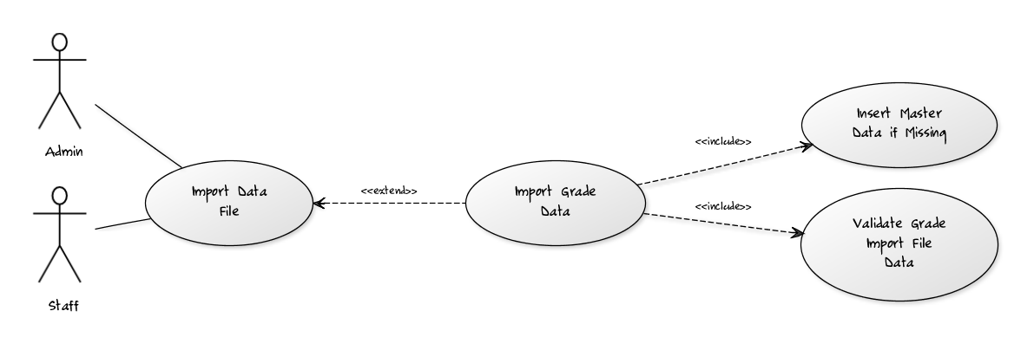

###### **Use Case Specification**

|  |  |  |  |  |
| --- | --- | --- | --- | --- |
| **USE CASE- Validate Staff Import File Data SPECIFICATION** | | | | |
| **Use-case No.** | UC001 | **Use-case Version** | | 1.0 |
| **Use-case Name** | Validate Grade Import File Data | | | |
| **Author** | KhuongPD | | | |
| **Date** | 01/02/2012 | **Priority** | Normal | |
| **Actor:** Admin, Staff  **Summary:** This use case supports admin and staff to validate template and data of Grade import file which are chosen in the input file component.  **Goal:** This use case helps staff and admin to validate template base on these conditions:   * Header Column of upload file must exactly like ones in template file. * Type of data field must be validated before import the data to system database. * Master data field must be inserted after validating and before using, means master data like class, semester, staff and student will be first imported to their own formation table before import grade. Note that grade can be understood as transaction data.   **Triggers:** Select file in “Select Import File” input file component in “Import Grade File Data” page and click “Import Grade”  **Preconditions:**  Logged into the system successfully as staff or admin role and open “Import Grade File Data” page.  **Post Conditions:**  Success: Data is validate, means system can move to import master data and import this Grade File into database, after import successfully, system shows message “Import Grade Successfully”  Fail: The highlight message like “Data is not validated. Errors happen in line 2 Column AB” appears right below the input file component.  **Main Success Scenario:**   |  |  |  | | --- | --- | --- | | Step | Actor Action | System Response | | 1 | On “Import Grade File Data” page, staff or admin click “Select Import File” input file component and select file that they want to import. | Show the url of selected file in input file component url box | | 2 | Staff and admin click “Import Grade” button after select import file. | Show confirm message for user to assure they want to import these data into system. | |  |  |  |   **Exceptions:**   * Header Columns is not exactly the same of template file. * Field data type is not corrected. * Import file is missing or its URL has been changed.   **Relationships:**  Log in use case, Import Grade Data use case.  **Business Rules:**  N/A | | | | |
| **Description:**  This use case is used to validate excel file that user want to import Grade data inside into FMTP data for using. A validated excel file is defined clearly above and need to be absolutely followed to prevent system data from corruption or error.  Staff and admin do not need to care about file validation, FMTP automatically do it before import an excel file into system database. The validation’s result is warned to user if error happens. | | | | |

**Screen**

**Not Avail now**

**Data Fields Definition – Validate Grade Import File Data**

|  |  |  |  |  |  |  |
| --- | --- | --- | --- | --- | --- | --- |
| **Field name** | **Description** | **Read**  **Only** | **Mandatory** | **Control Type** | **Data Type** | **Length** |
| (1) Input file label | A label contents “Select Grade Excel file to import” | N/A | N/A | Label | Text | Fixed |
| (2) Import Grade File Data Result label | A label contents the result of validation and import | N/A | N/A | Label | Text | Fixed |

**Buttons / Hyper Links – Validate Grade Import File Data**

|  |  |  |  |  |
| --- | --- | --- | --- | --- |
| **Function** | **Description** | **Available Criteria** | **Validations** | **Outcome** |
| (3) Import Grade Button | The button will validate the excel file then import data into database | Always available | No | Grade data will be imported into database, user can view theses data in view pages. |

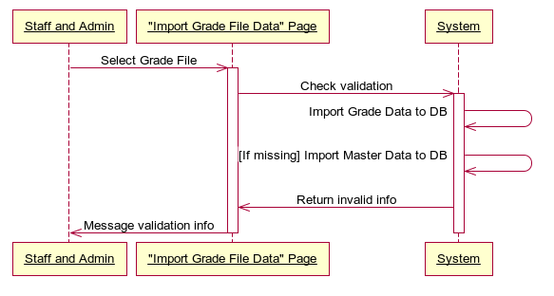

##### ***Insert Master Data if Missing (Import Grade Data)***



###### **Use Case Diagram**



###### **Use Case Specification**

|  |  |  |  |  |
| --- | --- | --- | --- | --- |
| **USE CASE- Insert Master Data if Missing SPECIFICATION** | | | | |
| **Use-case No.** | UC001 | **Use-case Version** | | 1.0 |
| **Use-case Name** | Insert Master Data if Missing | | | |
| **Author** | KhuongPD | | | |
| **Date** | 01/02/2012 | **Priority** | Normal | |
| **Actor:** Admin, Staff  **Summary:** This use case supports admin and staff to insert master data (data of student, staff, semester and class) into database before import grade data into database. The master data, ofcourse, must be validated and check if not existed in database first.  **Goal:** This use case helps staff and admin to master data into database, include:   * Columns that belong to master data (data of student, staff, semester and class) will be defined the name (caption). When import grade data, if data in a field is not available in the corresponding table, it will be inserted automatically. * A master data field that want to be inserted need to be validated first to check for type and range.   **Triggers:** Select file in “Select Import File” input file component in “Import Grade File Data” page and click “Import Grade”  **Preconditions:**  Logged into the system successfully as staff or admin role and open “Import Grade File Data” page.  **Post Conditions:**  Success: Data is validate, means system can move to import master data and import this Grade File into database, after import successfully, system shows message “Import Grade Successfully”  Fail: The highlight message like “Data is not validated. Errors happen in line 2 Column AB” appears right below the input file component.  **Main Success Scenario:**   |  |  |  | | --- | --- | --- | | Step | Actor Action | System Response | | 1 | On “Import Grade File Data” page, staff or admin click “Select Import File” input file component and select file that they want to import. | Show the url of selected file in input file component url box | | 2 | Staff and admin click “Import Grade” button after select import file. | Show confirm message for user to assure they want to import these data into system. | |  |  |  |   **Exceptions:**   * Header Columns is not exactly the same of template file. * Field data type is not corrected. * Import file is missing or its URL has been changed.   **Relationships:**  Log in use case, Import Grade Data use case, Validate Grade Import File Data use case.  **Business Rules:**  N/A | | | | |
| **Description:**  This use case is used to insert master data (data of student, staf, class and semester) into database if missing.  Staff and admin do not need to care about insert master data, FMTP automatically do it before import an excel file into system database. The result is warned to user if error happens. | | | | |

**Screen**

**Not Avail now**

**Data Fields Definition – Insert Master Data if Missing**

|  |  |  |  |  |  |  |
| --- | --- | --- | --- | --- | --- | --- |
| **Field name** | **Description** | **Read**  **Only** | **Mandatory** | **Control Type** | **Data Type** | **Length** |
| (1) Input file label | A label contents “Select Grade Excel file to import” | N/A | N/A | Label | Text | Fixed |
| (2) Import Grade File Data Result label | A label contents the result of validation and import | N/A | N/A | Label | Text | Fixed |

**Buttons / Hyper Links – Insert Master Data if Missing**

|  |  |  |  |  |
| --- | --- | --- | --- | --- |
| **Function** | **Description** | **Available Criteria** | **Validations** | **Outcome** |
| (3) Import Grade Button | The button will validate the excel file then import data into database | Always available | No | Grade data will be imported into database, user can view theses data in view pages. |



##### **Import Grade Data**



###### **Use Case Diagram**



###### **Use Case Specification**

|  |  |  |  |  |
| --- | --- | --- | --- | --- |
| **USE CASE- Import Grade Data SPECIFICATION** | | | | |
| **Use-case No.** | UC001 | **Use-case Version** | | 1.0 |
| **Use-case Name** | Import Grade Data | | | |
| **Author** | KhuongPD | | | |
| **Date** | 01/02/2012 | **Priority** | Normal | |
| **Actor:** Admin, Staff  **Summary:** This use case allows admin and staff to import data inside excel file into database for later using. Excel data file will be imported field by field after validation and insert missing mastert data phase.  **Goal:** This use case helps staff and admin to import grade data (transaction data) into database using excel file with corrected template.  **Triggers:** Select file in “Select Import File” input file component in “Import Grade File Data” page and click “Import Grade”  **Preconditions:**  Logged into the system successfully as staff or admin role and open “Import Grade File Data” page.  **Post Conditions:**  Success: Data is imported, means data is copy into database field by field, then system shows message “Import Grade Successfully”  Fail: The highlight message like “Error while importing into database” appears right below the input file component.  **Main Success Scenario:**   |  |  |  | | --- | --- | --- | | Step | Actor Action | System Response | | 1 | On “Import Grade File Data” page, staff or admin click “Select Import File” input file component and select file that they want to import. | Show the url of selected file in input file component url box | | 2 | Staff and admin click “Import Grade” button after select import file. | Show confirm message for user to assure they want to import these data into system. | |  |  |  |   **Exceptions:**   * SQL Connection information is not true * Other Exception happens while importing data in to SQL database   **Relationships:**  Log in use case, Validate Grade Import File Data use case.  **Business Rules:**  N/A | | | | |
| **Description:**  This use case is used to import excel data into SQL data. In this, validated excel file will then be stored into class, and system using function to import these classes into SQL database after import class, semester, student and staff data (if missed) into database.  Staff and admin do not need to care about file validation, FMTP automatically do it before import an excel file into system database. The import’s result is warned to user if error happens. | | | | |

**Screen**

**Not Avail now**

**Data Fields Definition – Validate Grade Import File Data**

|  |  |  |  |  |  |  |
| --- | --- | --- | --- | --- | --- | --- |
| **Field name** | **Description** | **Read**  **Only** | **Mandatory** | **Control Type** | **Data Type** | **Length** |
| (1) Input file label | A label contents “Select Gradeg Excel file to import” | N/A | N/A | Label | Text | Fixed |
| (2) Import Grade File Data Result label | A label contents the result of validation and import | N/A | N/A | Label | Text | Fixed |

**Buttons / Hyper Links – Validate Grade Import File Data**

|  |  |  |  |  |
| --- | --- | --- | --- | --- |
| **Function** | **Description** | **Available Criteria** | **Validations** | **Outcome** |
| (3) Import Gradeg Button | The button will validate the excel file then import data into database | Always available | No | Grade data will be imported into database, user can view theses data in view pages. |



### Software System Attributes

#### Usability

**GUI**

* All the text, image text and help documents should be in English.
* The interface should be elegant, simple and out-standing.
* All images must also provide alt attribute.

**Usability for end-users**

* Searching and filtering tool should be easy to use.
* The website must provide a help page to support novice users.
* Users have to log in to the system to use main functionalities.
* The system should remember information (but not confidential) that users have to provide regularly. For example: name, address…

**Usability for admin and staff**

* Website admin and staff should need no more than one day of training to be productive with the system.
* Detailed help must be available for the admin and staff, both in web pages and separate documentations.

**Installation**

* The system must be easy to deploy. Customer can deploy successfully and learn to configure, maintain the system within one day of training.
* The documentation for installation must be included. It describes detailed steps for installing or deploying the system. The customer can follow the steps without direct help from the developing team.

#### Reliability

* Initial data must be collected carefully and correctly
* The database must be backed up regularly and can be recovered if necessary
* Auto Email service must be reliable.
* Grading system must be reliable
* Not conflict with other software
* Rate of fault occurrence (ROFO): a number of 0.005 is acceptable. It means that it is acceptable to have 5 failures happen in each 1000 operational time units (e.g. 5 failures per 1000 hours of operation).
* Mean Time Between Failures (MTBF): 1 month
* Mean Time To Repair (MTTR): immediately when admin finds out problem or website is attacked by someone. Average 1 day.
* Accuracy: precision of floating number should be rounded to 0.01. All currency units must be displayed (e.g. $, VND…)
* Maximum Bugs or Defect Rate: 5 bugs / KLOC.
* Bugs or Defect Rate
  + - Minor bugs: bugs related to GUI
    - Significant bugs: bugs related to minor business logic
    - Critical *bugs: function can’t execute correctly, completely loss of data, disconnect to the server*

#### Availability

* Systems have to run 24 hours 7 days
* Can be turned off when upgrading and must display an alternative maintenance page in such occasions
* Percentage of time available is about 95-97%. Because the system uses client/server protocol through Internet network, we cannot control cases of force majeure such as power failure, disconnected network…

#### Security

* Privacy: the system should provide protection method for protecting user information and student’s grade information from outside or from other users. All the information of users must not be available for anyone or software that is not part of the system. User password is also invisible for the system administrator.
* The system must provide methods to prevent common security attacks. E.g. SQL injection …
* Transformation of confidential information must be encrypted.
* The system must provide secure methods for users to recovery their password, including the interference of system’s admin.
* Secure information of student’ grade should not be stored on client’s machine.
* Restrict communications between some areas of the program
* Check data integrity for critical variables

#### Maintainability

**Coding standards and naming conventions**

* Output of the project must include coding standards and naming conventions documentations. Implementation code must be easy to maintain.
* All code must be clearly commented, including class, method documentations.
* If some components are reused, the documentations of those components must also be included.

**Design**

* The design of the system must be loosely coupled that chances on some module will not affect others.

**Logging**

* All the errors should be logged, supporting for bug fixing and maintenance.
* All strange or sensitive situations should also be logged.

**Email**

* The system must provide an email address for using in Auto Send email Final Grade Report Service at server.

#### Portability

* Website can be used by any people with a browser and an Internet connection.

#### Performance

**Load time**

* Every page should be completely displayed within: average 1.5 second and maximum 5 seconds.
* Searching should return and display the result within 2 seconds.
* Paging, sorting data in table, suggesting result should affect immediately, without reloading the web page.

**Mailing system**

* Mail server should send emails within 10 minute after associated events happen.

**Capacity**

* The system should serve correctly and reasonably with at least 1000 online users at a moment.
* The system can store at least 10000 users without affecting the loading speed.
* If the system is busy, it has to inform users about that.

**Compatibility**

* The system should provide elegant responses for nowadays common screen resolutions: 1024\*768, 1280\*800.
* The output must be compatible with all common browsers: Mozilla Firefox, Internet Explorer, Google Chrome, Apple Safari, and Opera.

Information of the system can be accessed by searching bots.

## Entity Relationship Diagram (Specific Requirements)

Fig\_3 ERD

# References

[1] yuml., 2012, 'Use case', 1 February, viewed 1 February 2012

< <http://yuml.me/diagram/usecase/draw2> >

[2] websequencediagrams., 2012, ‘Sequence Diagram’, 2 Fubruary, viewed 2 February 2012

< <http://www.websequencediagrams.com/> >